Unit 7 Lesson 1: Positive and Negative Numbers

1 Notice and Wonder: Memphis and Bangor (Warm up)

Student Task Statement
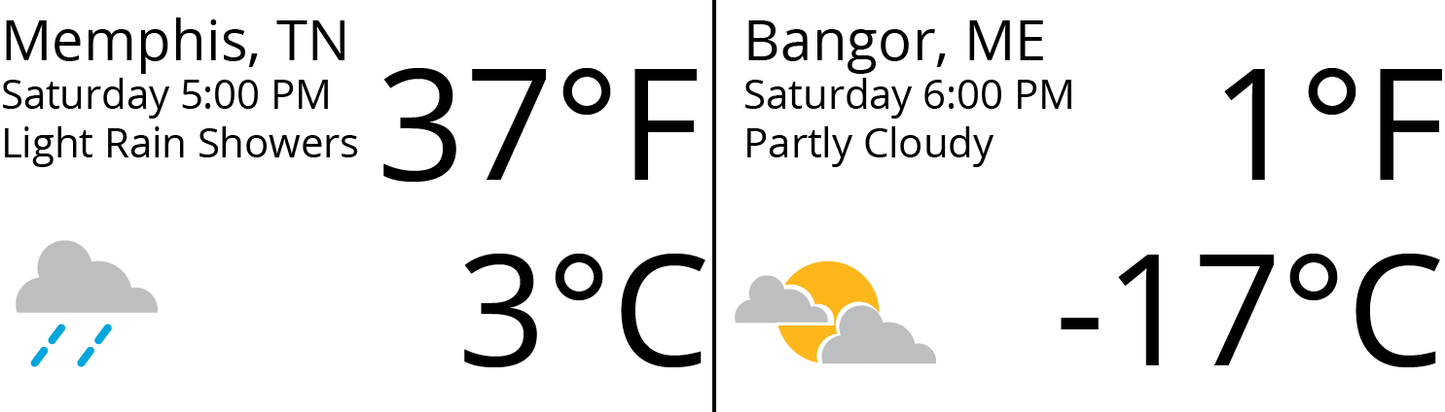
What do you notice? What do you wonder?

2 What’s the Temperature?

Student Task Statement
- Here are five thermometers. The first four thermometers show temperatures in Celsius. Write the temperatures in the blanks.
- 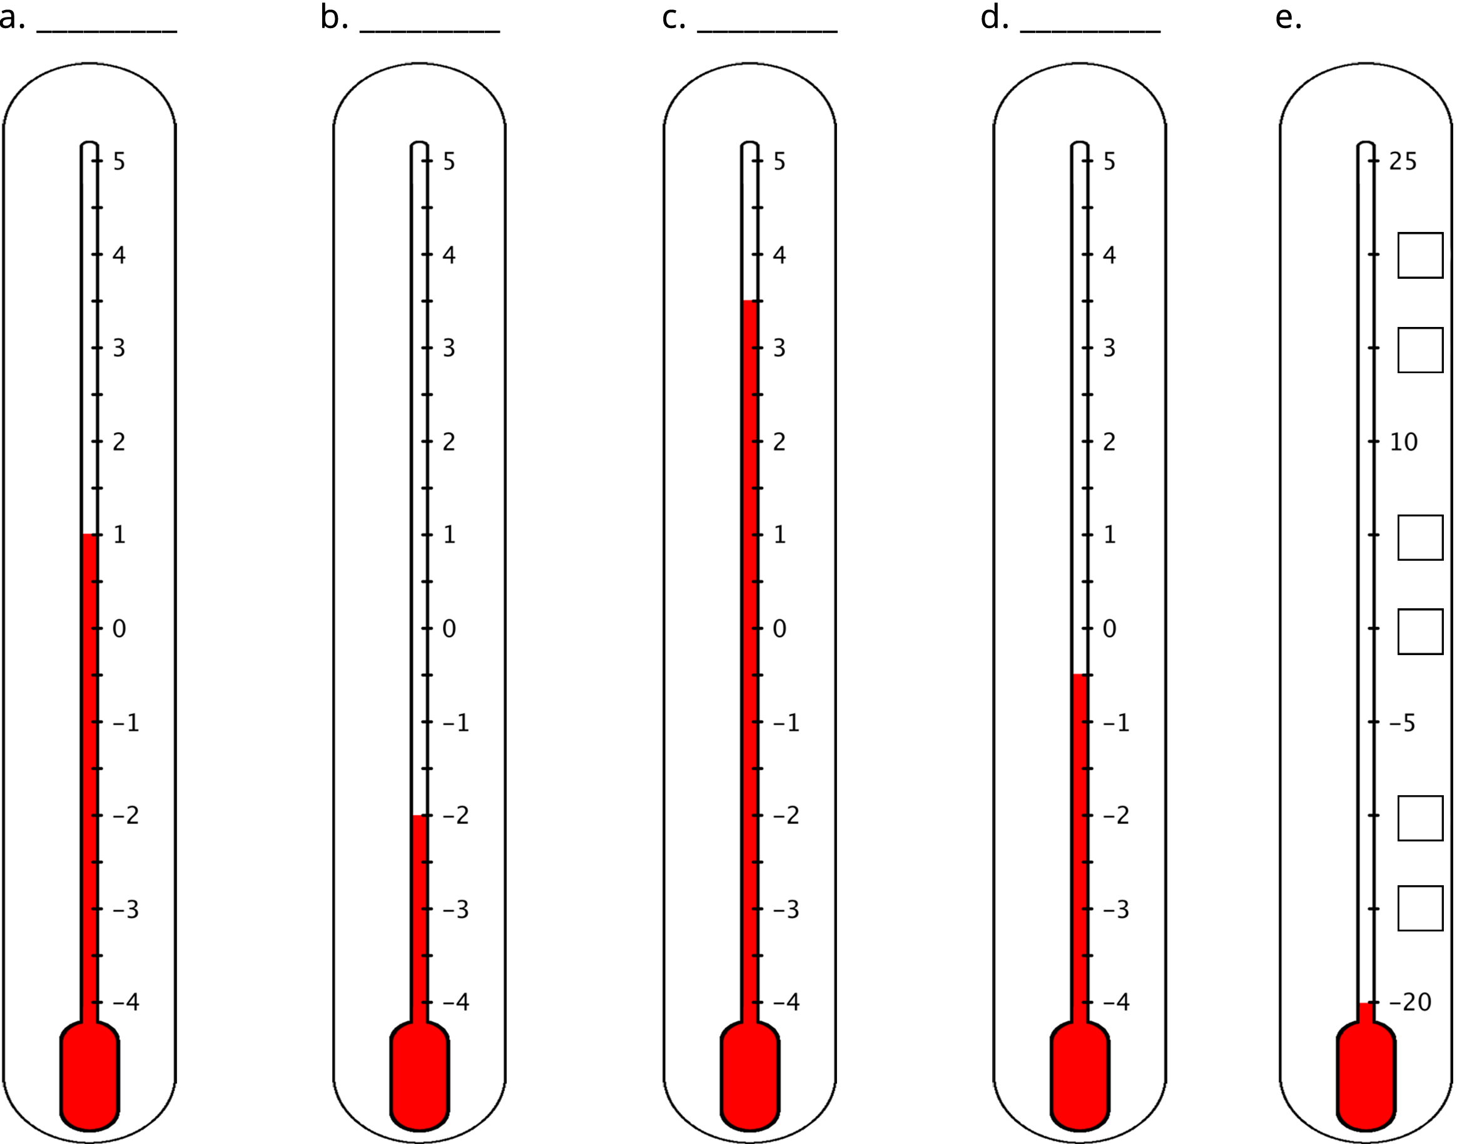
- The last thermometer is missing some numbers. Write them in the boxes.
- Elena says that the thermometer shown here reads $\text{-}{2.5}^{∘}\text{C}$ because the line of the liquid is above $\text{-}2^{∘}\text{C}$. Jada says that it is $\text{-}{1.5}^{∘}\text{C}$. Do you agree with either one of them? Explain your reasoning.
- 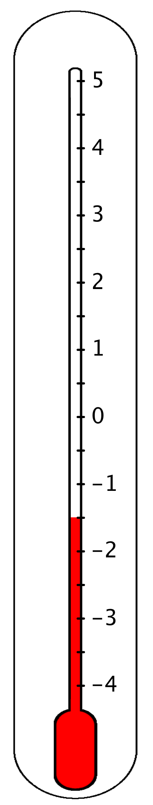
- One morning, the temperature in Phoenix, Arizona, was $8^{∘}\text{C}$ and the temperature in Portland, Maine, was ${12}^{∘}\text{C}$ cooler. What was the temperature in Portland?

3 Seagulls Soar, Sharks Swim

Student Task Statement
Here is a picture of some sea animals. The number line on the left shows the vertical position of each animal above or below sea level, in meters.
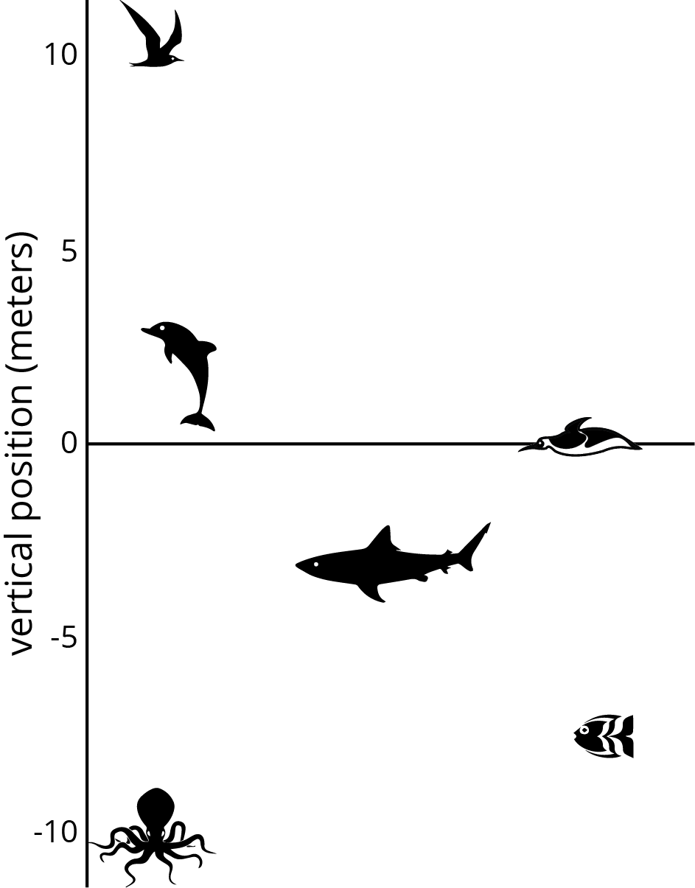
- How far above or below sea level is each animal? Measure to their eye level.
- A mobula ray is 3 meters above the surface of the ocean. How does its vertical position compare to the height or depth of:
- The jumping dolphin?
- The flying seagull?
- The octopus?
- An albatross is 5 meters above the surface of the ocean. How does its vertical position compare to the height or depth of:
- The jumping dolphin?
- The flying seagull?
- The octopus?
- A clownfish is 2 meters below the surface of the ocean. How does its vertical position compare to the height or depth of:
- The jumping dolphin?
- The flying seagull?
- The octopus?
- The vertical distance of a new dolphin from the dolphin in the picture is 3 meters. What is its distance from the surface of the ocean?

4 High Places, Low Places

Student Task Statement
- Here is a table that shows elevations of various cities.
- city | - elevation (feet)
- Harrisburg, PA | - 320
- Bethell, IN | - 1,211
- Denver, CO | - 5,280
- Coachella, CA | - -22
- Death Valley, CA | - -282
- New York City, NY | - 33
- Miami, FL | - 0
  - On the list of cities, which city has the second highest elevation?
  - How would you describe the elevation of Coachella, CA in relation to sea level?
  - How would you describe the elevation of Death Valley, CA in relation to sea level?
  - If you are standing on a beach right next to the ocean, what is your elevation?
  - How would you describe the elevation of Miami, FL?
  - A city has a higher elevation than Coachella, CA. Select all numbers that could represent the city’s elevation. Be prepared to explain your reasoning.
    - -11 feet
    - -35 feet
    - 4 feet
    - -8 feet
    - 0 feet
- Here are two tables that show the elevations of highest points on land and lowest points in the ocean. Distances are measured from sea level.
- mountain | - continent | - elevation (meters)
- Everest | - Asia | - 8,848
- Kilimanjaro | - Africa | - 5,895
- Denali | - North America | - 6,168
- Pikchu Pikchu | - South America | - 5,664

- trench | - ocean | - elevation (meters)
- Mariana Trench | - Pacific | - -11,033
- Puerto Rico Trench | - Atlantic | - -8,600
- Tonga Trench | - Pacific | - -10,882
- Sunda Trench | - Indian | - -7,725
  - Which point in the ocean is the lowest in the world? What is its elevation?
  - Which mountain is the highest in the world? What is its elevation?
  - If you plot the elevations of the mountains and trenches on a vertical number line, what would 0 represent? What would points above 0 represent? What about points below 0?
  - Which is farther from sea level: the deepest point in the ocean, or the top of the highest mountain in the world? Explain.

Images for Activity Synthesis
© CC BY Open Up Resources. Adaptations CC BY IM.

