Unit 3 Lesson 7: Finding an Algorithm for Dividing Fractions

1 Multiplying Fractions (Warm up)

Student Task Statement
Evaluate each expression.
- $\frac{2}{3}⋅27$
- $\frac{1}{2}⋅\frac{2}{3}$
- $\frac{2}{9}⋅\frac{3}{5}$
- $\frac{27}{100}⋅\frac{200}{9}$
- $\left(1\frac{3}{4}\right)⋅\frac{5}{7}$

2 Dividing by Non-unit Fractions

Student Task Statement
- To find the value of $6÷\frac{2}{3}$, Elena started by drawing a diagram the same way she did for $6÷\frac{1}{3}$.
- 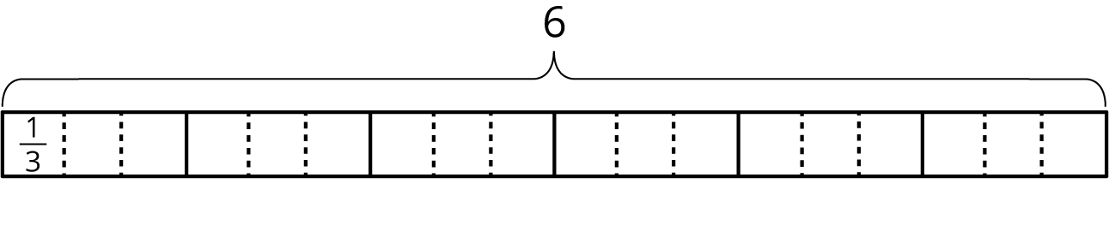
  - Complete the diagram to show how many $\frac{2}{3}$s are in 6.
  - Elena says, “To find $6÷\frac{2}{3}$, I can just take the value of $6÷\frac{1}{3}$ and then either multiply it by $\frac{1}{2}$ or divide it by 2.” Do you agree with her? Explain your reasoning.
- For each division expression, complete the diagram using the same method as Elena. Then, find the value of the expression. Think about how you could find that value without counting all the pieces in your diagram.
  - $6÷\frac{3}{4}$
  - 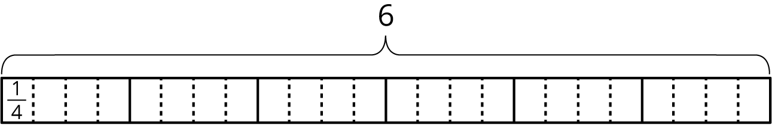
  - Value of the expression:___________
  - ​​​​​​
$6÷\frac{4}{3}$
  - 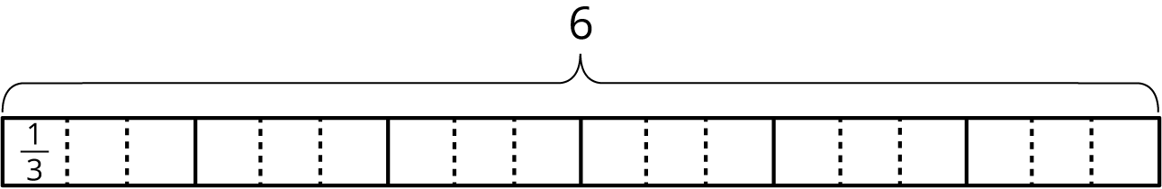
  - Value of the expression:___________
  - $6÷\frac{4}{6}$
  - 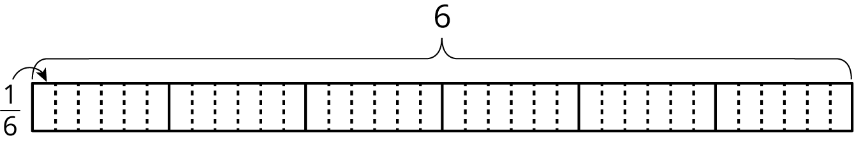
  - Value of the expression:___________
- Elena examined her diagrams and noticed that she always took the same two steps to show division by a fraction on a tape diagram. She said:
- “My first step was to divide each 1 whole into as many parts as the number in the denominator. So if the expression is $6÷\frac{3}{4}$, I would break each 1 whole into 4 parts. Now I have 4 times as many parts.
- My second step was to put a certain number of those parts into one group, and that number is the numerator of the divisor. So if the fraction is $\frac{3}{4}$, I would put 3 of the $\frac{1}{4}$s into one group. Then I could tell how many $\frac{3}{4}$s are in 6.”
- Which expression represents how many $\frac{3}{4}$s Elena would have after these two steps? Be prepared to explain your reasoning.
  - $6÷4⋅3$
  - $6÷4÷3$
  - $6⋅4÷3$
  - $6⋅4⋅3$
- Use the pattern Elena noticed to find the values of these expressions. If you get stuck, consider drawing a diagram.
  - $6÷\frac{2}{7}$
  - $6÷\frac{3}{10}$
  - $6÷\frac{6}{25}$

Activity Synthesis
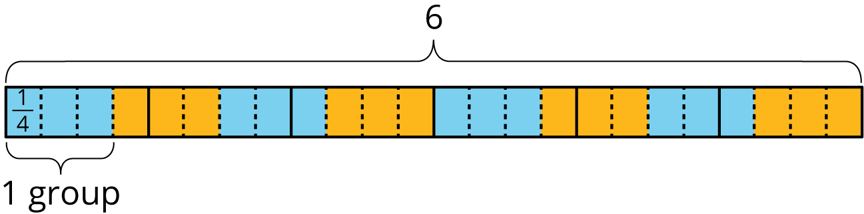

3 Dividing a Fraction by a Fraction

Student Task Statement
Work with a partner. One person works on the questions labeled “Partner A” and the other person works on those labeled “Partner B.”
- Partner A: Find the value of each expression by completing the diagram.

  - $\frac{3}{4}÷\frac{1}{8}$
  - How many $\frac{1}{8}$s in $\frac{3}{4}$?
  - 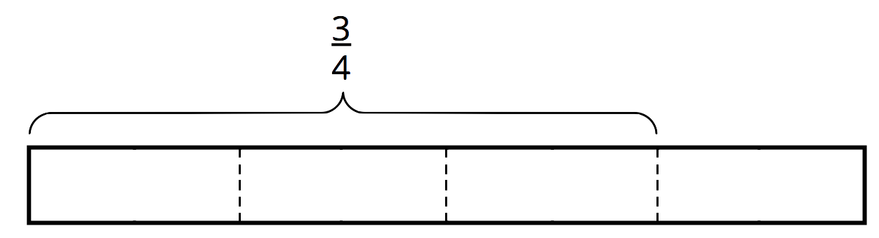

  - $\frac{9}{10}÷\frac{3}{5}$
  - How many $\frac{3}{5}$s in $\frac{9}{10}$?
  - 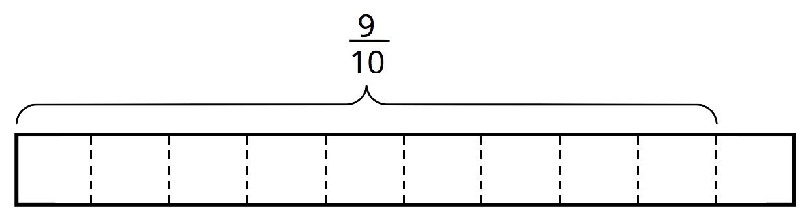
- Partner B:
- Elena said, “If I want to divide 4 by $\frac{2}{5}$, I can multiply 4 by 5 and then divide it by 2 or multiply it by $\frac{1}{2}$.”
- Find the value of each expression using the strategy Elena described.
  - $\frac{3}{4}÷\frac{1}{8}$
  - $\frac{9}{10}÷\frac{3}{5}$
- What do you notice about the diagrams and expressions? Discuss with your partner.
- Complete this sentence based on what you noticed:
- To divide a number $n$ by a fraction $\frac{a}{b}$, we can multiply $n$ by ________ and then divide the product by ________.
- Select all the equations that represent the sentence you completed.
  - $n÷\frac{a}{b}=n⋅b÷a$
  - $n÷\frac{a}{b}=n⋅a÷b$
  - $n÷\frac{a}{b}=n⋅\frac{a}{b}$
  - $n÷\frac{a}{b}=n⋅\frac{b}{a}$
© CC BY Open Up Resources. Adaptations CC BY IM.

