Lesson 7 Practice Problems
- There is a proportional relationship between the volume of a sample of helium in liters and the mass of that sample in grams. If the mass of a sample is 5 grams, its volume is 28 liters. (5, 28) is shown on the graph below.
- 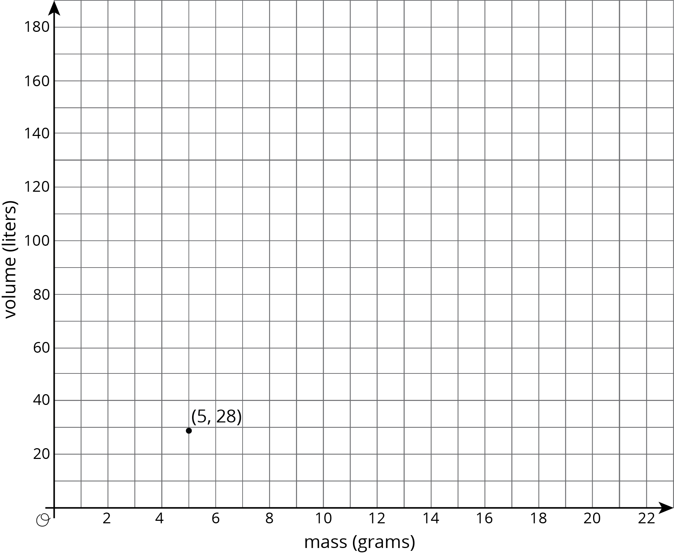
  - What is the constant of proportionality in this relationship?
  - In this situation, what is the meaning of the number you found in part a?
  - Add at least three more points to the graph above, and label with their coordinates.
  - Write an equation that shows the relationship between the mass of a sample of helium and its volume. Use $m$ for mass and $v$ for volume.
- (From Unit 2, Lesson 11.)
- Explain how the parts of the balanced hanger compare to the parts of the equation.
- $7=2x+3$
- 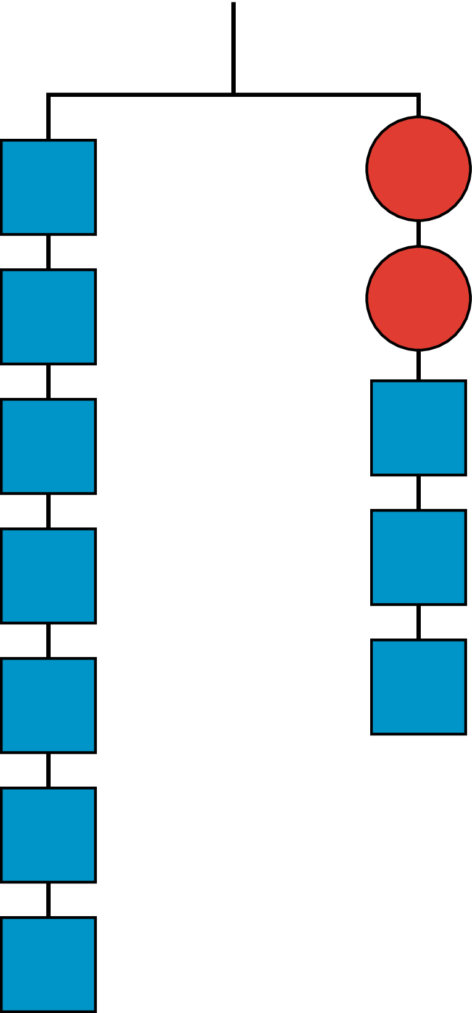
- For the hanger below:
  - Write an equation to represent the hanger.
  - Draw more hangers to show each step you would take to find $x$. Explain your reasoning.
  - Write an equation to describe each hanger you drew. Describe how each equation matches its hanger.
- 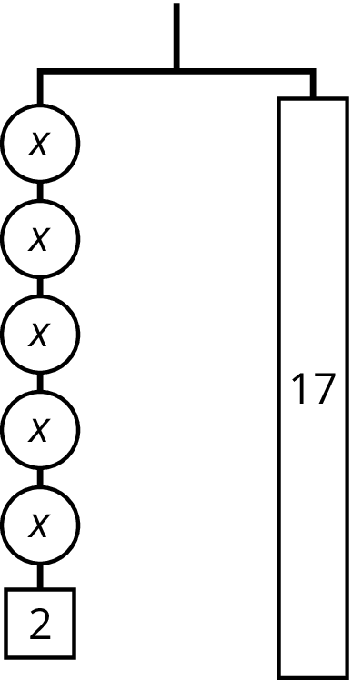
© CC BY Open Up Resources. Adaptations CC BY IM.

