Unit 5 Lesson 13: Reasoning about Exponential Graphs (Part 2)

1 Which One Doesn’t Belong: Four Functions (Warm up)

Student Task Statement
Which one doesn’t belong?
$f\left(n\right)=8⋅2^{n}$
$g\left(n\right)=2⋅8^{n}$
$h\left(n\right)=8+2n$
$j\left(n\right)=8⋅{\left(\frac{1}{2}\right)}^{n}$

2 Value of A Computer

Student Task Statement
- Here is a graph representing an exponential function $f$. The function $f$ gives the value of a computer, in dollars, as a function of time, $x$, measured in years since the time of purchase.
- 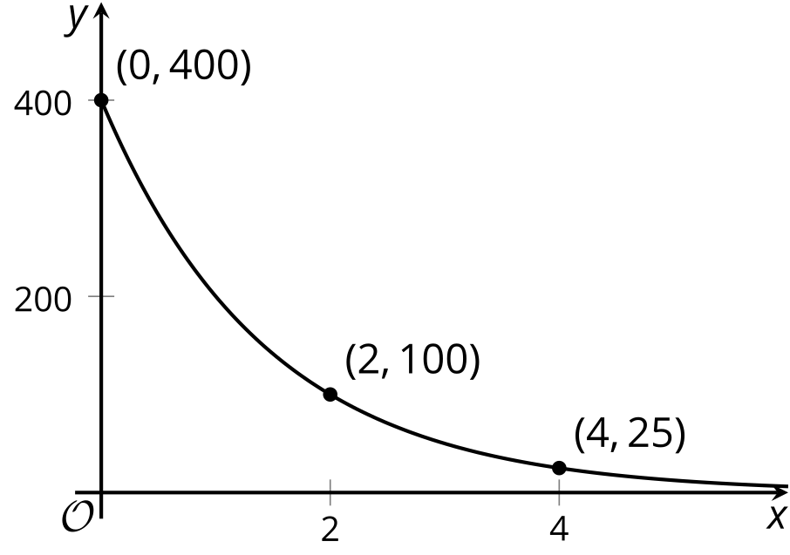
- Based on the graph, what can you say about the following?
  - The purchase price of the computer
  - The value of $f$ when $x$ is 1
  - The meaning of $f\left(1\right)$
  - How the value of the computer is changing each year
  - An equation that defines $f$
  - Whether the value of $f$ will reach 0 after 10 years
- Here are graphs of two exponential functions. For each, write an equation that defines the function and find the value of the function when $x$ is 5.
  - 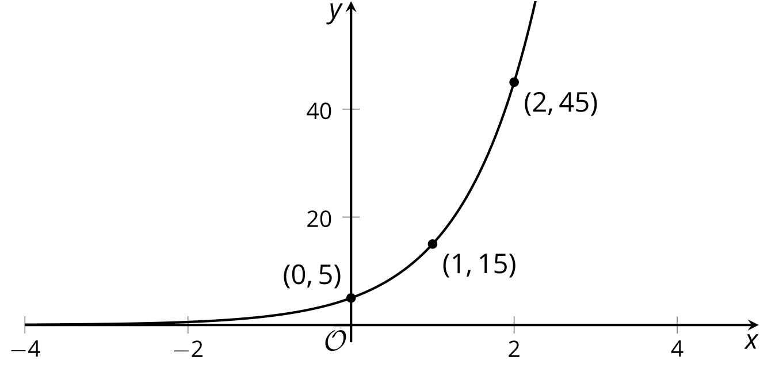
  - 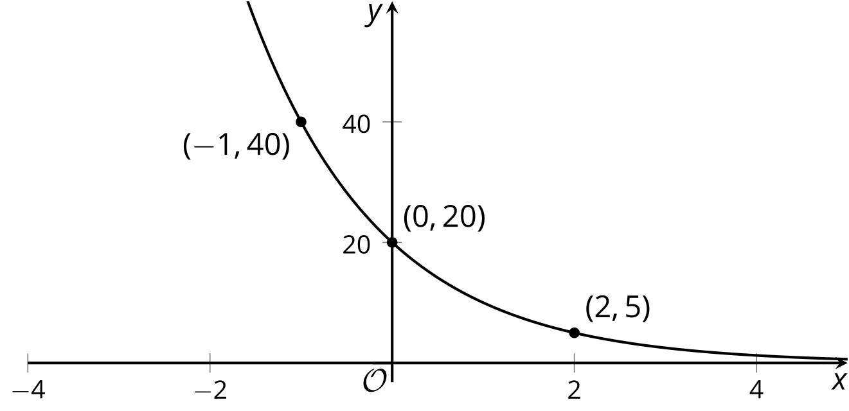

3 Moldy Wall

Student Task Statement
Here are graphs representing two functions, and descriptions of two functions.
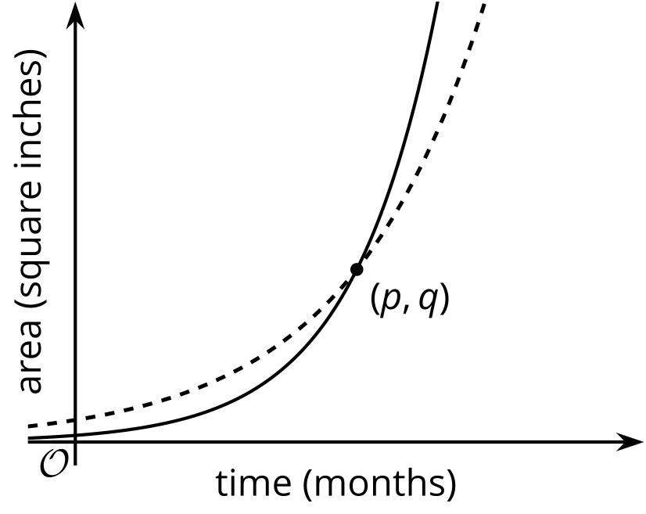
- Function $f$: The area of a wall that is covered by Mold A, in square inches, doubling every month.
- Function $g$: The area of a wall that is covered by Mold B, in square inches, tripling every month.
- Which graph represents each function? Label the graphs accordingly and explain your reasoning.
- When the mold was first spotted and measured, was there more of Mold A or Mold B? Explain how you know.
- What does the point $\left(p,q\right)$ tell us in this situation?

Images for Activity Synthesis
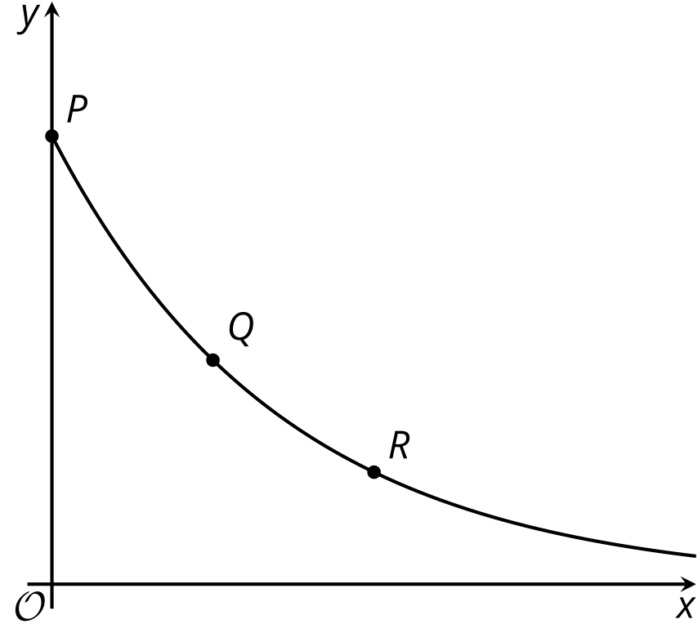
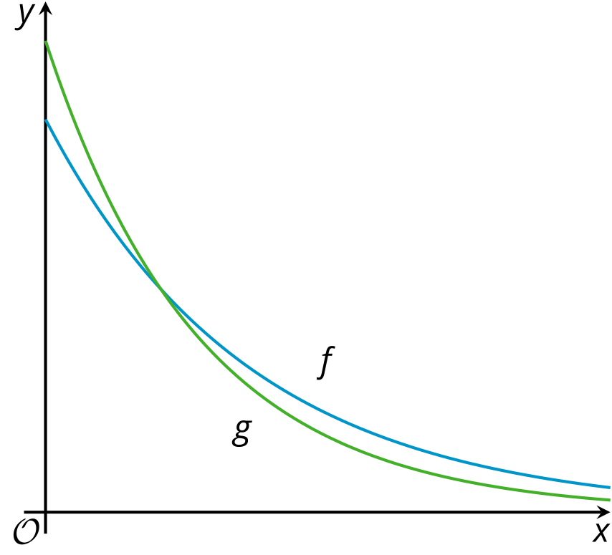
© CC BY 2019 by Illustrative Mathematics®

