Unit 6 Lesson 14: Transforming Trigonometric Functions

1 Translated Parabolas (Warm up)

Student Task Statement
Match each equation with its graph. Be prepared to explain your reasoning.
- $y=x^{2}$
- $y={\left(x−1\right)}^{2}$
- $y={\left(x+3\right)}^{2}$

A
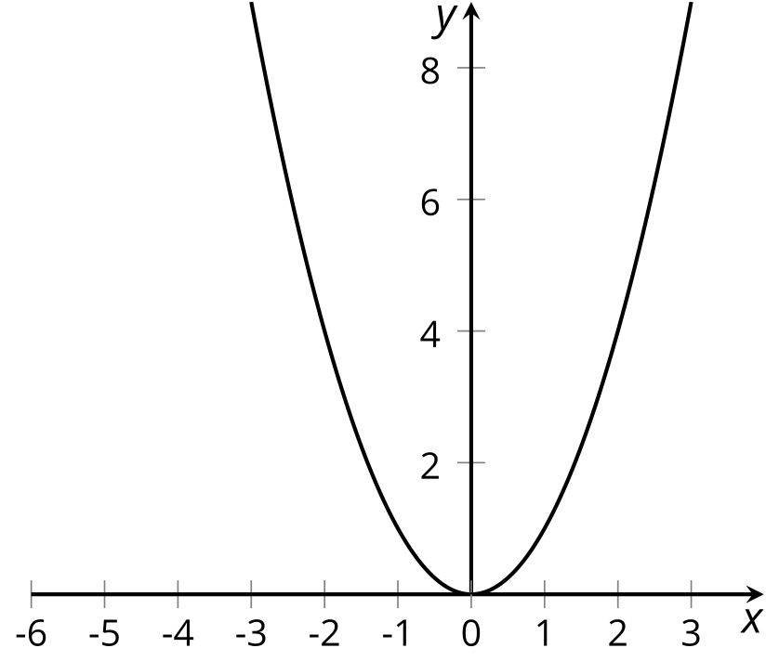

B
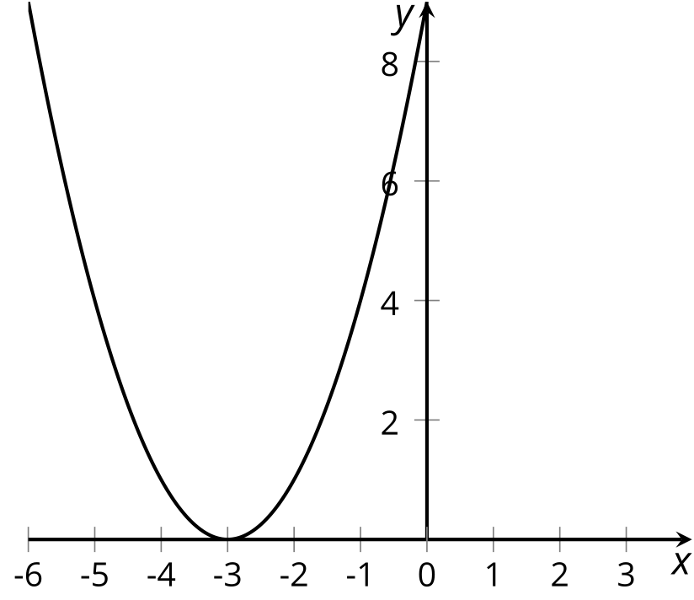

C
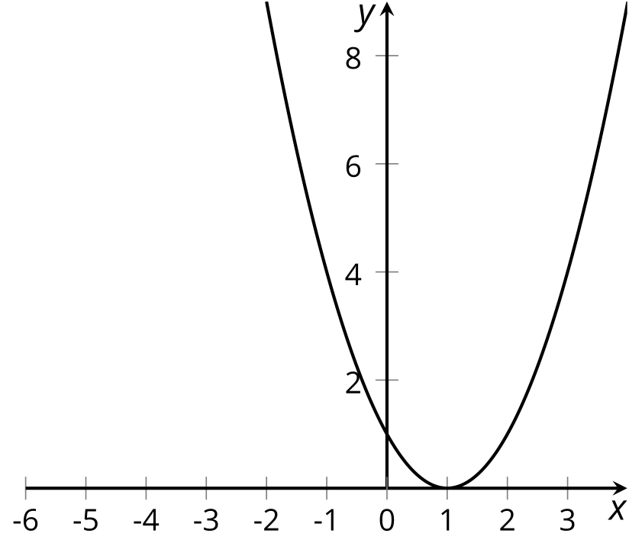

Activity Synthesis
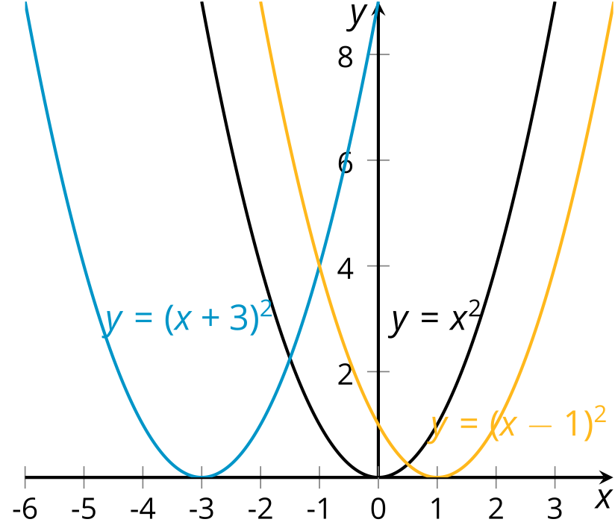

2 Windmills Everywhere

Images for Launch
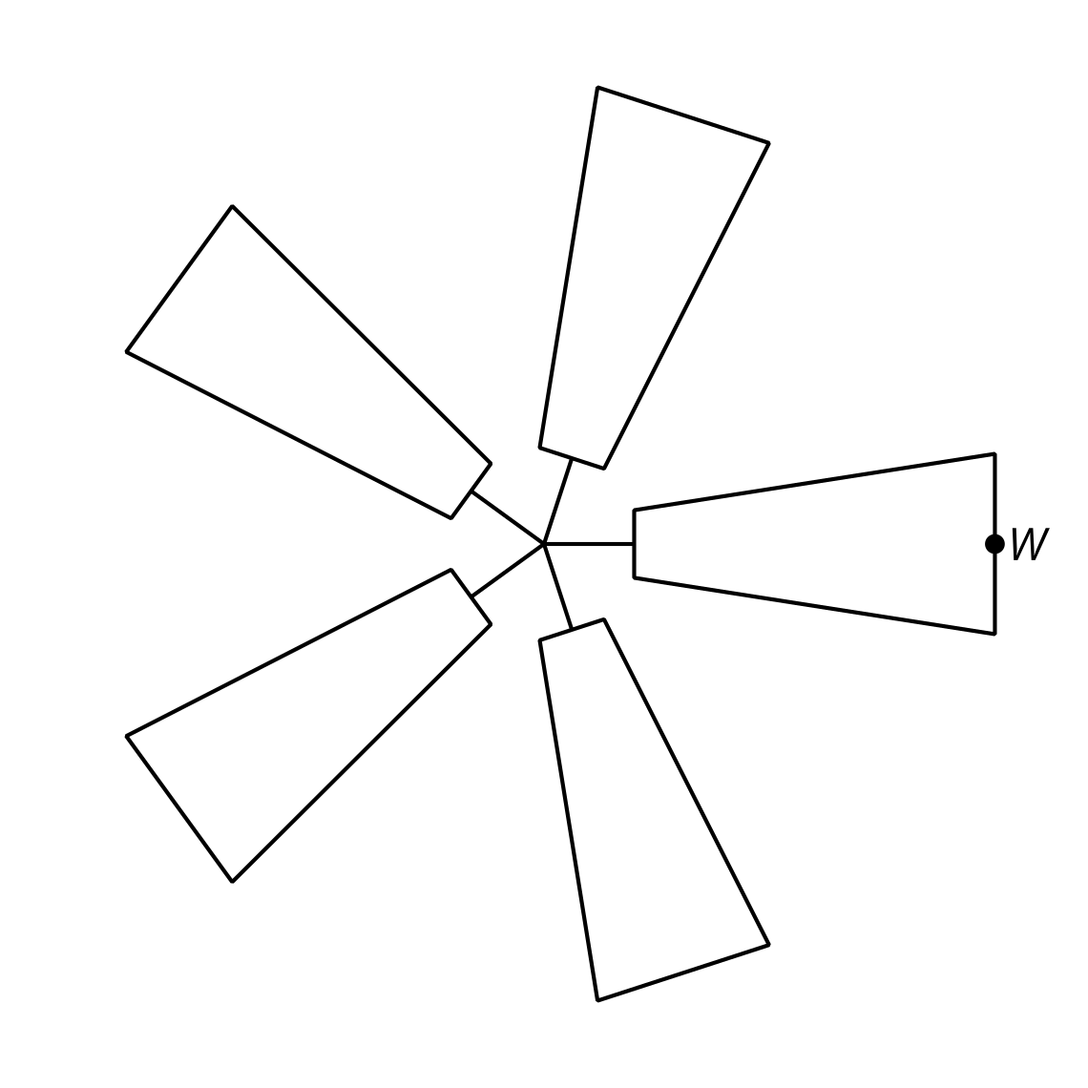

Student Task Statement
Here are three equations for three different windmills. Each equation describes the height $h$, in feet above the ground, of a point at the tip of a blade of a different windmill. The point is at the far right when the angle $θ$ takes the value 0. Describe each windmill and how it is spinning.
- $h=2.5sin\left(θ\right)+10$
- $h=\frac{4}{5}sin\left(θ\right)+3$
- $h=\text{-}1.5sin\left(θ\right)+5$

3 Spinning Fan

Student Task Statement
A fan has radius 1 foot. A point $P$ starts in the position shown in the picture. The center of the fan is at $\left(0,0\right)$ and the point $P$ is at the $\frac{π}{6}$ position on the circle. The fan turns in a counterclockwise direction.
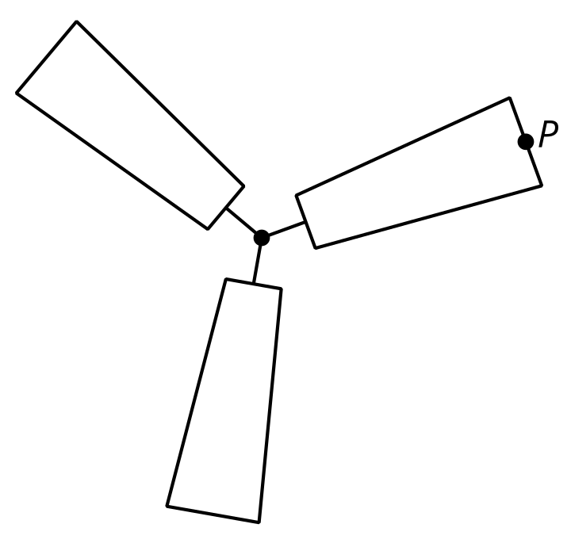
- Sketch a graph of the horizontal position $h$, in feet, of $P$ as a function of the angle of rotation $θ$ of the fan from its starting position.
- 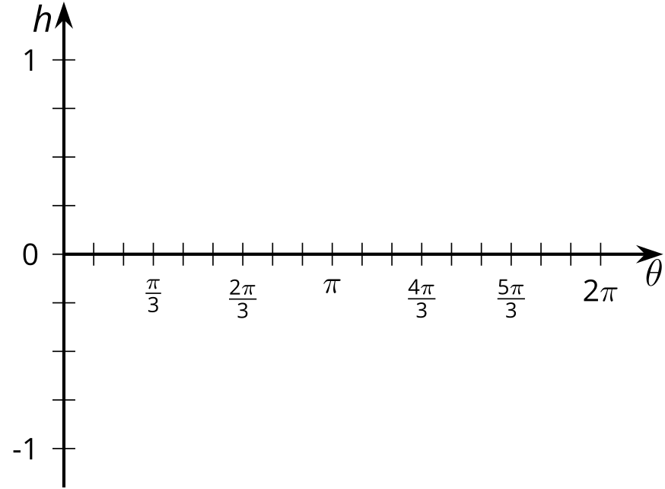
- How does this graph compare to the graph of $h=cos\left(θ\right)$?
- Sketch a graph of the vertical position $v$, in feet, of $P$ as a function of the angle of rotation $θ$ of the fan.
- 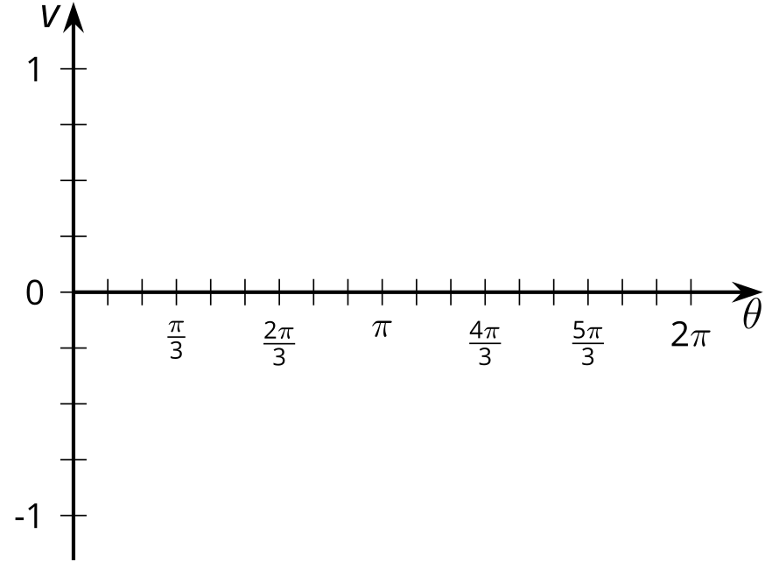
- How does this graph compare to the graph of $v=sin\left(θ\right)$?

Activity Synthesis
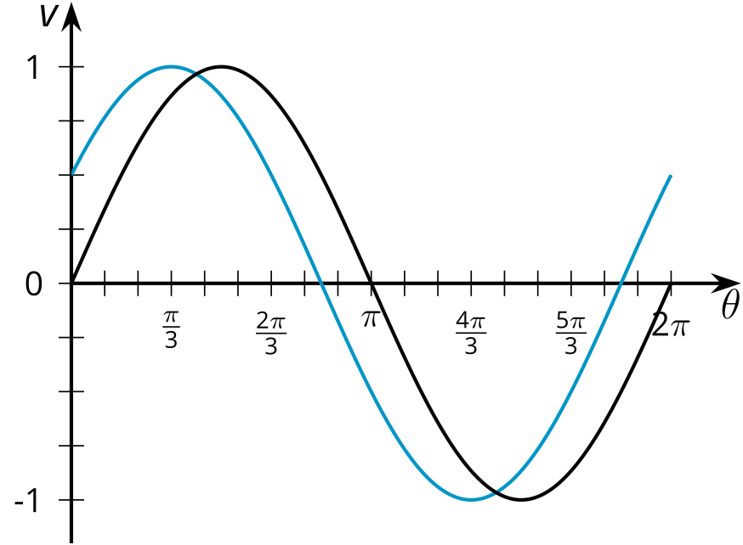

Images for Activity Synthesis
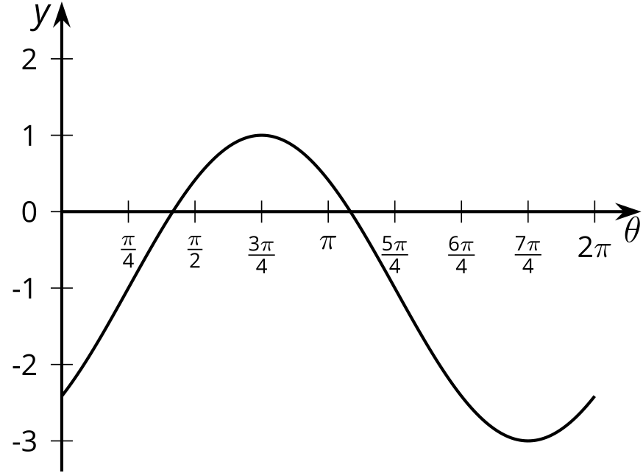
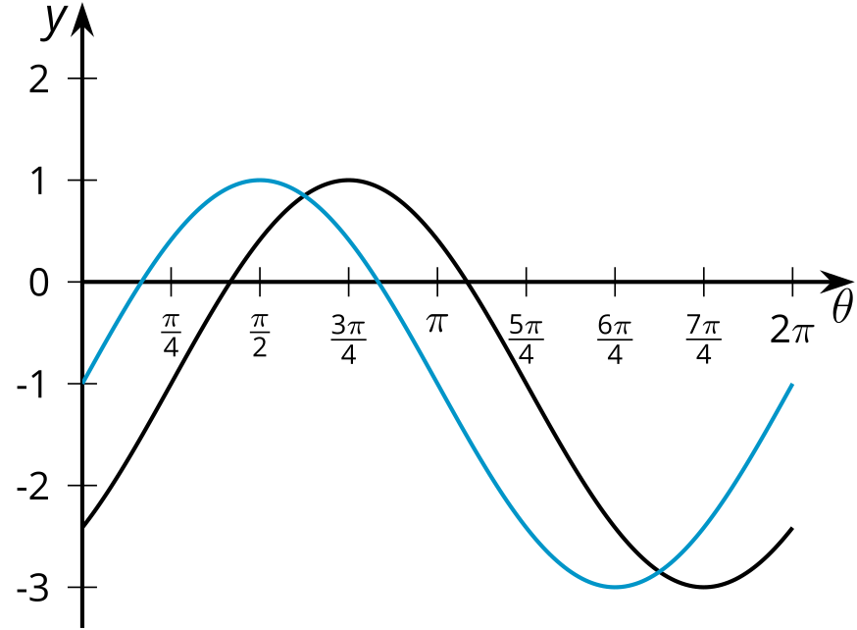
© CC BY 2019 by Illustrative Mathematics®

