Unit 5 Lesson 11: Modeling Exponential Behavior

1 Wondering about Windows (Warm up)

Student Task Statement
Here is a graph of a function $f$ defined by $f\left(x\right)=400⋅{\left(0.2\right)}^{x}$.
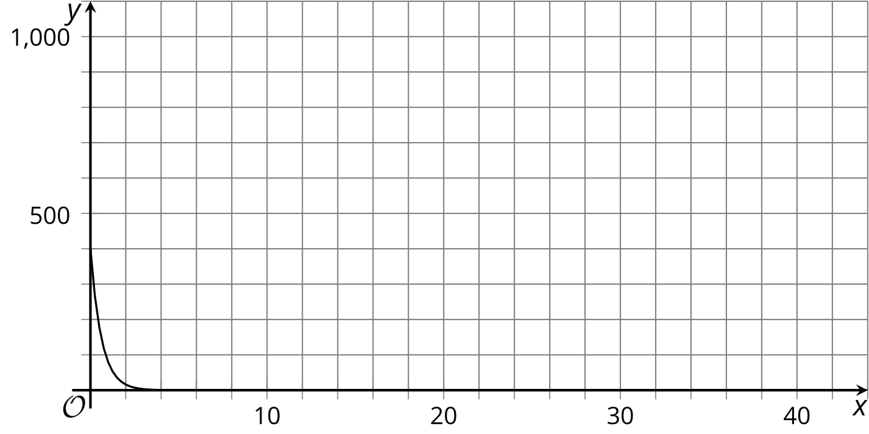
- Identify the approximate graphing window shown.
- Suggest a new graphing window that would:
  - make the graph more informative or meaningful
  - make the graph less informative or meaningful
- Be prepared to explain your reasoning.

2 Beholding Bounces

Student Task Statement
Here are measurements for the maximum height of a tennis ball after bouncing several times on a concrete surface.
$n$, bounce number | $h$, height (centimeters)
0 | 150
1 | 80
2 | 43
3 | 20
4 | 11
- Which is more appropriate for modeling the maximum height $h$, in centimeters, of the tennis ball after $n$ bounces: a linear function or an exponential function? Use data from the table to support your answer.
- Regulations say that a tennis ball, dropped on concrete, should rebound to a height between 53% and 58% of the height from which it is dropped. Does the tennis ball here meet this requirement? Explain your reasoning.
- Write an equation that models the bounce height $h$ after $n$ bounces for this tennis ball.
- About how many bounces will it take before the rebound height of the tennis ball is less than 1 centimeter? Explain your reasoning.

3 Which is the Bounciest of All? (Optional)

Student Task Statement
Your teacher will give your group three different kinds of balls.
Your goal is to measure the rebound heights, model the relationship between the number of bounces and the heights, and compare the bounciness of the balls.
- Complete the table. Make sure to note which ball goes with which column.
- n, number of bounces | - a, height for ball 1 (cm) | - b, height for ball 2 (cm) | - c, height for ball 3 (cm)
- 0
- 1
- 2
- 3
- 4
- Which one appears to be the bounciest? Which one appears to be the least bouncy? Explain your reasoning.
- For each one, write an equation expressing the bounce height in terms of the bounce number $n$.
- Explain how the equations could tell us which one is the most bouncy.
- If the bounciest one were dropped from a height of 300 cm, what equation would model its bounce height $h$?

4 Beholding More Bounces

Student Task Statement
The table shows some heights of a ball after a certain number of bounces.
bounce number | height in centimeters
0
1
2 | 73.5
3 | 51.5
4 | 36
- Is this ball more or less bouncy than the tennis ball in the earlier task? Explain or show your reasoning.
- From what height was the ball dropped? Explain or show your reasoning.
- Write an equation that represents the bounce height of the ball, $h$, in centimeters after $n$ bounces.
- Which graph would more appropriately represent the equation for $h$: Graph A or Graph B? Explain your reasoning.

- A
- 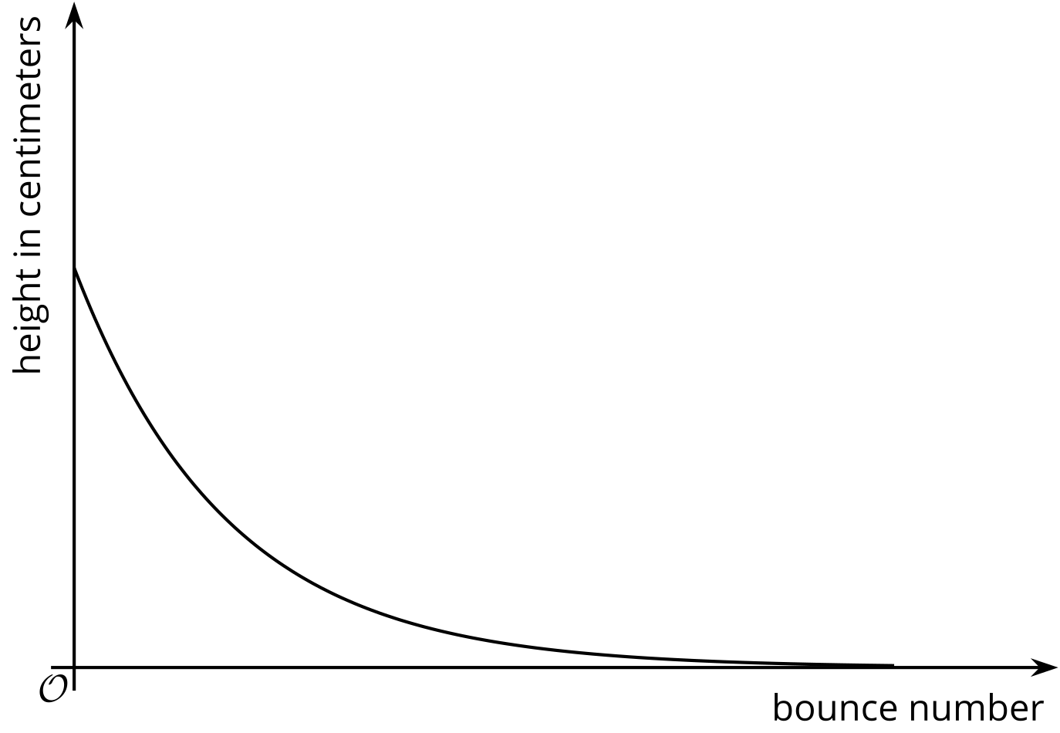

- B
- 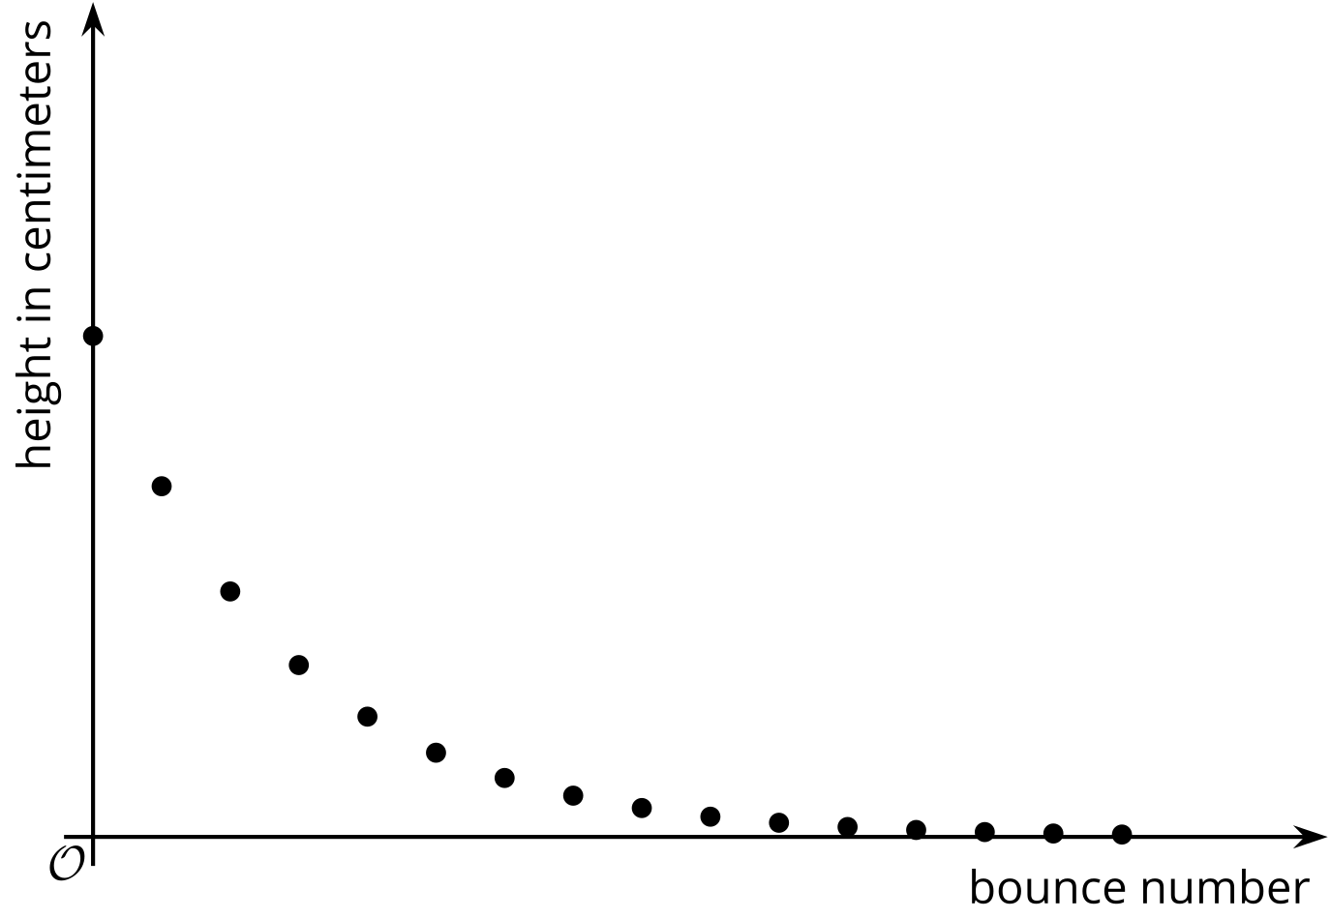
- Will the $n$-th bounce of this ball be lower than the $n$-th bounce of the tennis ball? Explain your reasoning.
© CC BY 2019 by Illustrative Mathematics®

