Unit 5 Lesson 14: Recalling Percent Change

1 Wheels (Warm up)

Student Task Statement
A scooter costs $160.
For each question, show your reasoning.
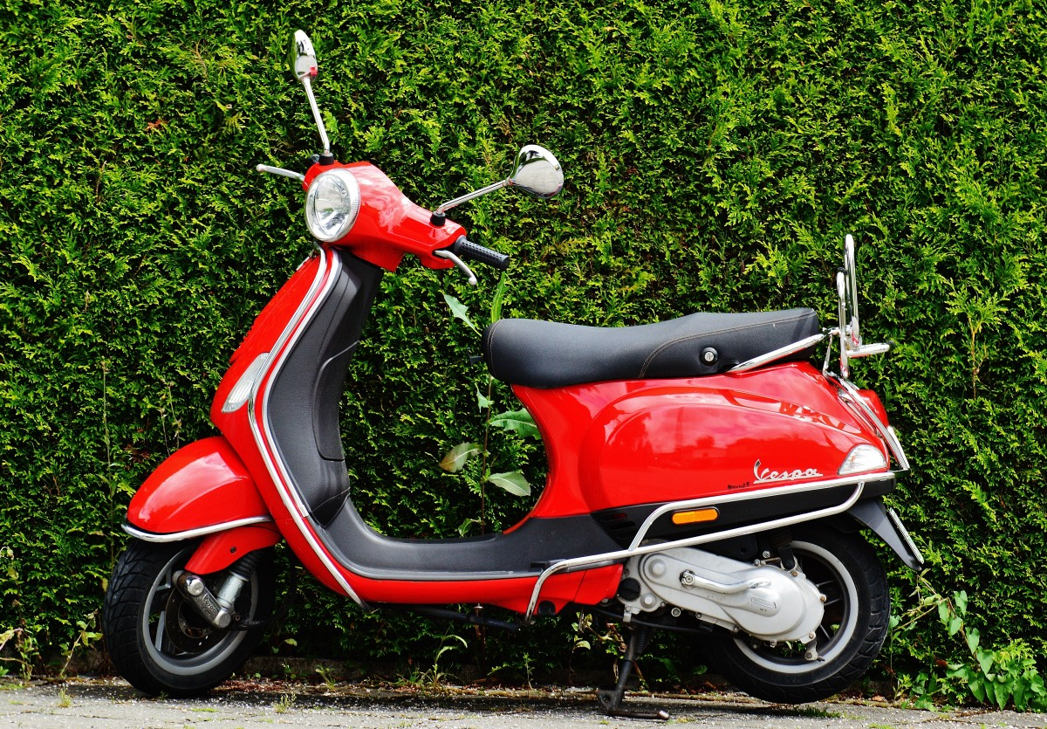
- The cost of a pair of roller skates is 20% of the cost of the scooter. How much do the roller skates cost?
- A bicycle costs 20% more than the scooter. How much does the bicycle cost?
- A skateboard costs 25% less than the bicycle. How much does the skateboard cost?

2 Taxes and Sales (Optional)

Student Task Statement
- You need to pay 8% tax on a car that costs $12,000. What will you end up paying in total? Show your reasoning.
- Burritos are on sale for 30% off. Your favorite burrito normally costs $8.50. How much does it cost now? Show your reasoning.
- A pair of shoes that originally cost $79 are on sale for 35% off. Does the expression $0.65\left(79\right)$ represent the sale price of the shoes (in dollars)? Explain your reasoning.

3 Expressing Percent Increase and Decrease (Optional)

Student Task Statement
Complete the table so that each row has a description and two different expressions that answer the question asked in the description. The second expression should use only multiplication. Be prepared to explain how the two expressions are equivalent.
description and question | expression 1 | expression 2 (using only multiplication)
A one-night stay at a hotel in Anaheim, CA costs $160. Hotel room occupancy tax is 15%. What is the total cost of a one-night stay? | $160+\left(0.15\right)⋅160$
Teachers receive 30% educators discount at a museum. An adult ticket costs $24. How much would a teacher pay for admission into the museum? |  | $\left(0.7\right)⋅24$
The population of a city was 842,000 ten years ago. The city now has 2% more people than it had then. What is the population of the city now?
After a major hurricane, 46% of the 90,500 households on an island lost their access to electricity. How many households still have electricity?
 | $754−\left(0.21\right)⋅754$
Two years ago, the number of students in a school was 150. Last year, the student population increased 8%. This year, it increased about 8% again. What is the number of students this year?
© CC BY 2019 by Illustrative Mathematics®

