Unit 1 Lesson 15: Comparing Data Sets

1 Bowling Partners (Warm up)

Student Task Statement
Each histogram shows the bowling scores for the last 25 games played by each person. Choose 2 of these people to join your bowling team. Explain your reasoning.
Person A
- mean: 118.96
- median: 111
- standard deviation:​ ​32.96
- interquartile range: 44
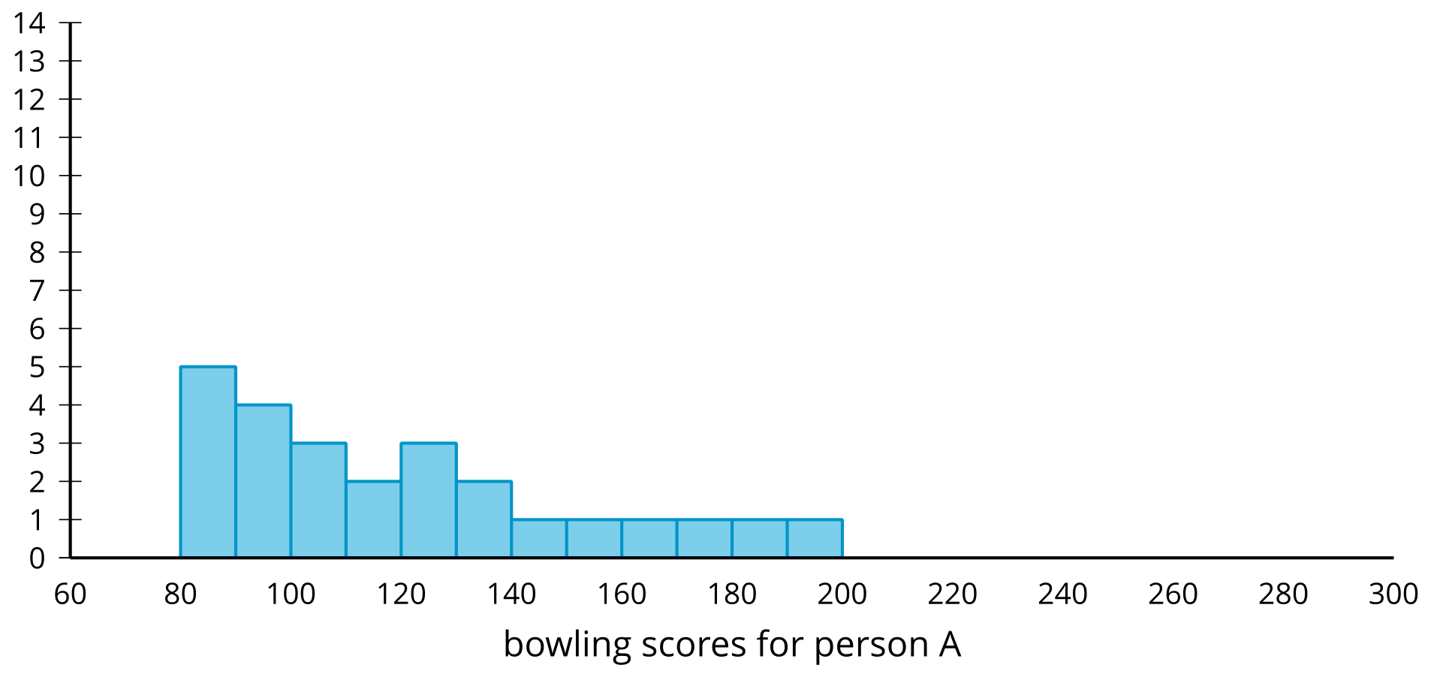
Person B
- mean: 131.08
- median: 129
- standard deviation: 8.64
- interquartile range: 8
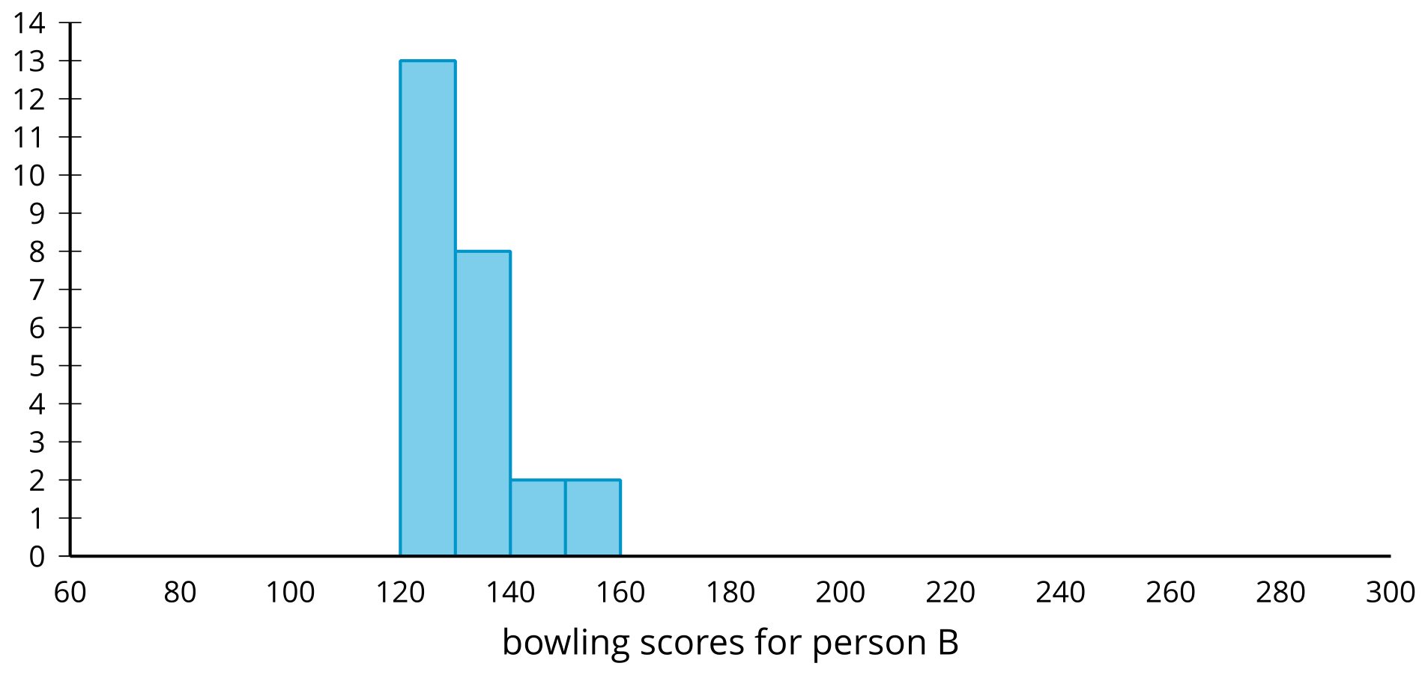
Person C
- mean: 133.92
- median: 145
- standard deviation: 45.04
- interquartile range: 74
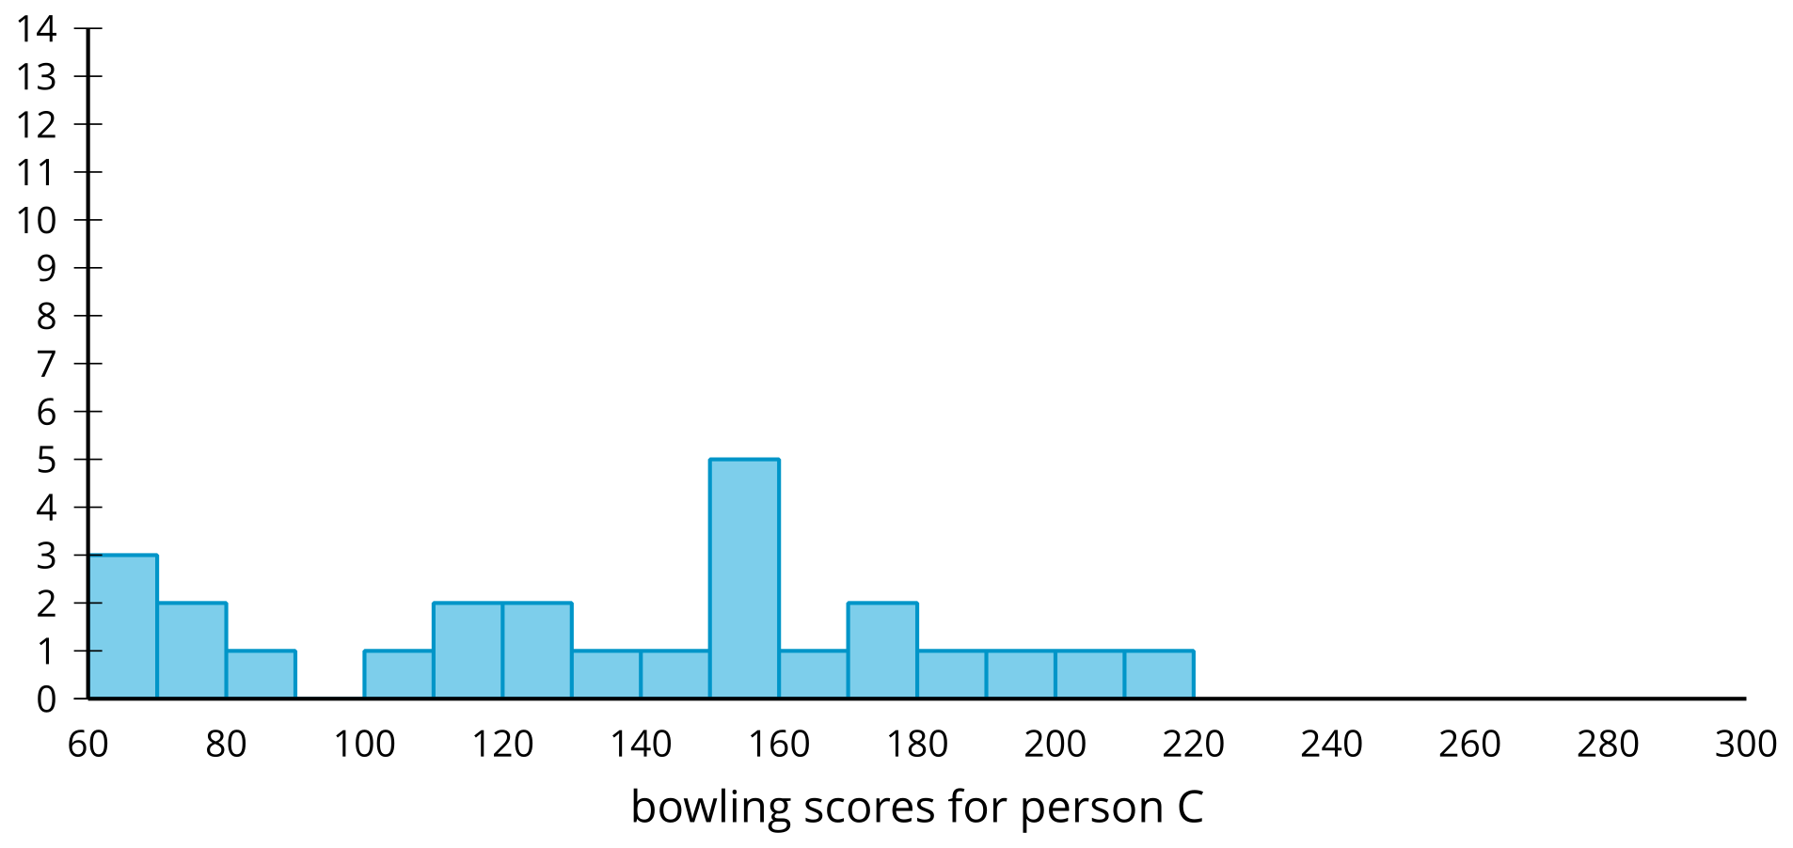
Person D
- mean: 116.56
- median: 103
- standard deviation: 56.22
- interquartile range: 31.5
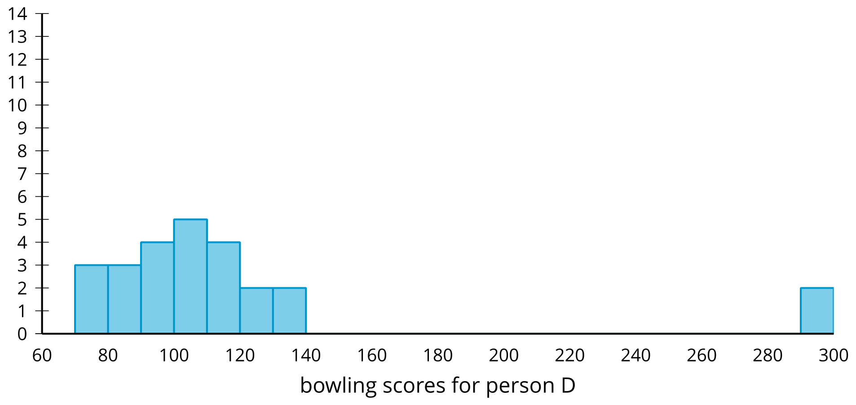

2 Comparing Marathon Times

Student Task Statement
All of the marathon runners from each of two different age groups have their finishing times represented in the dot plot.
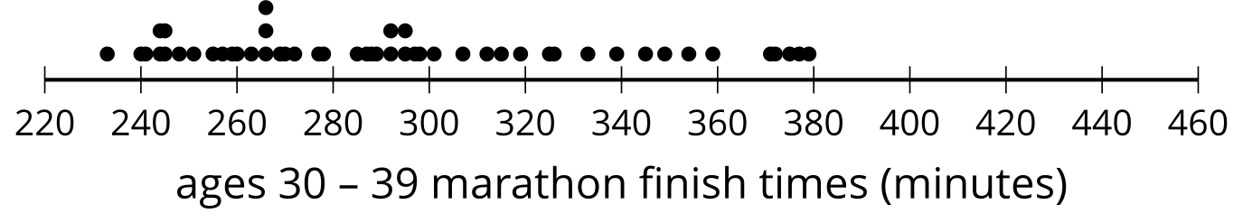
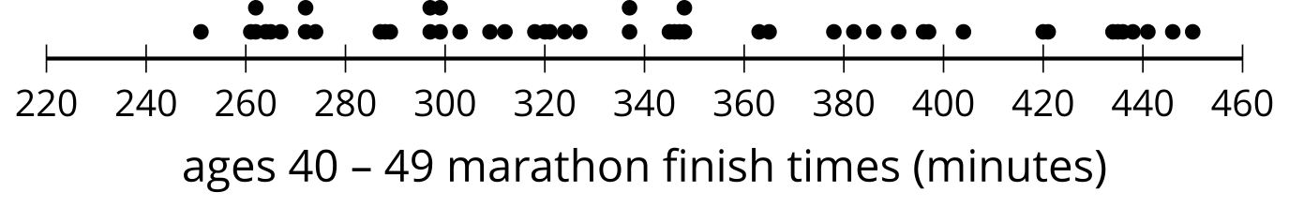
- Which age group tends to take longer to run the marathon? Explain your reasoning.
- Which age group has more variable finish times? Explain your reasoning.

3 Comparing Measures

Student Task Statement
For each group of data sets,
- Determine the best measure of center and measure of variability to use based on the shape of the distribution.
- Determine which set has the greatest measure of center.
- Determine which set has the greatest measure of variability.
- Be prepared to explain your reasoning.
1a
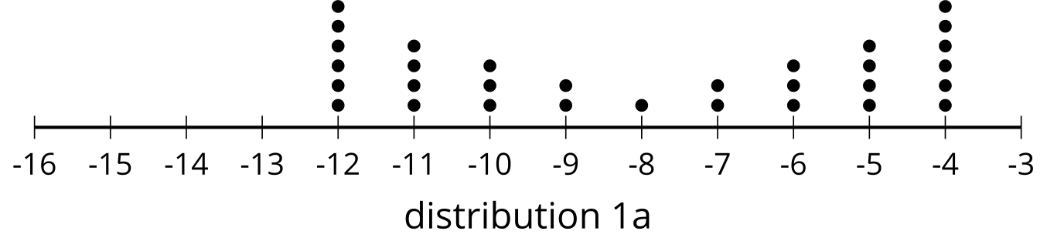
1b
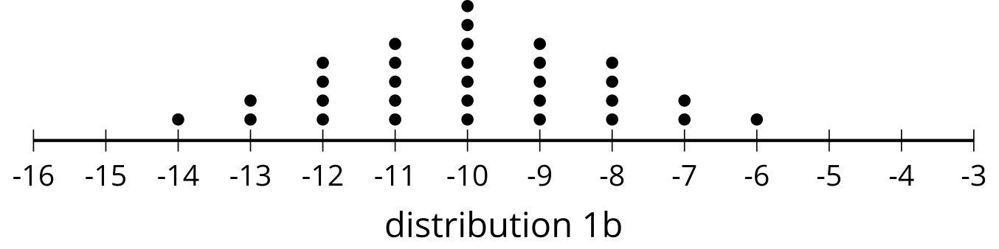
2a
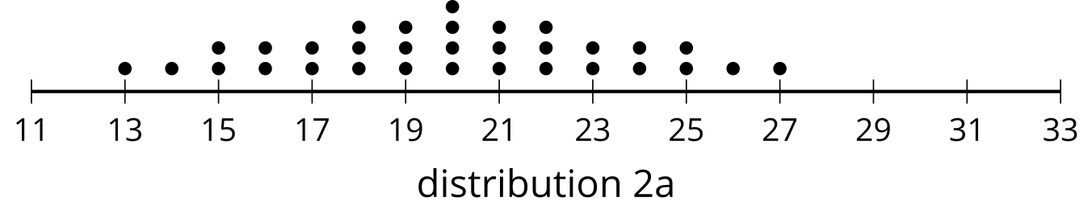
2b
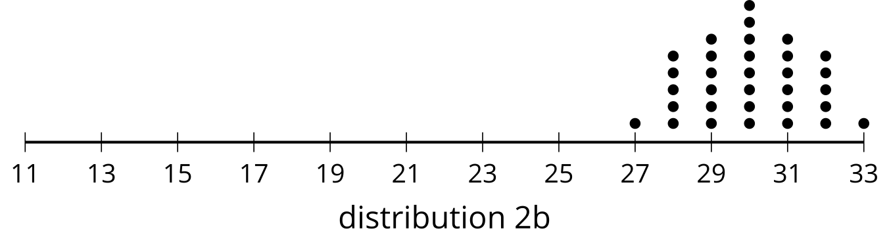
3a
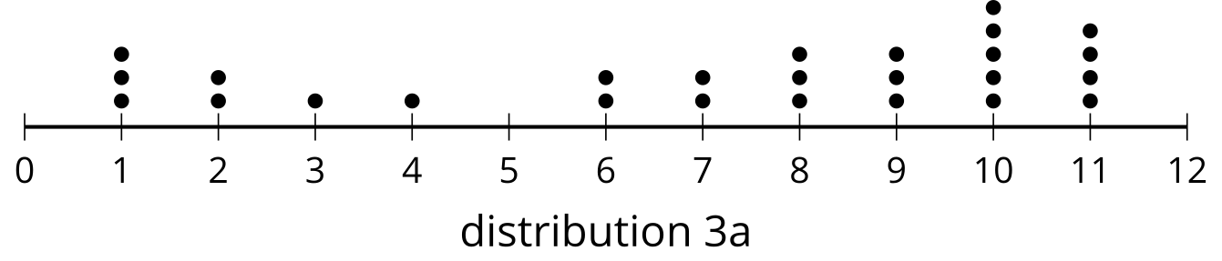
3b
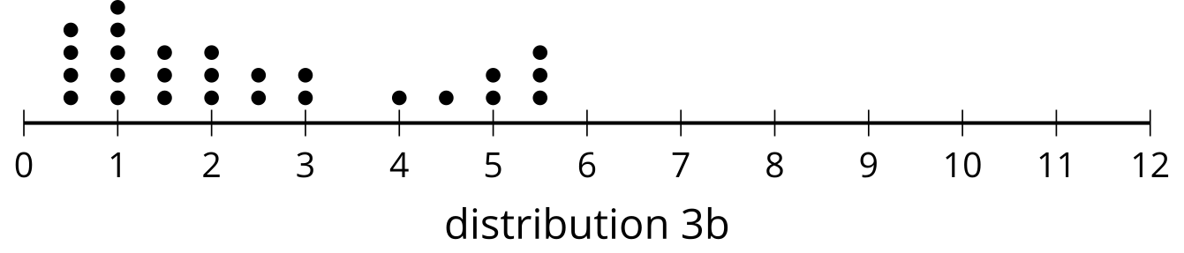
4a
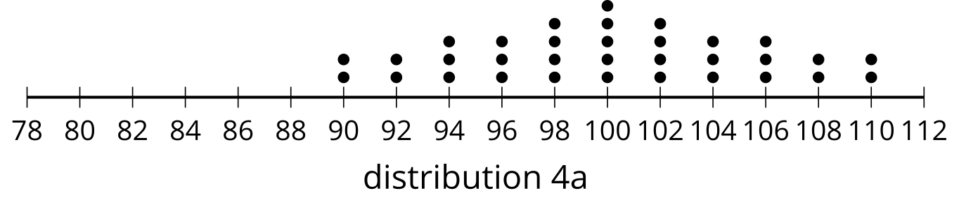
4b
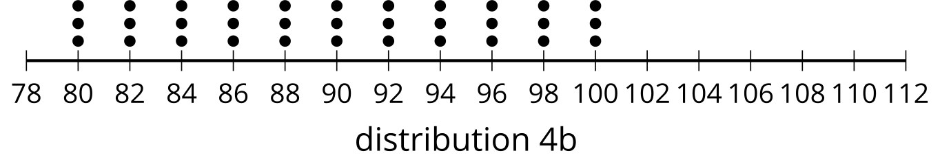
5a
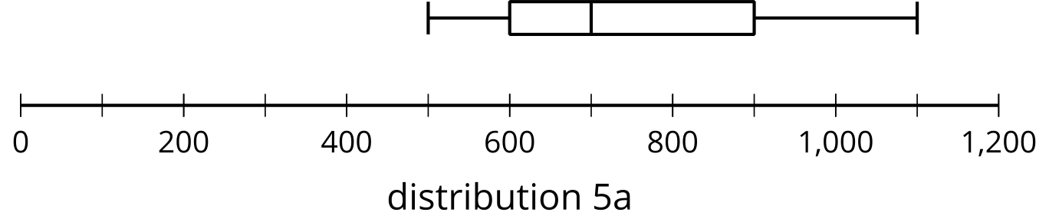
5b
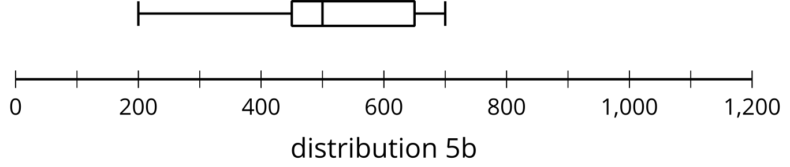
6a
A political podcast has mostly reviews that either love the podcast or hate it.
6b
A cooking podcast has reviews that neither hate nor love the podcast.​​​
7a
Stress testing concrete from site A has all 12 samples break at 450 pounds per square inch (psi).
7b
Stress testing concrete from site B has samples break every 10 psi starting at 450 psi until the last core is broken at 560 psi.
7c
Stress testing concrete from site C has 6 samples break at 430 psi and the other 6 break at 460 psi.
© CC BY 2019 by Illustrative Mathematics®

