Lesson 6: Comparemos métodos de resta

Standards Alignments
Addressing | 2.NBT.B.5

Teacher-facing Learning Goals
- Describe how methods of subtraction are the same and different when subtracting a one-digit number from a two-digit number.

Student-facing Learning Goals
- Comparemos métodos de resta.

Lesson Purpose
The purpose of this lesson is for students to compare methods for subtracting a one-digit number from a two-digit number with and without decomposing a ten.
In the first activity, students consider 3 methods for finding the difference represented using base-ten diagrams. In the second activity, students find the difference with and without decomposing a ten and represent their thinking using base-ten diagrams, words, or equations. Students are not expected to draw their work with base-ten diagrams in a specific way. Students should have access to base-ten blocks throughout the lesson and the cool-down. Students compare their methods, and the teacher records student thinking using base-ten diagrams and equations in the activity synthesis. In the lesson synthesis, students consider different ways to represent decomposing.

Access for:

Students with Disabilities
- Representation (Activity 1)

Instructional Routines
MLR2 Collect and Display (Activity 1), True or False (Warm-up)

Materials to Gather
- Base-ten blocks: Activity 1, Activity 2
- Number cards 0–10: Activity 2

Materials to Copy
- Target Numbers Stage 4 Recording Sheet, Spanish (groups of 1): Activity 2

Lesson Timeline
Warm-up | 10 min
Activity 1 | 15 min
Activity 2 | 20 min
Lesson Synthesis | 10 min
Cool-down | 5 min

Teacher Reflection Question
In upcoming lessons, students will subtract two-digit numbers from two-digit numbers with and without decomposing a ten. What do students need to understand about place value in order to use strategies that would require decomposing when subtracting by place?

Cool-down
(to be completed at the end of the lesson) 5min
El método de Mai

Standards Alignments
Addressing | 2.NBT.B.5

Student-facing Task Statement
A Mai le pidieron encontrar el valor de la diferencia $52−7$. Ella comenzó, pero no supo cómo seguir. Completa el método de Mai.
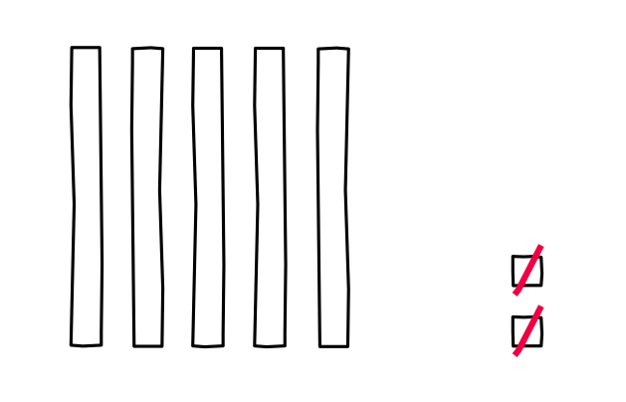

Student Responses
Sample response:
- Students draw to show decomposing a ten into 10 ones. Students cross out 5 more ones.
- $52−2=50$
- $50−5=45$

