Lesson 1: Positive and Negative Numbers
Let’s explore how we represent temperatures and elevations.

1.1: Notice and Wonder: Memphis and Bangor
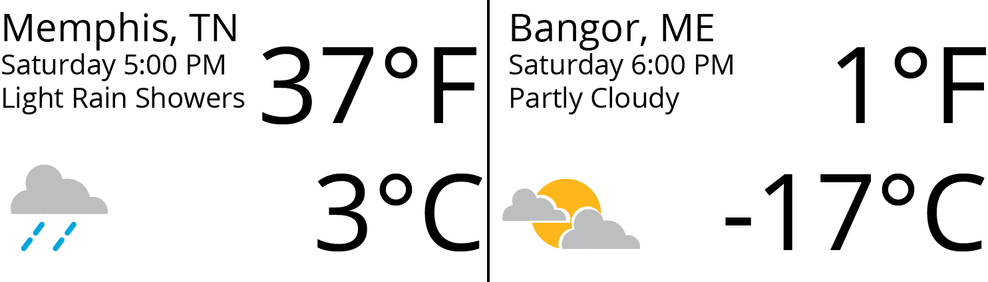
What do you notice? What do you wonder?

1.2: Above and Below Zero
- Here are three situations involving changes in temperature and three number lines. Represent each change on a number line. Then, answer the question.
  - At noon, the temperature was 5 degrees Celsius. By late afternoon, it has risen 6 degrees Celsius. What was the temperature late in the afternoon?
  - The temperature was 8 degrees Celsius at midnight. By dawn, it has dropped 12 degrees Celsius. What was the temperature at dawn?
  - Water freezes at 0 degrees Celsius, but the freezing temperature can be lowered by adding salt to the water. A student discovered that adding half a cup of salt to a gallon of water lowers its freezing temperature by 7 degrees Celsius. What is the freezing temperature of the gallon of salt water?
- Discuss with a partner:
  - How did each of you name the resulting temperature in each situation?
  - What does it mean when the temperature is above 0? Below 0?
  - Do numbers less than 0 make sense in other contexts? Give some specific examples to show how they do or do not make sense.

1.3: High Places, Low Places
- Here is a table that shows elevations of various cities.
- city | - elevation (feet)
- Harrisburg, PA | - 320
- Bethell, IN | - 1,211
- Denver, CO | - 5,280
- Coachella, CA | - -22
- Death Valley, CA | - -282
- New York City, NY | - 33
- Miami, FL | - 0
  - On the list of cities, which city has the second highest elevation?
  - How would you describe the elevation of Coachella, CA in relation to sea level?
  - How would you describe the elevation of Death Valley, CA in relation to sea level?
  - If you are standing on a beach right next to the ocean, what is your elevation?
  - How would you describe the elevation of Miami, FL?
  - A city has a higher elevation than Coachella, CA. Select all numbers that could represent the city’s elevation. Be prepared to explain your reasoning.
    - -11 feet
    - -35 feet
    - 4 feet
    - -8 feet
    - 0 feet
- Here are two tables that show the elevations of highest points on land and lowest points in the ocean. Distances are measured from sea level.
- mountain | - continent | - elevation (meters)
- Everest | - Asia | - 8,848
- Kilimanjaro | - Africa | - 5,895
- Denali | - North America | - 6,168
- Pikchu Pikchu | - South America | - 5,664

- trench | - ocean | - elevation (meters)
- Mariana Trench | - Pacific | - -11,033
- Puerto Rico Trench | - Atlantic | - -8,600
- Tonga Trench | - Pacific | - -10,882
- Sunda Trench | - Indian | - -7,725
  - Which point in the ocean is the lowest in the world? What is its elevation?
  - Which mountain is the highest in the world? What is its elevation?
  - If you plot the elevations of the mountains and trenches on a vertical number line, what would 0 represent? What would points above 0 represent? What about points below 0?
  - Which is farther from sea level: the deepest point in the ocean, or the top of the highest mountain in the world? Explain.

Are you ready for more?
A spider spins a web in the following way:
- It starts at sea level.
- It moves up one inch in the first minute.
- It moves down two inches in the second minute.
- It moves up three inches in the third minute.
- It moves down four inches in the fourth minute.
Assuming that the pattern continues, what will the spider’s elevation be after an hour has passed?

Lesson 1 Summary
Positive numbers are numbers that are greater than 0. Negative numbers are numbers that are less than zero. The meaning of a negative number in a context depends on the meaning of zero in that context.
For example, if we measure temperatures in degrees Celsius, then 0 degrees Celsius corresponds to the temperature at which water freezes.
In this context, positive temperatures are warmer than the freezing point and negative temperatures are colder than the freezing point. A temperature of -6 degrees Celsius means that it is 6 degrees away from 0 and it is less than 0. This thermometer shows a temperature of -6 degrees Celsius.
If the temperature rises a few degrees and gets very close to 0 degrees without reaching it, the temperature is still a negative number.
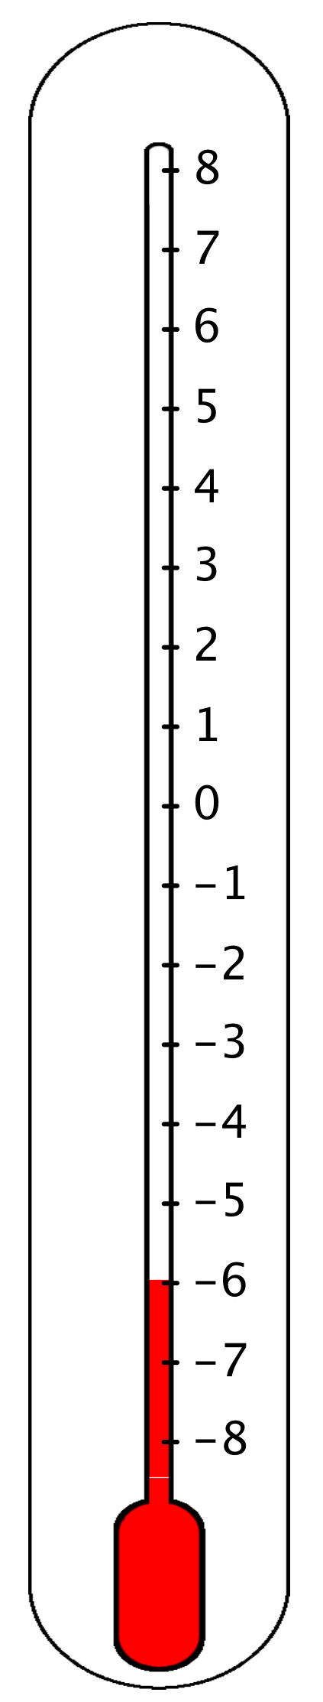
Another example is elevation, which is a distance above or below sea level. An elevation of 0 refers to the sea level. Positive elevations are higher than sea level, and negative elevations are lower than sea level.
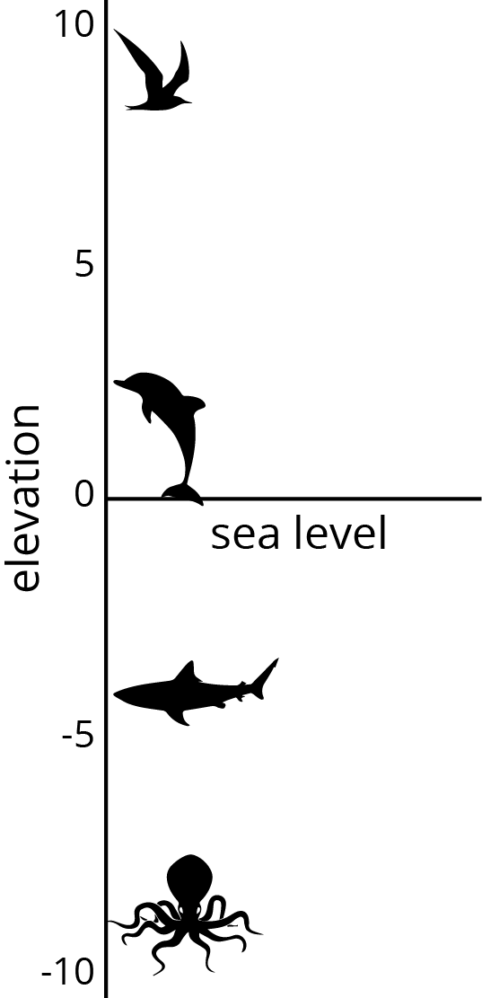
© CC BY Open Up Resources. Adaptations CC BY IM.

