Lesson 11: Adding Up
- Let’s look at sequences and the sum of their terms.

11.1: Math Talk: Adding Terms
Evaluate mentally.
$\frac{1}{2}+\frac{1}{4}$
$\frac{1}{2}+\frac{1}{4}+\frac{1}{8}$
$\frac{1}{2}+\frac{1}{4}+\frac{1}{8}+\frac{1}{16}$
$\frac{3}{2}+\frac{3}{4}+\frac{3}{8}+\frac{3}{16}$

11.2: Paper Trail
- Tyler has a piece of paper and is sharing it with Elena, Clare, and Andre. He cuts the paper to create four equal pieces, then hands one piece each to the others and keeps one for himself. What fraction of the original piece of paper does each person have?
- Tyler then takes his remaining paper and does it again. He cuts the paper to create four equal pieces, then hands one piece each to the others and keeps one for himself. What fraction of the original piece of paper does each person have now?
- Tyler then takes his remaining paper and does it again. What fraction of the original piece of paper does each person have now? What happens after more steps of the same process?

11.3: A Threefold Design
Here is a geometric shape built in steps.
- Step 0 is an equilateral triangle.
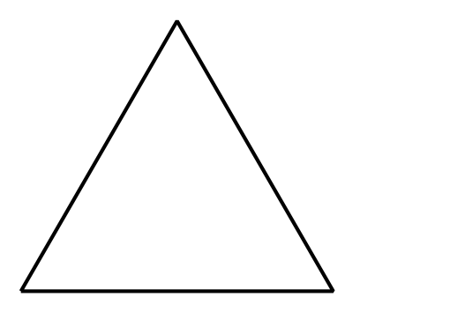
- To go from Step 0 to Step 1, take every edge of Step 0 and replace its middle third with an outward-facing equilateral triangle.
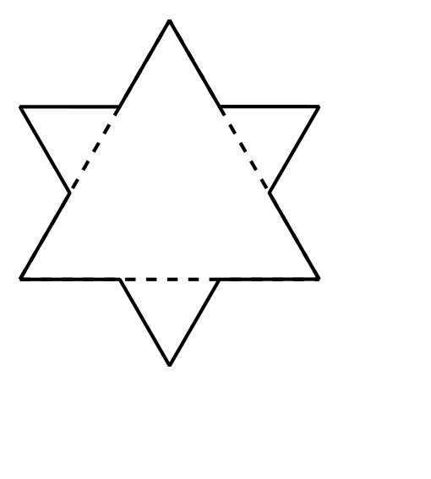
- To go from Step 1 to Step 2, take every edge of Step 1 and replace its middle third with an outward-facing equilateral triangle.
- This process can continue to create any step of the design.
- Find an equation to represent function $S$, where $S\left(n\right)$ is the number of sides in Step $n$. What is $S\left(2\right)$?
- Consider a different function $T$, where $T\left(n\right)$ is the number of new triangles added when drawing Step $n$. Let $T\left(0\right)=1.$ How many new triangles are there in Steps 1, 2, and 3? Explain how you know.
- What is the total number of triangles used in building Step 3?

Are you ready for more?
Suppose the Step 0 triangle has area 1 square unit. Complete the table.
What patterns do you notice?
step | area
0 | 1
1
2
3

Lesson 11 Summary
The sum of a sequence is the sum of its terms.
For example, suppose you were given $1 on the first day, then $2 the second day, then $4 the third day, and it doubled each day for seven days. After finding each term of the sequence, you can find the sum:
$1+2+4+8+16+32+64=127$
For these seven days, the total amount of money is $127. In a later unit, you will learn a method to find the sum of a geometric sequence more efficiently.
© CC BY 2019 by Illustrative Mathematics®

