Lesson 9: Part to Whole
- Let’s see what we can figure out about a circle if we’re given information about a sector of the circle.

9.1: What’s Your Angle?
A circle has radius 10 centimeters. Suppose an arc on the circle has length $π$ centimeters. What is the measure of the central angle whose radii define the arc?

9.2: Enough Information?
The central angle of this shaded sector measures 45 degrees, and the sector’s area is $32π$ square inches.
Kiran says, “We can find the area of the whole circle, the arc length of the sector, and the circumference of the circle with this information.”
Priya says, “But how? We don’t know the circle’s radius!”
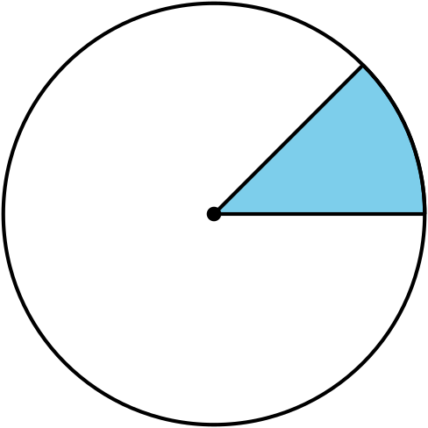
Do you agree with either of them? Explain or show your reasoning. Calculate as many of the values Kiran mentioned as possible.

Are you ready for more?
A Greek mathematician named Eratosthenes calculated the circumference of Earth more than 2,000 years ago. He used information similar to what is given here:
Seattle and San Francisco are on the same longitude line and 680 miles apart. At noon on a summer day, an upright meter stick in Seattle casts a shadow with an angle of 2 degrees. On the same day at the same time, an upright meter stick in San Francisco casts a shadow with an angle of 7.83 degrees.

image not to scale
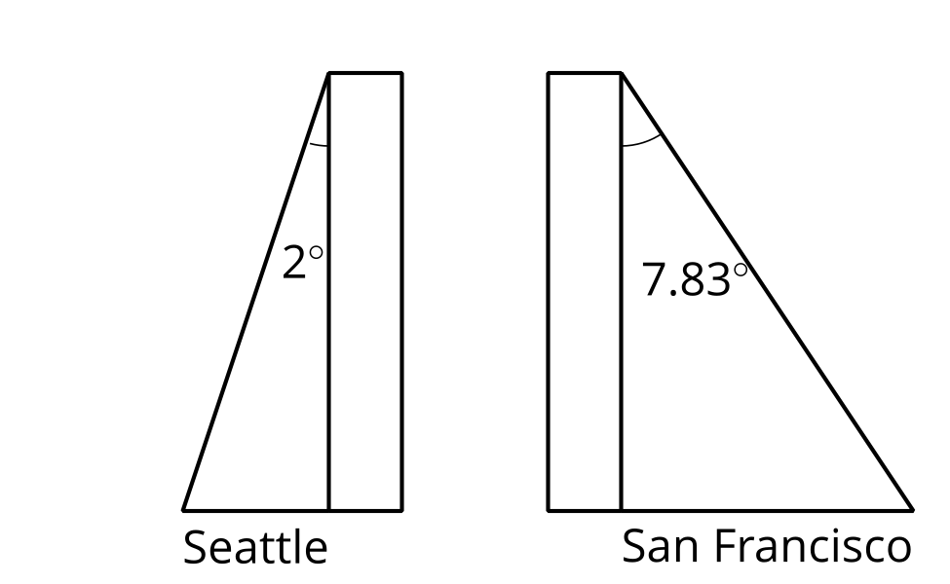
Use this information to calculate the circumference of Earth. Explain or show your reasoning.

9.3: Info Gap: From Sector to Circle
Your teacher will give you either a problem card or a data card. Do not show or read your card to your partner.
If your teacher gives you the data card:
- Silently read the information on your card.
- Ask your partner, “What specific information do you need?” and wait for your partner to ask for information. Only give information that is on your card. (Do not figure out anything for your partner!)
- Before telling your partner the information, ask, “Why do you need to know (that piece of information)?”
- Read the problem card, and solve the problem independently.
- Share the data card, and discuss your reasoning.
If your teacher gives you the problem card:
- Silently read your card and think about what information you need to answer the question.
- Ask your partner for the specific information that you need.
- Explain to your partner how you are using the information to solve the problem.
- When you have enough information, share the problem card with your partner, and solve the problem independently.
- Read the data card, and discuss your reasoning.
Pause here so your teacher can review your work. Ask your teacher for a new set of cards and repeat the activity, trading roles with your partner.

Lesson 9 Summary
We can work backward from information about a sector or arc to get information about the whole circle.
Suppose a circle has an arc with length $7π$ units that is defined by a 90 degree central angle. This arc makes up $\frac{1}{4}$ of the entire circumference of the circle because $360÷90=4$. So, we can multiply the arc’s length by 4 to find that the entire circumference measures $28π$ units. The circumference of a circle can be calculated using the expression $2πr$, so we know that $2πr=28π$. The value of $r$ must be 14 units.
For more difficult problems, we can write equations. Suppose a circle has a sector with area $135π$ square units and a central angle of 216 degrees. Let $x$ stand for the area of the whole circle. Dividing 216 by 360 gives the fraction of the circle represented by the sector. Multiply that fraction by $x$ and set it equal to the area of the sector.
$\frac{216}{360}x=135π$
Solve this equation to find that the circle’s area is $225π$ square units. This tells us that $πr^{2}=225π$. The value of $r$ must be the positive number that squares to make 225, or 15 units.
© CC BY 2019 by Illustrative Mathematics®

