Lesson 4 Practice Problems
- Match each statement using only the information shown in the pairs of congruent triangles.
  - In the 2 triangles there are 3 pairs of congruent sides.
  - The 2 sides and the included angle of one triangle are congruent to 2 sides and the included angle of another triangle.
  - The 2 angles and the included side of one triangle are congruent to 2 angles and the included side of another triangle.
  - 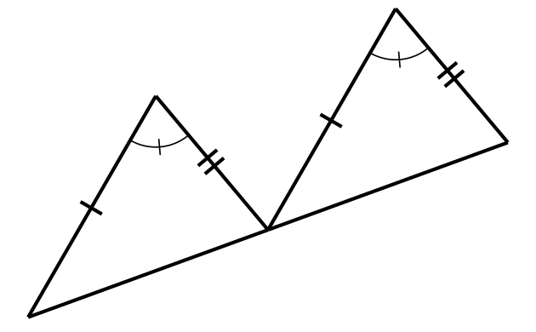
  - 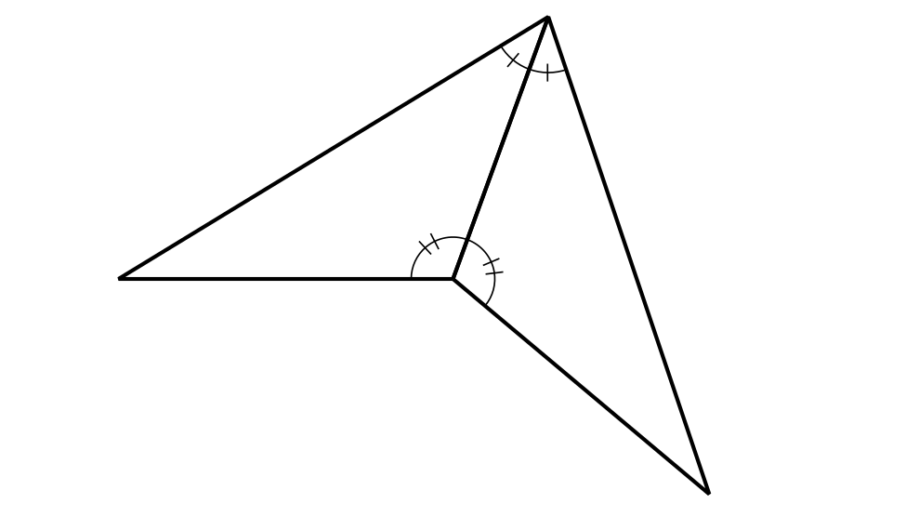
  - 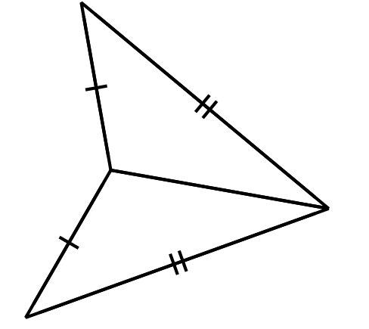
- Sketch the unique triangles that can be made with angle measures ${40}^{∘}$ and ${100}^{∘}$ and side length 3. How do you know you have sketched all possibilities?
- What is the least amount of information that you need to construct a triangle congruent to this one?
- 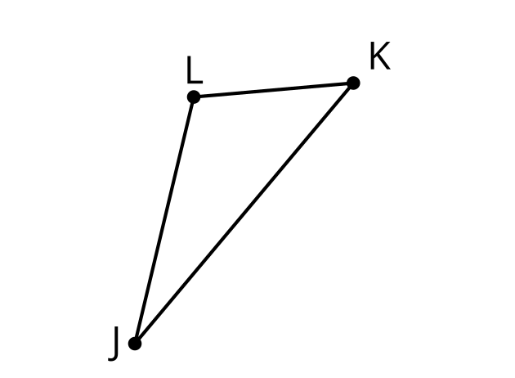
- Triangle $ABC$ is congruent to triangle $EDF$. So, Mai knows that there is a sequence of rigid motions that takes $ABC$ to $EDF$.
- 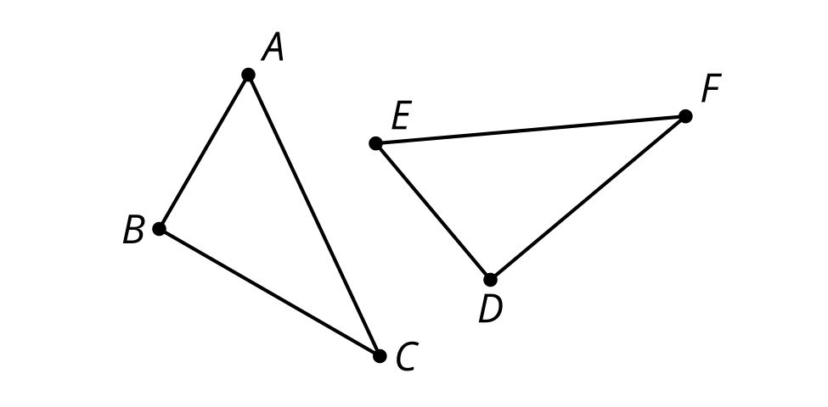
- Select all true statements after the transformations:
  - Angle $A$ coincides with angle $E$.
  - Angle $B$ coincides with angle $F$.
  - Segment $AB$ coincides with segment $EF$.
  - Segment $BC$ coincides with segment $DF$.
  - Segment $AC$ coincides with segment $ED$.
- (From Unit 2, Lesson 3.)
- A rotation by angle $ACE$ using point $C$ as the center takes triangle $CBA$ onto triangle $CDE$.
- 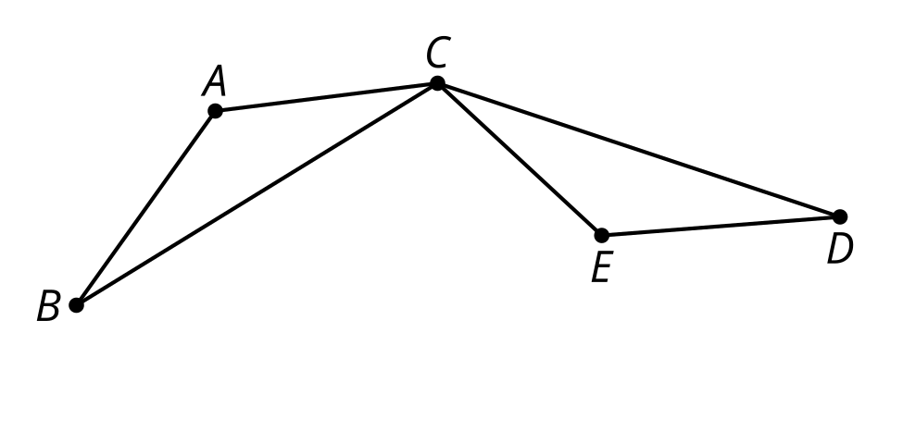
  - Explain why the image of segment $CB$ lines up with segment $CD$.
  - Explain why the image of $B$ coincides with $D$.
  - Is triangle $ABC$ congruent to triangle $EDC$? Explain your reasoning.
- (From Unit 2, Lesson 3.)
- Line $EF$ is a line of symmetry for figure $ABECDF$. Clare says that $ABEF$ is congruent to $CDFE$ because sides $AB$ and $CD$ are corresponding.
- 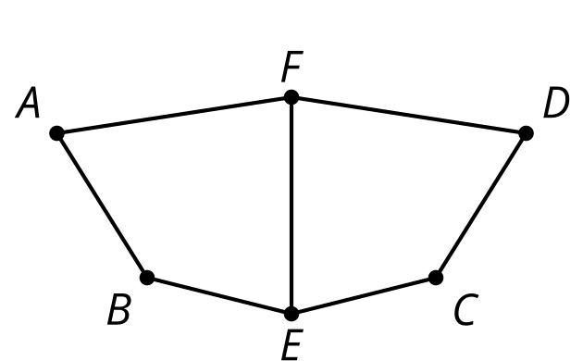
  - Why is Clare's congruence statement incorrect?
  - Write a correct congruence statement for the quadrilaterals.
- (From Unit 2, Lesson 2.)
- Triangle $HEF$ is the image of triangle $HGF$ after a reflection across line $FH$. Select all statements that must be true.
- 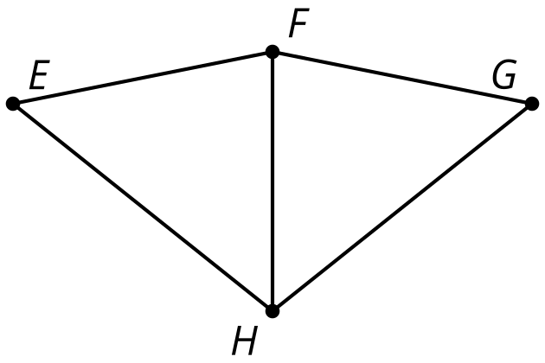
  - Triangle $FGH$ is congruent to triangle $FEH$.
  - Triangle $EFH$ is congruent to triangle $GFH$.
  - Angle $HFE$ is congruent to angle $FHG$.
  - Angle $EFG$ is congruent to angle $EHG$.
  - Segment $EH$ is congruent to segment $FG$.
  - Segment $GH$ is congruent to segment $EH$.
- (From Unit 2, Lesson 2.)
- When rectangle $ABCD$ is reflected across line $EF$, the image is $BADC$. How do you know that segment $AD$ is congruent to segment $BC$?
  - A rectangle has 2 pairs of parallel sides.
  - Any 2 sides of a rectangle are congruent.
  - Corresponding parts of congruent figures are congruent.
  - Congruent parts of congruent figures are corresponding.
- (From Unit 2, Lesson 1.)
- This design began from the construction of a regular hexagon. Describe a rigid motion that will take the figure onto itself.
- 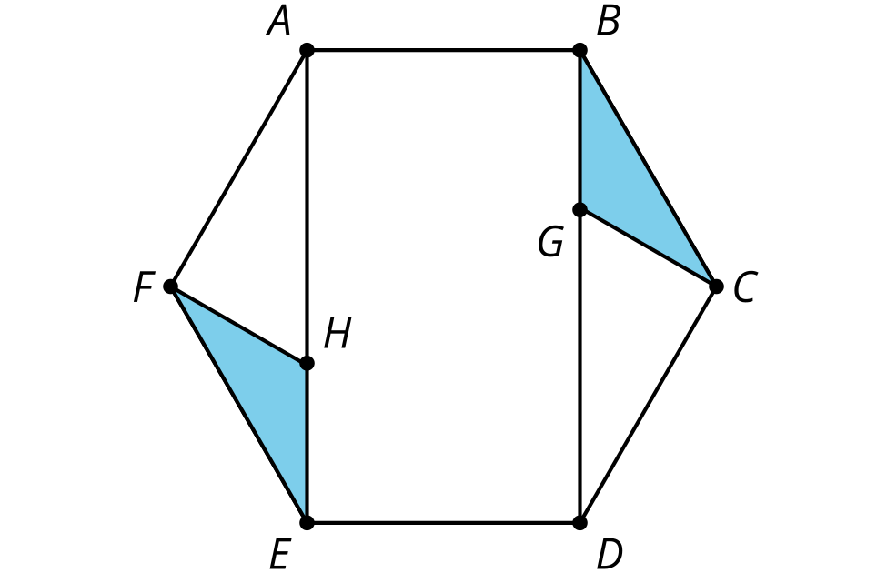
- (From Unit 1, Lesson 22.)
© CC BY 2019 by Illustrative Mathematics®

