Lesson 10: Situations and Sequence Types
- Let’s decide what type of sequence we are looking at and how to represent it.

10.1: Describing Growth
- Here is a geometric sequence. What is the growth factor? 16, 24, 36, 54, 81
- One way to describe its growth is to say it’s growing by $\underset{_}{​}$% each time. What number goes in the blank for the sequence 16, 24, 36, 54, 81? Be prepared to explain your reasoning.

10.2: Finding Population Patterns
The table shows two animal populations growing over time.
years since 1990 | Population $A$ | Population $B$
0 | 23,000 | 3,125
1 | 29,000 | 3,750
2 | 35,000 | 4,500
3 | 41,000 | 5,400
4 | 47,000 | 6,480
- Are the sequences represented by Population $A$ and Population $B$ arithmetic or geometric? Explain how you know.
- Write an equation to define Population $A$.
- Write an equation to define Population $B$.
- Does Population $B$ ever overtake Population $A$? If so, when? Explain how you know.

10.3: Finding Square Patterns
Define the sequence $W$ so that $W\left(n\right)$ is the number of white squares in Step $n$, and define the sequence $B$ so that $B\left(n\right)$ is the number of black squares in Step $n$.
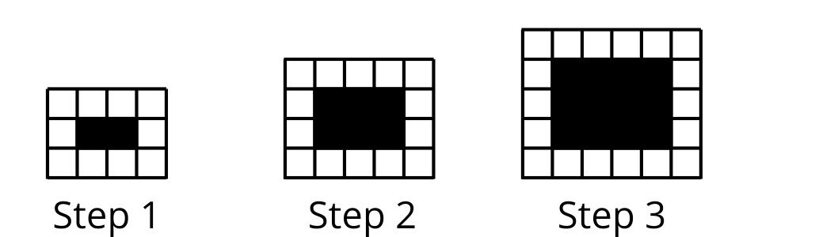
- Are the sequences $W$ and $B$ arithmetic, geometric, or neither? Explain how you know.
- Write an equation for sequence $W$.
- Write an equation for sequence $B$.
- Is the number of black squares ever larger than the number of white squares? Explain how you know.

Are you ready for more?
A definition for the $n^{\text{th}}$ term of the Fibonacci sequence is surprisingly complicated. Humans have been interested in this sequence for a long time—it is named after an Italian mathematician who lived from around 1175 to 1250. The first person known to have stated the $n^{\text{th}}$ term definition, though, was Abraham de Moivre, a French mathematician who lived from 1667 to 1754. So, this definition was unknown for hundreds of years! Here it is:
$F\left(n\right)=\frac{1}{\sqrt{5}}\left({\left(\frac{1+\sqrt{5}}{2}\right)}^{n}−{\left(\frac{1−\sqrt{5}}{2}\right)}^{n}\right)$
- Which form (recursive or $n^{\text{th}}$ term) is more convenient to use for finding $F\left(5\right)$? What about $F\left(10\right)$? $F\left(100\right)$?
- What are some advantages and disadvantages of each form?

Lesson 10 Summary
Some situations can be accurately modeled with geometric sequences, arithmetic sequences, or sequences that are neither geometric nor arithmetic.
For example, here is a pattern of black squares surrounded by white squares, growing in steps.
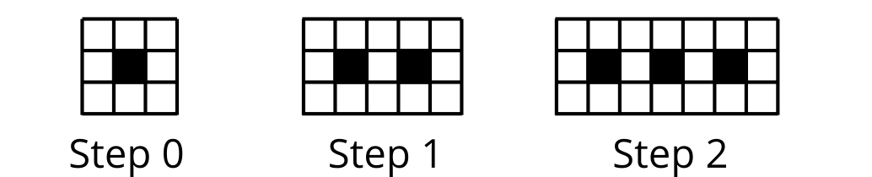
The number of white squares in each step grows (8, 13, 18. . .), with 5 more white squares each time. Since the same number of squares is added each time, the number of white squares forms an arithmetic sequence. The definition for the $n^{\text{th}}$ term of $W$, where $W\left(n\right)$ is the number of white squares in Step $n$, is $W\left(n\right)=5n+8$ for $n≥0$.
Geometric sequences are involved in situations such as population growth and scaling. For example, the sequence of areas we got when we imagined cutting a piece of paper in half at each Step $n$ in an earlier lesson.
Many situations lead to sequences that are neither geometric nor arithmetic. For example, consider these patterns of dots where a new row of $n$ dots introduced in each step:
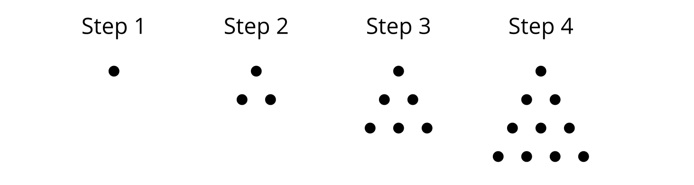
The number of dots in each step grows (1, 3, 6, 10, . . .), but there is no constant being multiplied or added to get from term to term. If we create a graph of this sequence showing the number of dots as a function of the step number, the dots would form neither a linear nor an exponential shape. This sequence is neither geometric nor arithmetic, but it does have a pattern that we can define with an equation.
© CC BY 2019 by Illustrative Mathematics®

