Unit 3 Lesson 14: Proving the Pythagorean Theorem

1 Notice and Wonder: Variable Version (Warm up)

Student Task Statement
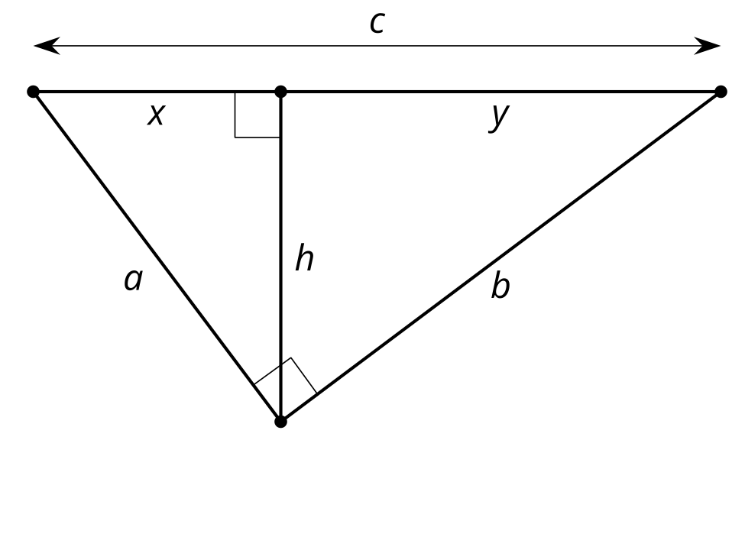
What do you notice? What do you wonder?

2 Prove Pythagoras Right

Student Task Statement
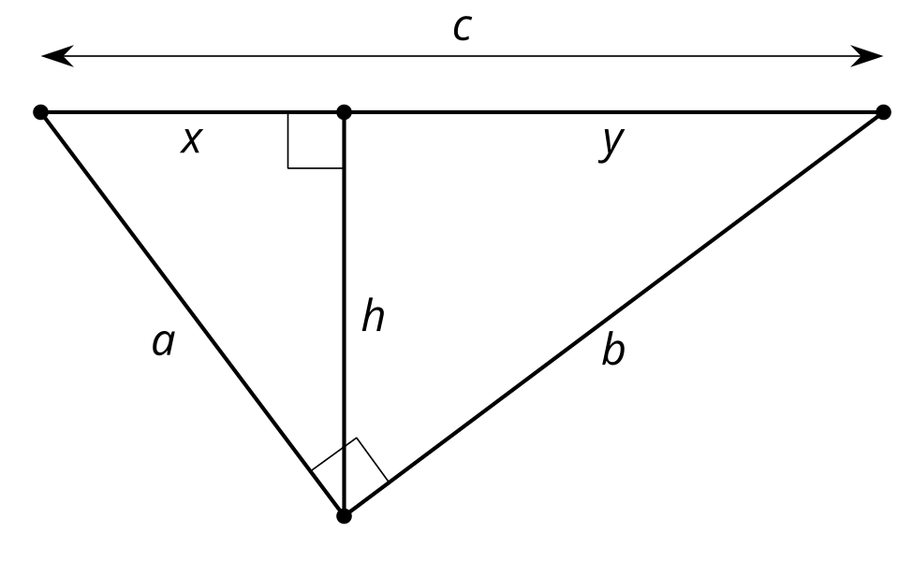
Elena is playing with the equivalent ratios she wrote in the warm-up. She rewrites $\frac{a}{x}=\frac{c}{a}\text{ as }a^{2}=xc$. Diego notices and comments, “I got $b^{2}=yc$. The $a^{2}$ and $b^{2}$ remind me of the Pythagorean Theorem.” Elena says, “The Pythagorean Theorem says that $a^{2}+b^{2}=c^{2}$. I bet we could figure out how to show that.”
- How did Elena get from $\frac{a}{x}=\frac{c}{a}\text{ to }a^{2}=xc$?
- What equivalent ratios of side lengths did Diego use to get $b^{2}=yc$?
- Prove $a^{2}+b^{2}=c^{2}$ in a right triangle with legs length $a$ and $b$ and hypotenuse length $c$.

3 An Alternate Approach

Student Task Statement
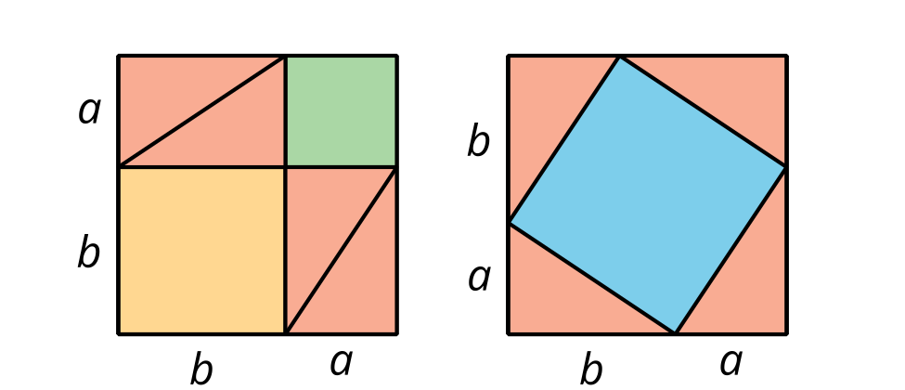
When Pythagoras proved his theorem he used the 2 images shown here. Can you figure out how he used these diagrams to prove $a^{2}+b^{2}=c^{2}$ in a right triangle with hypotenuse length $c$?

Images for Activity Synthesis

$a^{2}+b^{2}=c^{2}$
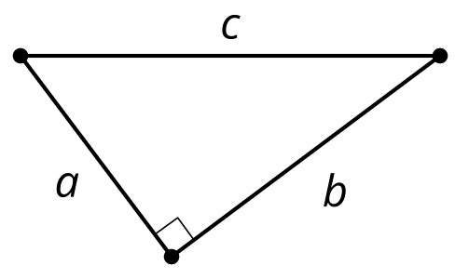
© CC BY 2019 by Illustrative Mathematics®

