Unit 7 Lesson 10: Subtracting Rational Numbers

1 Number Talk: Missing Addend (Warm up)

Student Task Statement
Solve each equation mentally. Rewrite each addition equation as a subtraction equation.
$247+c=458$
$c+43.87=58.92$
$\frac{15}{8}+c=\frac{51}{8}$

2 Expressions with Altitude

Student Task Statement
A mountaineer is changing elevations. Write an expression that represents the difference between the final elevation and beginning elevation. Then write the value of the change. The first one is done for you.
beginning  elevation  (feet) | final  elevation  (feet) | difference  between final  and beginning | change
+400 | +900 | $900−400$ | +500
+400 | +50
+400 | -120
-200 | +610
-200 | -50
-200 | -500
-200 | 0

3 Does the Order Matter?

Student Task Statement
- Find the value of each subtraction expression.
- A
- $3−2$
- $5−\left(\text{-}9\right)$
- $\left(\text{-}11\right)−2$
- $\left(\text{-}6\right)−\left(\text{-}3\right)$
- $\left(\text{-}1.2\right)−\left(−3.6\right)$
- $\left(\text{-}2\frac{1}{2}\right)−\left(\text{-}3\frac{1}{2}\right)$

- B
- $2−3$
- $\left(\text{-}9\right)−5$
- $2−\left(\text{-}11\right)$
- $\left(\text{-}3\right)−\left(\text{-}6\right)$
- $\left(\text{-}3.6\right)−\left(\text{-}1.2\right)$
- $\left(\text{-}3\frac{1}{2}\right)−\left(\text{-}2\frac{1}{2}\right)$
- What do you notice about the expressions in Column A compared to Column B?
- What do you notice about their values?

Activity Synthesis
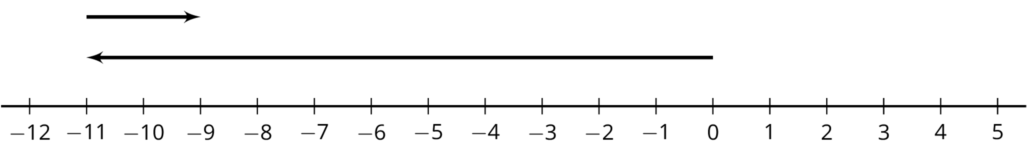
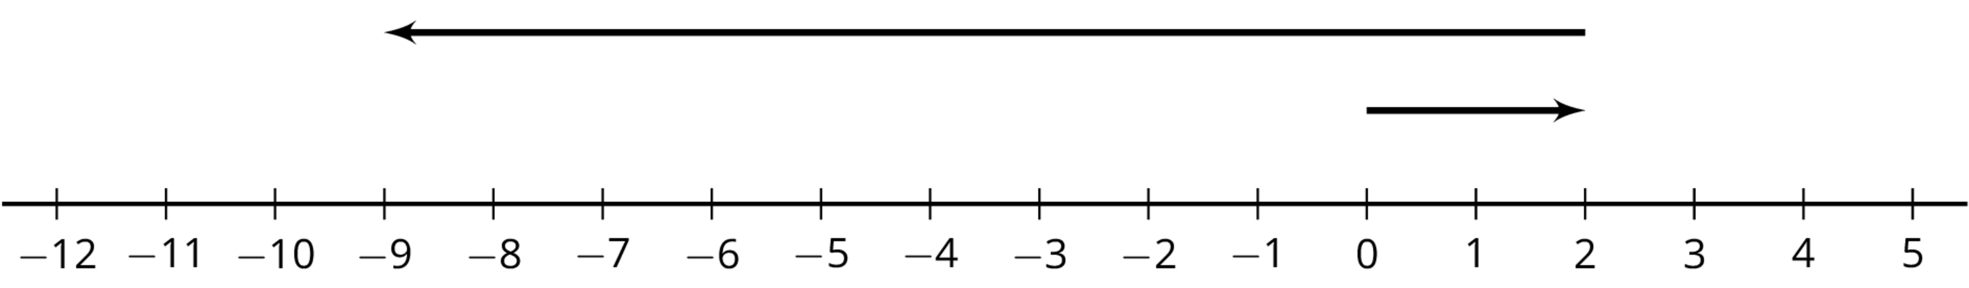
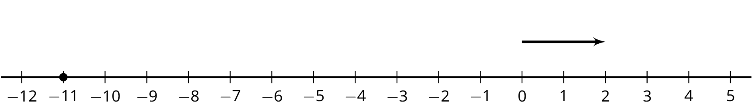
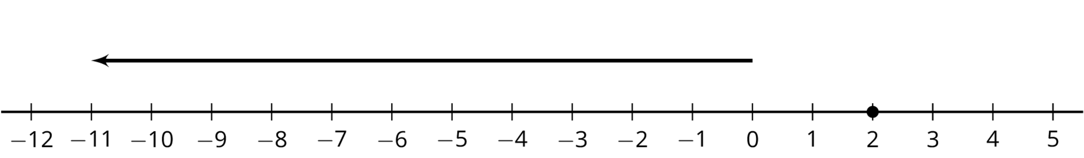

4 Phone Inventory

Student Task Statement
A store tracks the number of cell phones it has in stock and how many phones it sells.
The table shows the inventory for one phone model at the beginning of each day last week. The inventory changes when they sell phones or get shipments of phones into the store.
 | inventory | change
Monday | 18 | -2
Tuesday | 16 | -5
Wednesday | 11 | -7
Thursday | 4 | -6
Friday | -2 | 20
- What do you think it means when the change is positive? Negative?
- What do you think it means when the inventory is positive? Negative?
- Based on the information in the table, what do you think the inventory will be at on Saturday morning? Explain your reasoning.
- What is the difference between the greatest inventory and the least inventory?
© CC BY Open Up Resources. Adaptations CC BY IM.

