Lesson 16 Practice Problems
- Priya looks at the inequality $12−x>5$ and says “I subtract a number from 12 and want a result that is bigger than 5. That means that the solutions should be values of $x$ that are smaller than something.”
- Do you agree with Priya? Explain your reasoning and include solutions to the inequality in your explanation.
- When a store had sold $\frac{2}{5}$ of the shirts that were on display, they brought out another 30 from the stockroom. The store likes to keep at least 150 shirts on display. The manager wrote the inequality $\frac{3}{5}x+30≥150$ to describe the situation.
  - Explain what $\frac{3}{5}$ means in the inequality.
  - Solve the inequality.
  - Explain what the solution means in the situation.
- You know $x$ is a number less than 4. Select all the inequalities that must be true.
  - $x<2$
  - $x+6<10$
  - $5x<20$
  - $x−2>2$
  - $x<8$
- (From Unit 6, Lesson 13.)
- Here is an unbalanced hanger.
- 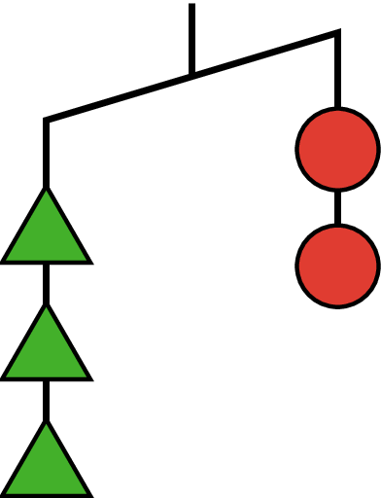
  - If you knew each circle weighed 6 grams, what would that tell you about the weight of each triangle? Explain your reasoning.
  - If you knew each triangle weighed 3 grams, what would that tell you about the weight of each circle? Explain your reasoning.
- (From Unit 6, Lesson 13.)
- Match each sentence with the inequality that could represent the situation.
  - Han got $2 from Clare, but still has less than $20.
  - Mai spent $2 and has less than $20.
  - If Tyler had twice the amount of money he has, he would have less than $20.
  - If Priya had half the money she has, she would have less than $20.
  - $x−2<20$
  - $2x<20$
  - $x+2<20$
  - $\frac{1}{2}x<20$
- (From Unit 6, Lesson 13.)
- At a skateboard shop:
  - The price tag on a shirt says $12.58. Sales tax is 7.5% of the price. How much will you pay for the shirt?
  - The store buys a helmet for $19.00 and sells it for $31.50. What percentage was the markup?
  - The shop pays workers $14.25 per hour plus 5.5% commission. If someone works 18 hours and sells $250 worth of merchandise, what is the total amount of their paycheck for this pay period? Explain or show your reasoning.
- (From Unit 4, Lesson 12.)
© CC BY Open Up Resources. Adaptations CC BY IM.

