Lesson 5 Practice Problems
- Write a sequence of rigid motions to take figure $ABC$ to figure $DEF$.
- 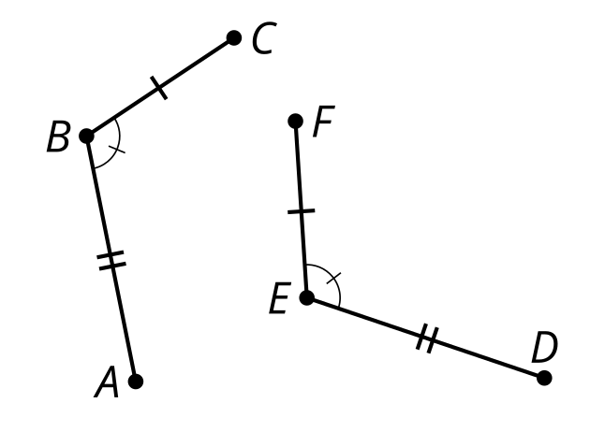
- Prove the circle centered at $A$ is congruent to the circle centered at $C$.

- $AB=CD$
- 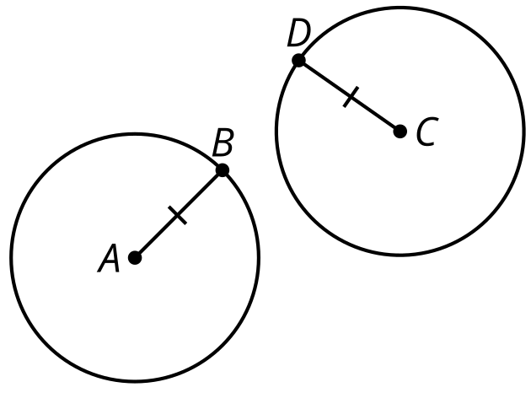
- Which conjecture is possible to prove?
  - All quadrilaterals with at least one side length of 3 are congruent.
  - All rectangles with at least one side length of 3 are congruent.
  - All rhombuses with at least one side length of 3 are congruent.
  - All squares with at least one side length of 3 are congruent.
- Match each statement using only the information shown in the pairs of congruent triangles.
  - The 2 sides and the included angle of one triangle are congruent to 2 sides and the included angle of another triangle.
  - The 2 angles and the included side of one triangle are congruent to 2 angles and the included side of another triangle.
  - In the 2 triangles there are 3 pairs of congruent sides.
  - 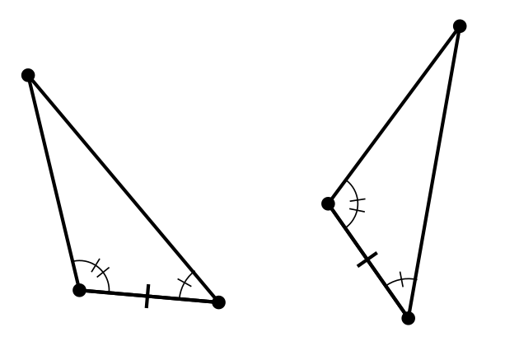
  - 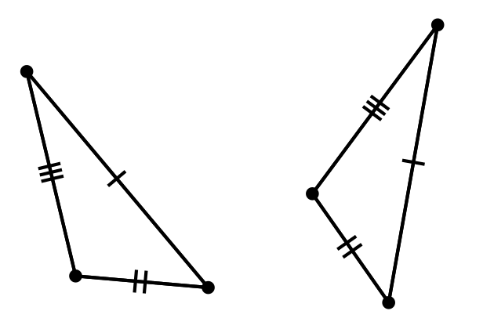
  - 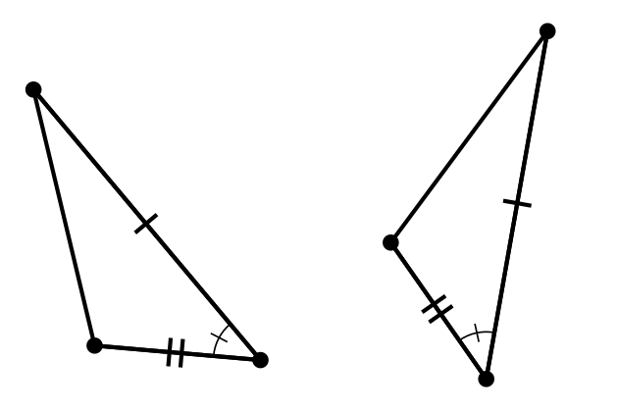
- (From Unit 2, Lesson 4.)
- Triangle $HEF$ is the image of triangle $HGF$ after a reflection across line $FH$. Write a congruence statement for the 2 congruent triangles.
- 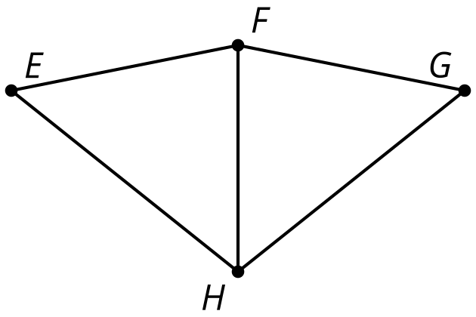
- (From Unit 2, Lesson 2.)
- Triangle $ABC$ is congruent to triangle $EDF$. So, Lin knows that there is a sequence of rigid motions that takes $ABC$ to $EDF$.
- Select all true statements after the transformations:
- 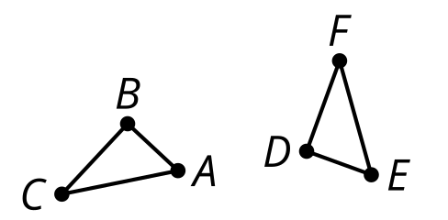
  - Angle $A$ coincides with angle $F$.
  - Angle $B$ coincides with angle $D$.
  - Angle $C$ coincides with angle $E$.
  - Segment $BA$ coincides with segment $DE$.
  - Segment $BC$ coincides with segment $FE$.
- (From Unit 2, Lesson 3.)
- This design began from the construction of a regular hexagon. Is quadrilateral $JKLO$ congruent to the other 2 quadrilaterals? Explain how you know.
- 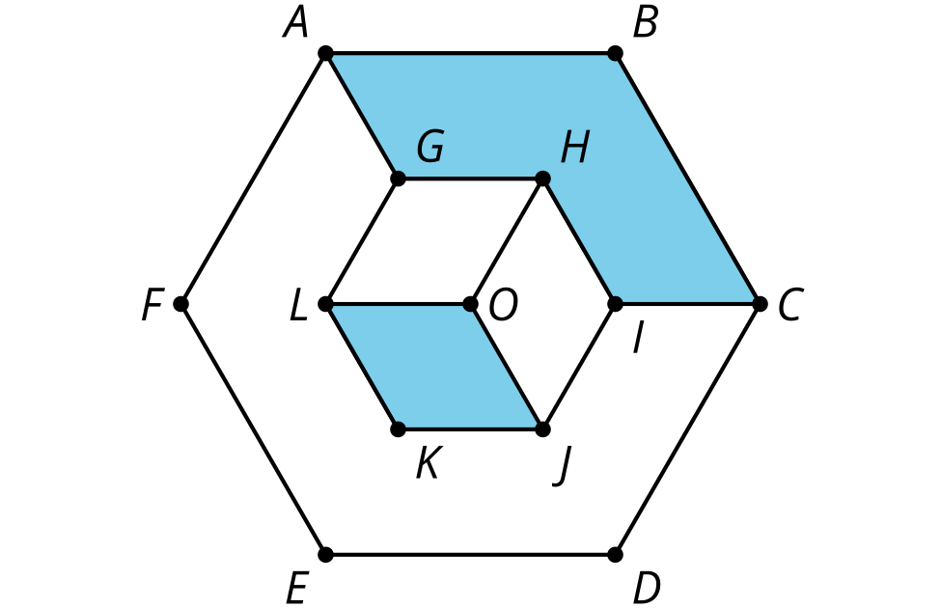
- (From Unit 1, Lesson 22.)
© CC BY 2019 by Illustrative Mathematics®

