Lesson 5 Practice Problems
- Classify each function as odd, even, or neither.
- 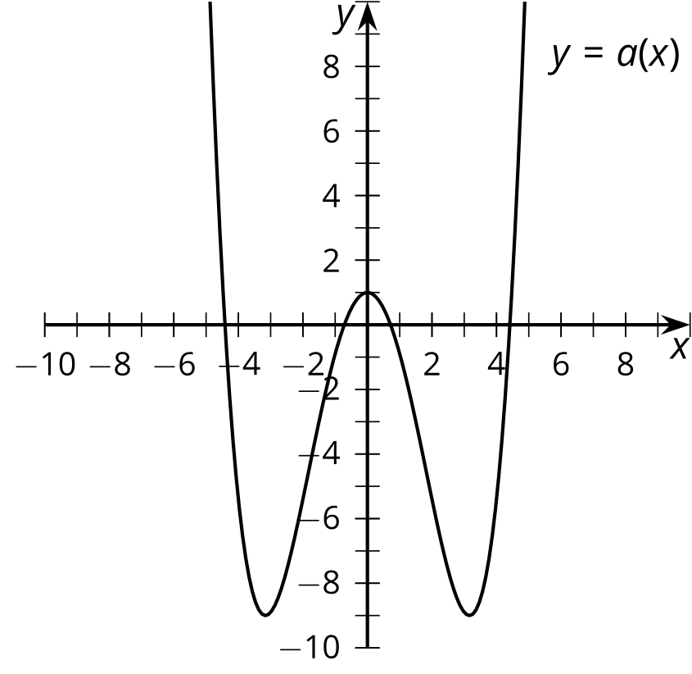
- 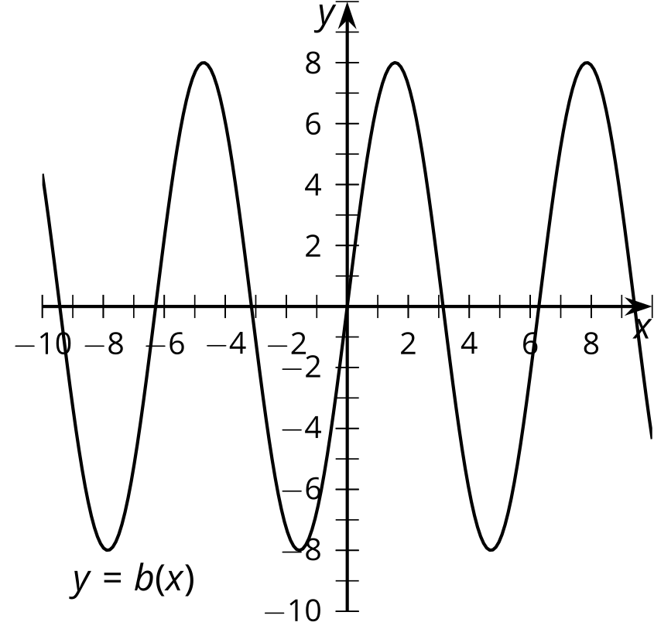
- 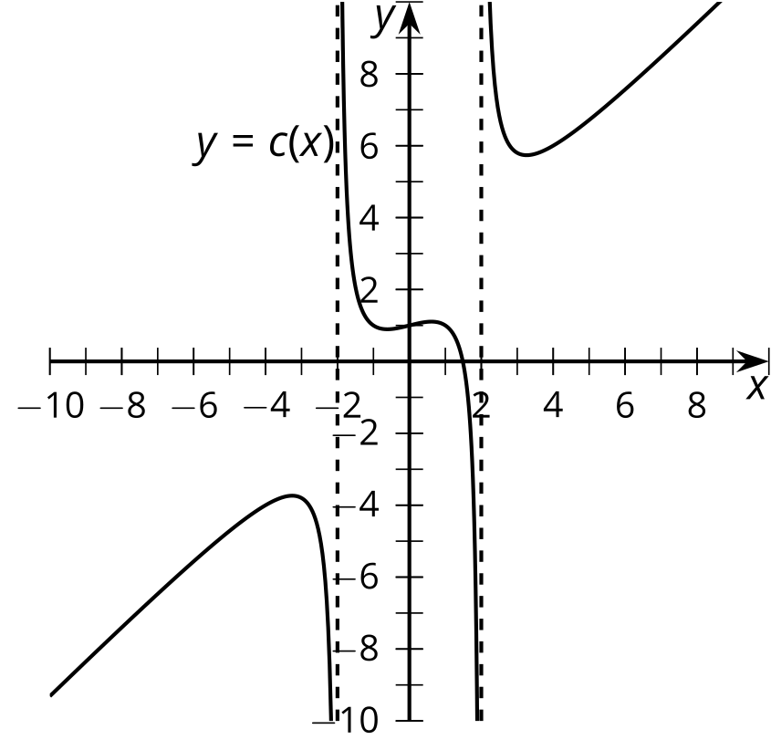
- 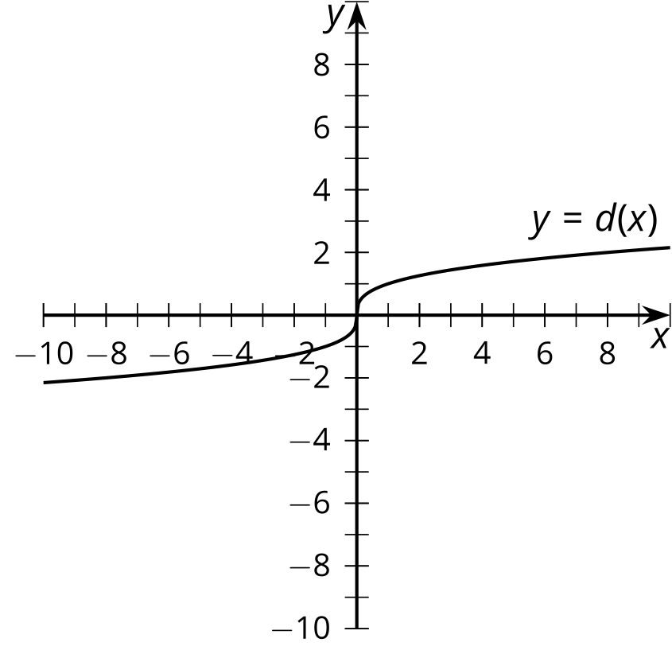
- The table shows the values of an even function $f$ for some inputs.
- $x$ | - -4 | - -3 | - -2 | - -1 | - 0 | - 1 | - 2 | - 3 | - 4
- $f\left(x\right)$ | - 2 |  | - 8 |  | - 10 | - -1 |  | - 0
- Complete the table.
- Here is the graph of $y=x−2$.
- 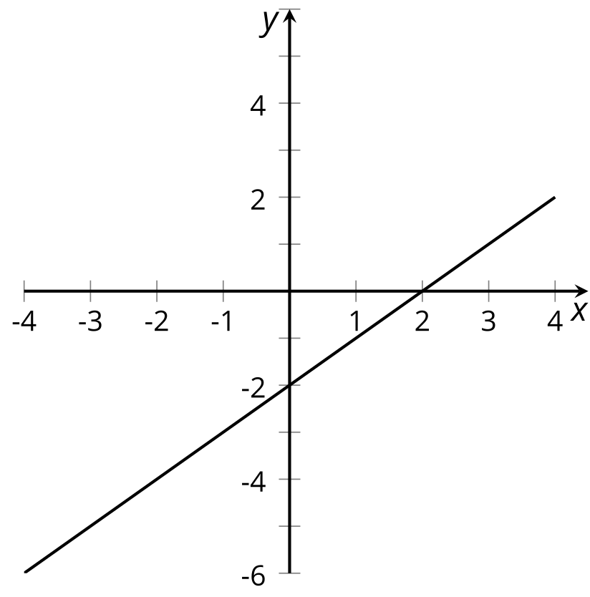
  - Is there a vertical translation of the graph that represents an even function? Explain your reasoning.
  - Is there a vertical translation of the graph that represents an odd function? Explain you reasoning.
- The function $f$ is odd. Which statements must be true? Select all that apply.
  - If $f\left(5\right)=2$, then $f\left(\text{-}5\right)=2$.
  - If $f\left(5\right)=3$, then $f\left(\text{-}5\right)=\text{-}3$.
  - Reflection over the $y$-axis takes the graph of $f$ to itself.
  - Reflecting $f$ across both axes takes the graph of $f$ to itself.
  - $f\left(0\right)=0$
- Find the exact solution(s) to each of these equations, or explain why there is no solution.
  - $\frac{1}{4}\sqrt[3]{d}=15$
  - $\text{-}\sqrt[3]{e}=7$
  - $\sqrt[3]{f−5}+2=4$
- (From Unit 3, Lesson 8.)
- Here is the graph of $f$.
  - Graph the function $g$ given by $g\left(x\right)=\text{-}f\left(x\right)$.
  - Graph the function $h$ given by $h\left(x\right)=f\left(\text{-}x\right)$.
- 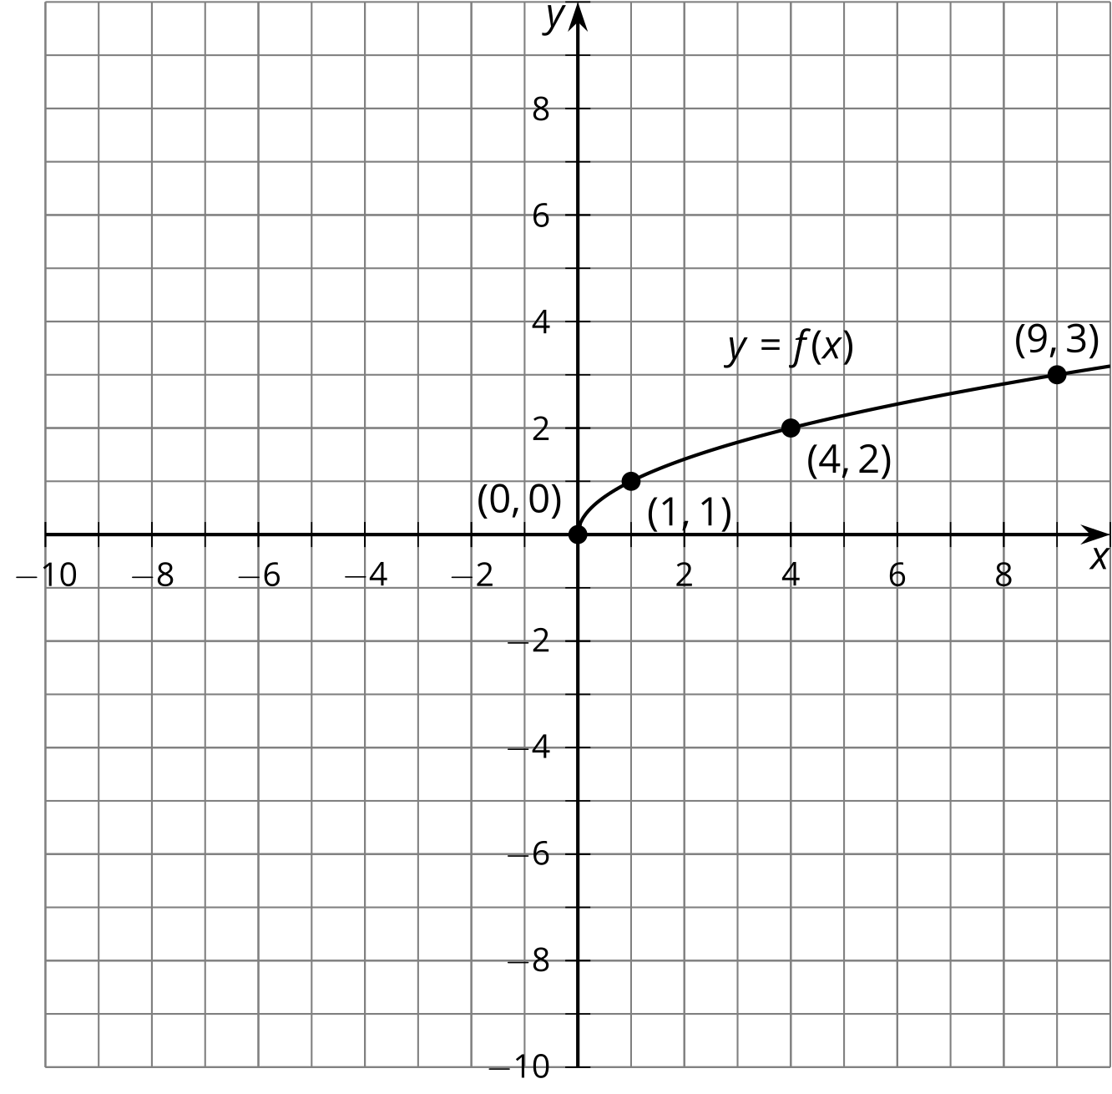
- (From Unit 5, Lesson 4.)
- The graph models Priya's heart rate before, during, and after a run.
- 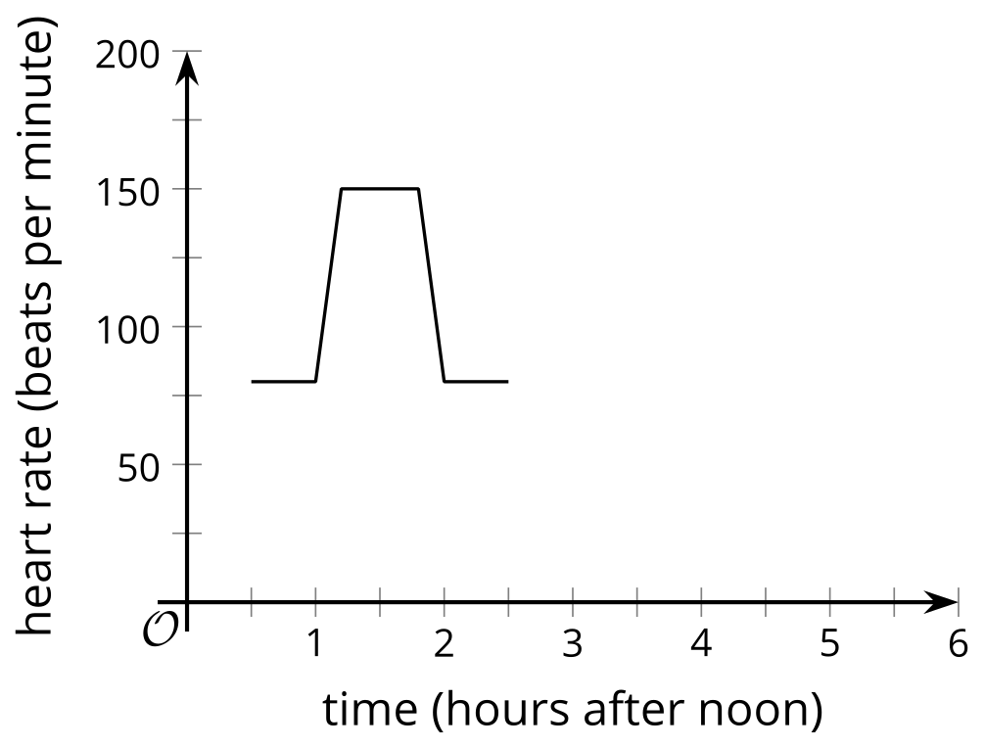
  - What was Priya's approximate heart rate before and after the run?
  - About how high did Priya's heart rate get during the run?
  - Sketch what the graph would look like if Priya went for the run three hours later.
- (From Unit 5, Lesson 2.)
© CC BY 2019 by Illustrative Mathematics®

