Unit 2 Lesson 5: Connecting Factors and Zeros

1 Notice and Wonder: Factored Form (Warm up)

Student Task Statement
What do you notice? What do you wonder?

$f\left(x\right)=\left(x+5\right)\left(x+1\right)\left(x−3\right)$
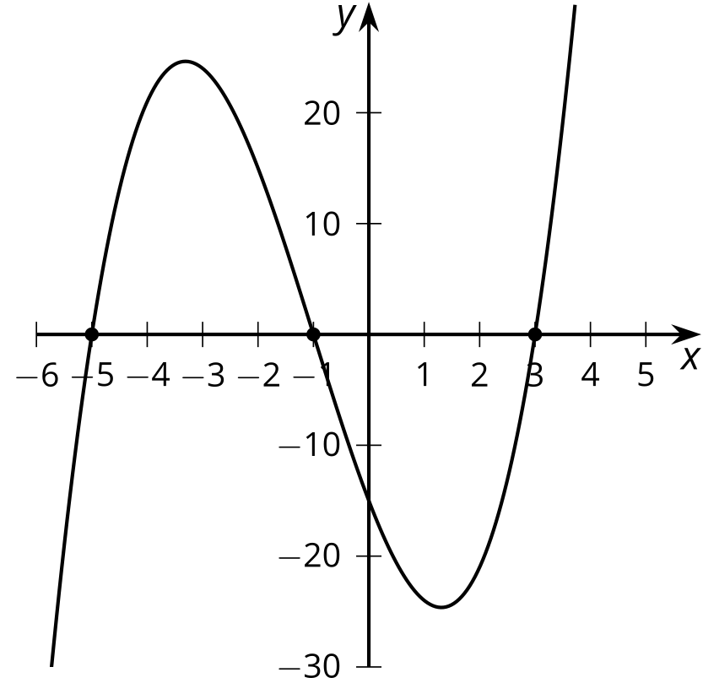

$g\left(x\right)=\left(x+5\right)\left(x+1\right)\left(x−2\right)$
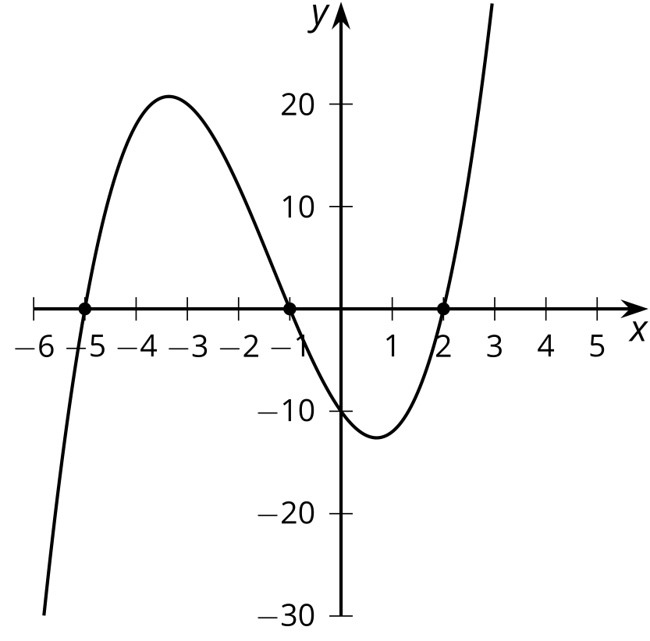

$h\left(x\right)=\left(x+4\right)\left(x+1\right)\left(x−2\right)$
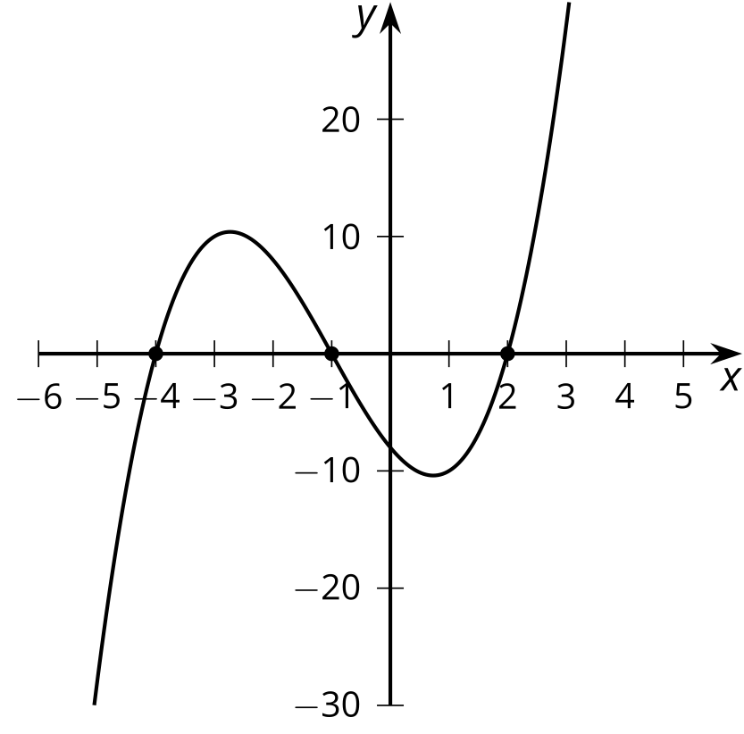

2 What Values of $x$ Make These Equations True?

Student Task Statement
Find all values of $x$ that make the equation true.
- $\left(x+4\right)\left(x+2\right)\left(x−1\right)=0$
- $\left(x+4\right)\left(x+2\right)\left(x−1\right)\left(x−3\right)=0$
- ${\left(x+4\right)}^{2}{\left(x+2\right)}^{2}=0$
- $\text{-}2\left(x−4\right)\left(x−2\right)\left(x+1\right)\left(x+3\right)=0$
- $\left(2x+8\right)\left(7x−3\right)\left(x−10\right)=0$
- $x^{2}+3x−4=0$
- $x\left(3−x\right)\left(x−1\right)\left(x+0.75\right)=0$
- $\left(x^{2}−4\right)\left(x+9\right)=0$

3 Factors, Intercepts, and Graphs

Student Task Statement
Your teacher will give you a set of cards. Match each equation to either a graph or a description.
Take turns with your partner to match an equation with a graph or a description of a graph.
- For each match that you find, explain to your partner how you know it’s a match.
- For each match that your partner finds, listen carefully to their explanation. If you disagree, discuss your thinking and work to reach an agreement.
© CC BY 2019 by Illustrative Mathematics®

