Lesson 8 Practice Problems
- Select all of the digital construction tools that do the same job as a pencil alone (without straightedge or compass).
  - Point plotted on an object
  - Polygon
  - Circle with center through point
  - Point of intersection
  - Line
- How can you test to see if a diagram made using digital tools is a construction or just a drawing based on estimation?
- Han thought he constructed a rectangle using digital tools. When he moved point $A$ the screen looked like this. What did Han do wrong?
- 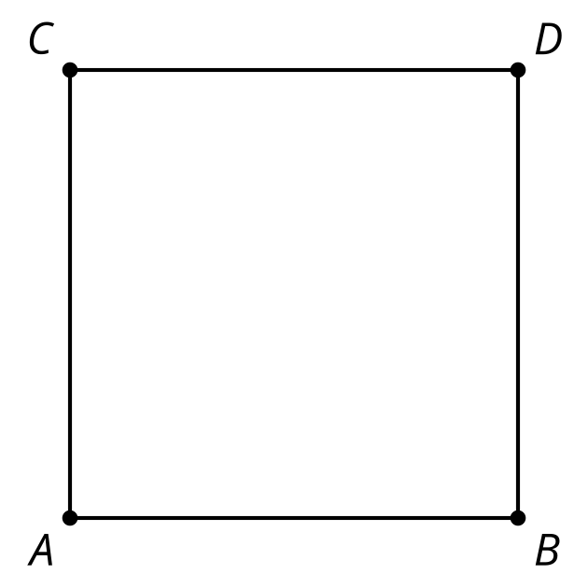
- 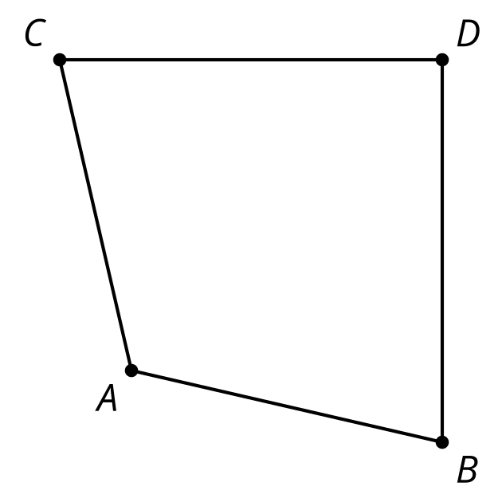
- Select all the digital construction tools that do the same job as a straightedge.
  - Circle with center through point
  - Point plotted on an object
  - Point of intersection
  - Segment
  - Line
- Which digital construction tool does the same job as a compass?
  - Point
  - Line
  - Polygon
  - Circle with center through point
- This diagram was made using digital construction tools. One of these triangles was made using the polygon tool and the other was made using the regular polygon tool. Explain what you could do to tell the difference between them.
- 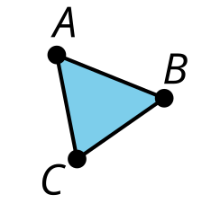
- 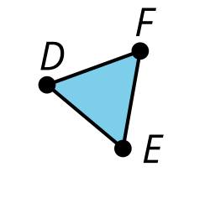
- Which digital construction tool would help you determine whether point $C$ or point $D$ is the midpoint of segment $AB$?
- 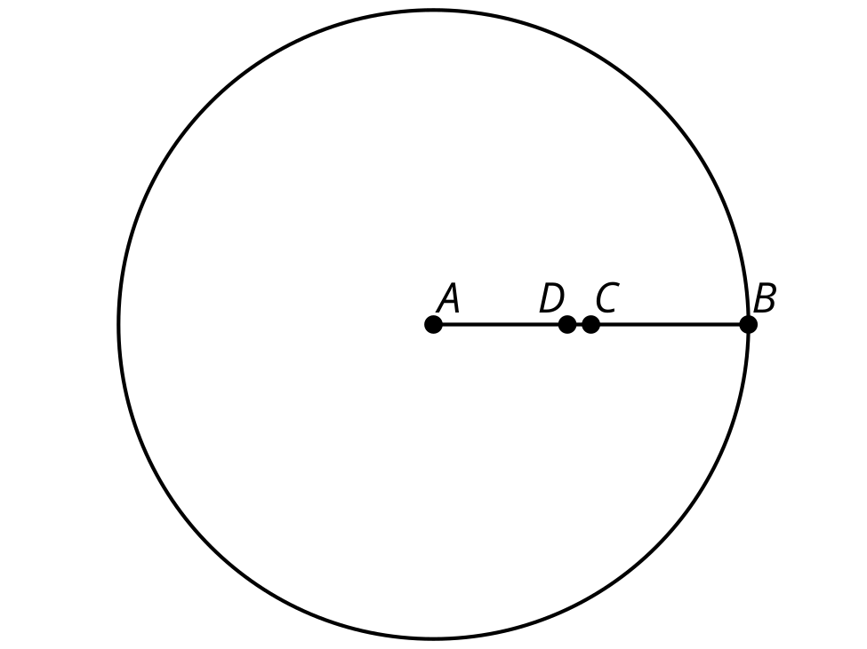
  - Angle bisector
  - Perpendicular bisector
  - Perpendicular line
  - Parallel line
- Here is as construction of a regular hexagon inscribed in a circle. Not all parts of the construction are shown. Explain how to construct an equilateral triangle inscribed in the circle centered at $A$ using digital construction tools.
- 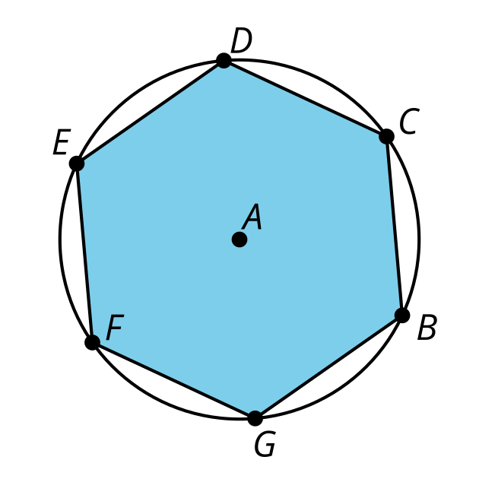
- Here is a construction of a regular hexagon inscribed in a circle. Not all parts of the construction are shown. Explain how to construct a regular 12-sided polygon inscribed in the circle centered at $A$ using digital construction tools.
© CC BY 2019 by Illustrative Mathematics®

