Lesson 14 Practice Problems
- Here is a dot plot that shows the ages of teachers at a school.
- Which of these statements is true of the data set shown in the dot plot?
- 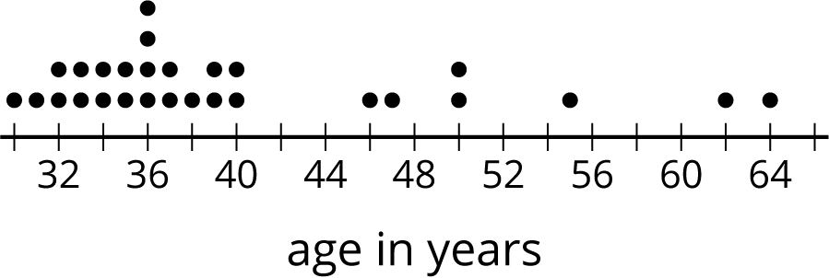
  - The mean is less than the median.
  - The mean is approximately equal to the median.
  - The mean is greater than the median.
  - The mean cannot be determined.
- Priya asked each of five friends to attempt to throw a ball in a trash can until they succeeded. She recorded the number of unsuccessful attempts made by each friend as: 1, 8, 6, 2, 4. Priya made a mistake: The 8 in the data set should have been 18.
- How would changing the 8 to 18 affect the mean and median of the data set?
  - The mean would decrease and the median would not change.
  - The mean would increase and the median would not change.
  - The mean would decrease and the median would increase.
  - The mean would increase and the median would increase.
- In his history class, Han's homework scores are:
- 100
- 100
- 100
- 100
- 95
- 100
- 90
- 100
- 0
- The history teacher uses the mean to calculate the grade for homework. Write an argument for Han to explain why median would be a better measure to use for his homework grades.
- The dot plots show how much time, in minutes, students in a class took to complete each of five different tasks. Select all the dot plots of tasks for which the mean time is approximately equal to the median time.
- 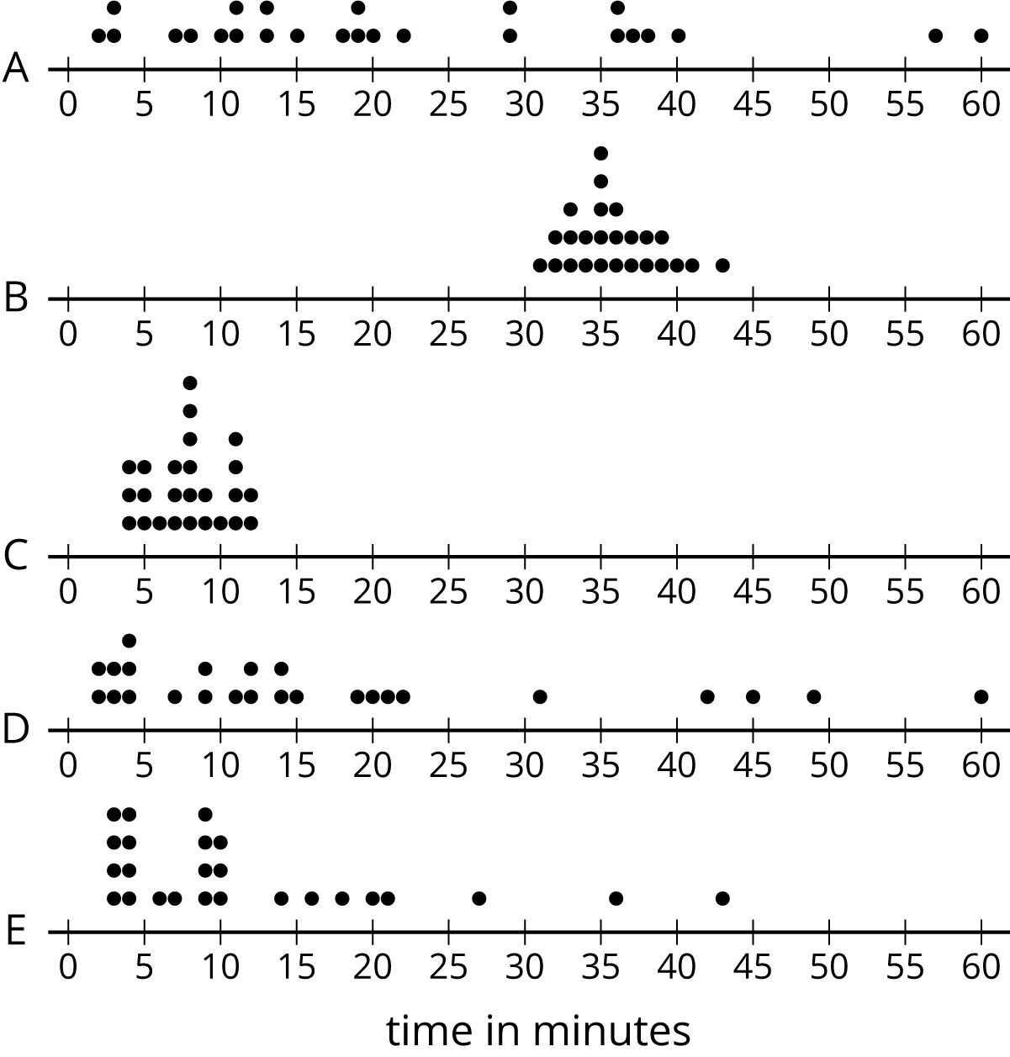
- Zookeepers recorded the ages, weights, genders, and heights of the 10 pandas at their zoo. Write two statistical questions that could be answered using these data sets.
- (From Unit 8, Lesson 2.)
- Here is a set of coordinates. Draw and label an appropriate pair of axes and plot the points. $A=\left(1,0\right)$, $B=\left(0,0.5\right)$, $C=\left(4,3.5\right)$, $D=\left(1.5,0.5\right)$
- (From Unit 7, Lesson 12.)
© CC BY Open Up Resources. Adaptations CC BY IM.

