Lesson 7 Practice Problems
- Which of these statements is true?
  - All rectangles are regular polygons.
  - All squares are regular polygons.
  - All rhombi are regular polygons.
  - All parallelograms are regular polygons.
- This diagram is a straightedge and compass construction of a square $BACD$ (not all markings are shown). The construction followed these steps:
- 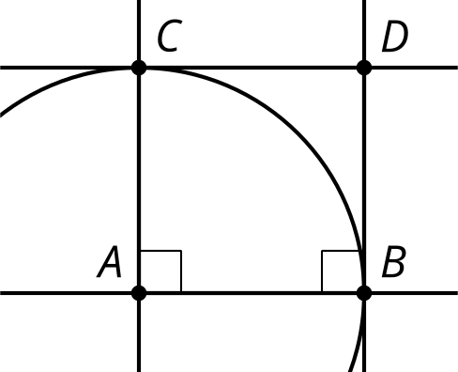
  - Start with two marked points $A$ and $B$
  - Use a straightedge to construct line $AB$
  - Use a previous construction to construct a line perpendicular to $AB$ passing through $A$
  - Use a previous construction to construct a line perpendicular to $AB$ passing through $B$
  - Use a compass to construct a circle centered at $A$ passing through $B$
  - Label an intersection point of that circle and the line from step 3 as $C$
  - Use a previous construction to construct a line parallel to $AB$ passing through $C$
  - Label the intersection of that line and the line from step 4 as $D$
  - Use a straightedge to construct the segments $AC$, $CD$, and $DB$
- Explain why you need to construct a circle in step 5.
- To construct a line passing through the point $C$ that is parallel to the line $AB$, the first step is to create a line through $C$ perpendicular to $AB$. What is the next step?
- 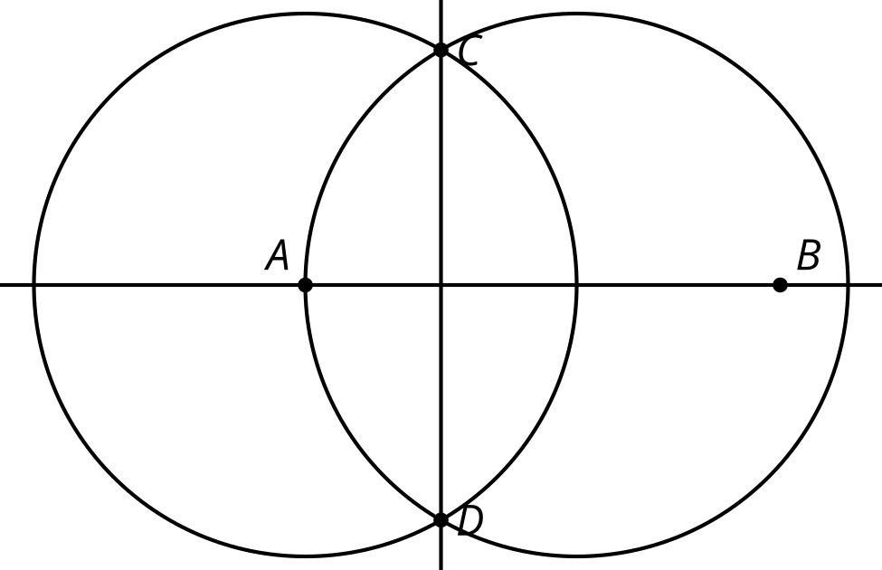
  - Construct an equilateral triangle with side $CD$.
  - Construct a line through point $B$ perpendicular to $AB$.
  - Construct a segment with the same length as $AB$ with endpoint $C$.
  - Construct a line through point $C$ perpendicular to $CD$.
- (From Unit 1, Lesson 6.)
- Jada wanted to construct a line perpendicular to line $ℓ$ through point $C$. The diagram shows her construction. What was her mistake?
- 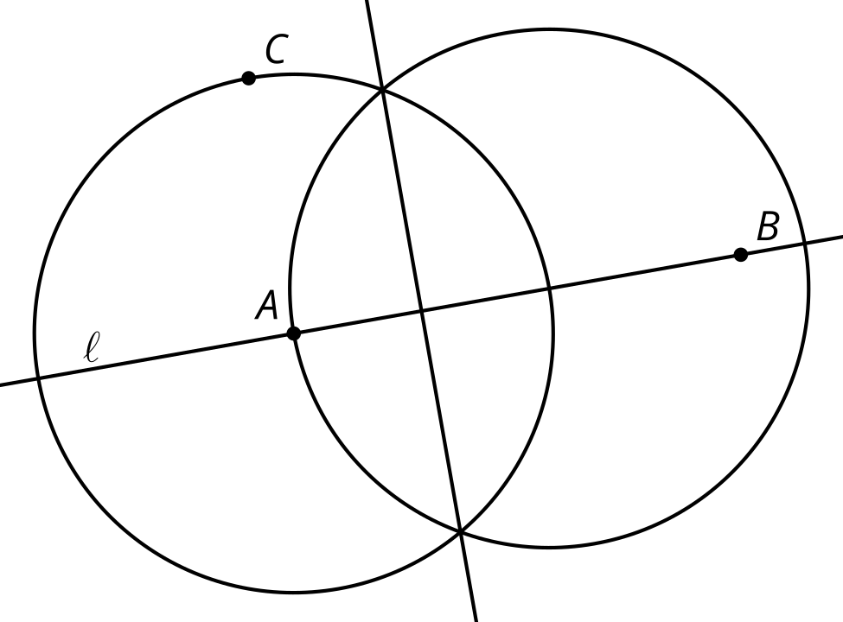

- (From Unit 1, Lesson 6.)
- Noah is trying to bisect angle $BAC$. He draws circles of the same radius with centers $B$ and $C$ and then uses one of the points of intersection for his ray. What mistake has Noah made in his construction?
- 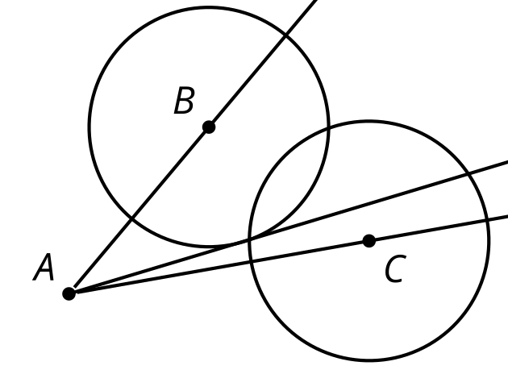
- (From Unit 1, Lesson 5.)
- Here is a straightedge and compass construction. Use a straightedge to draw an equilateral triangle on the figure. Explain how you know the triangle is equilateral.
- 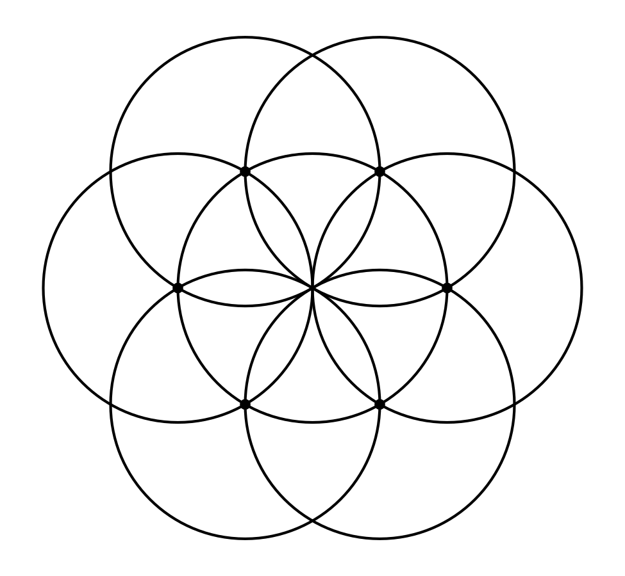
- (From Unit 1, Lesson 4.)
- Here are 2 points in the plane. Explain how to construct a line segment that is half the length of segment $AB$.
- 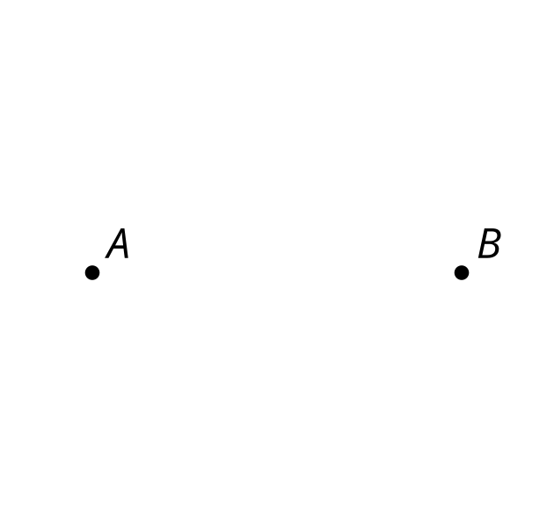
- (From Unit 1, Lesson 3.)
© CC BY 2019 by Illustrative Mathematics®

