Unit 8 Lesson 2: Side Lengths and Areas

1 Notice and Wonder: Intersecting Circles (Warm up)

Student Task Statement
What do you notice? What do you wonder?
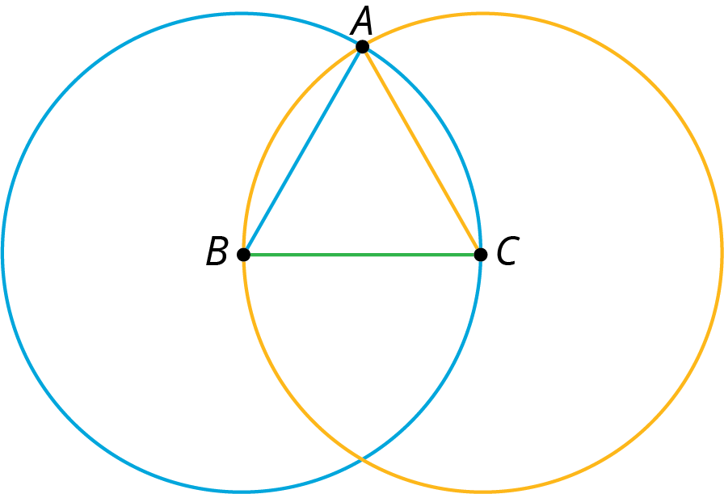

2 One Square

Student Task Statement
- Use the circle to estimate the area of the square shown here:
- 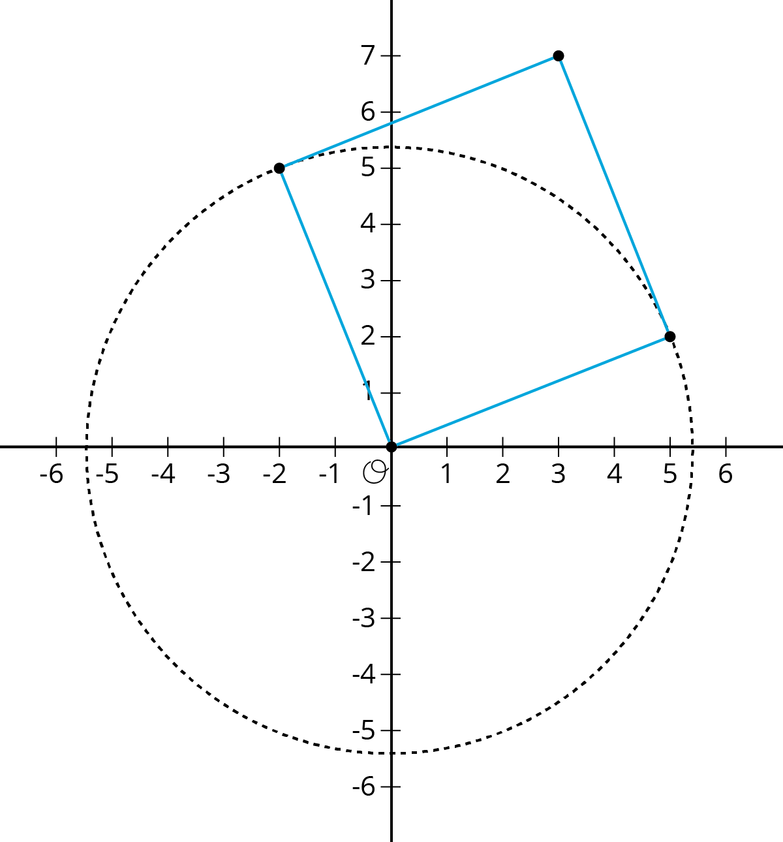
- Use the grid to check your answer to the first problem.
- 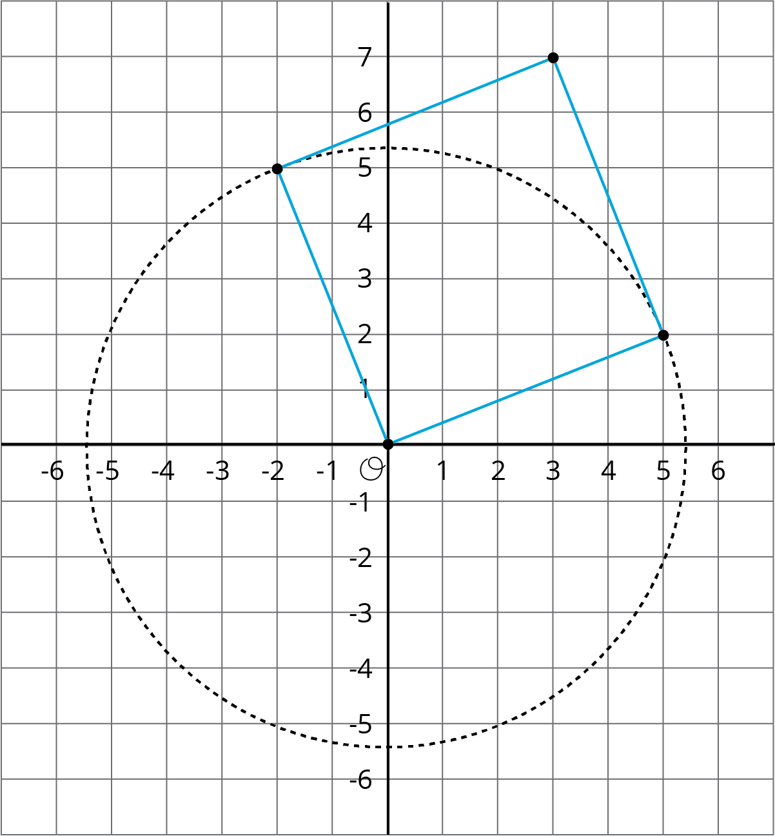

3 The Sides and Areas of Tilted Squares

Student Task Statement
- Find the area of each square and estimate the side lengths using your geometry toolkit. Then write the exact lengths for the sides of each square.
- 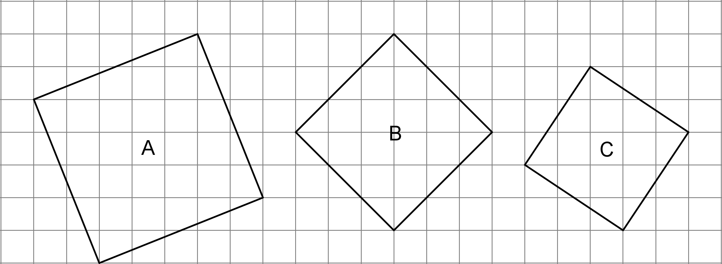
- Complete the tables with the missing side lengths and areas.
- side length, $s$ | - 0.5 |  | - 1.5 |  | - 2.5 |  | - 3.5
- area, $a$ |  | - 1 |  | - 4 |  | - 9 |  | - 16

- side length, $s$ | - 4.5 |  | - 5.5 |  | - 6.5 |  | - 7.5
- area, $a$ |  | - 25 |  | - 36 |  | - 49 |  | - 64
- Plot the points, $\left(s,a\right)$, on the coordinate plane shown here.
- 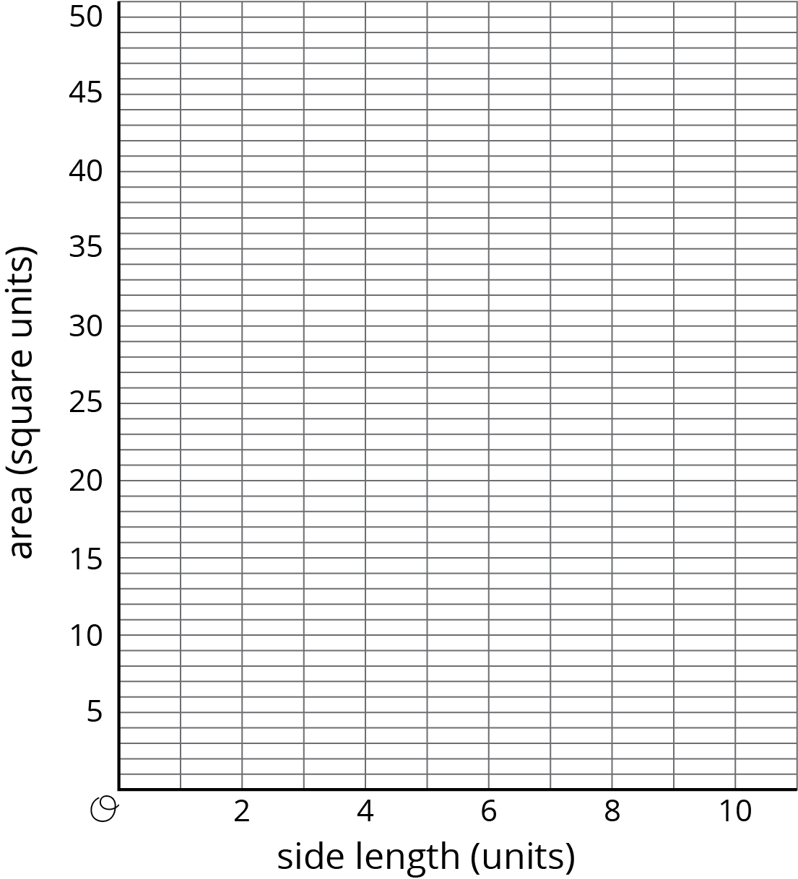
- Use this graph to estimate the side lengths of the squares in the first question. How do your estimates from the graph compare to the estimates you made initially using your geometry toolkit?
- Use the graph to approximate $\sqrt{45}$.
© CC BY Open Up Resources. Adaptations CC BY IM.

