Unit 9 Lesson 3: Rectangle Madness

1 Squares in Rectangles (Optional)

Student Task Statement
- Rectangle $ABCD$ is not a square. Rectangle $ABEF$ is a square.
- 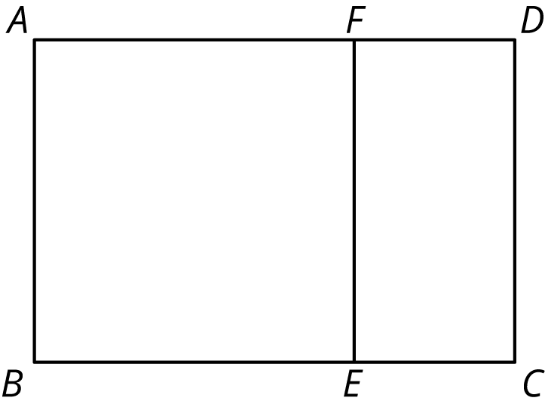
  - Suppose segment $AF$ were 5 units long and segment $FD$ were 2 units long. How long would segment $AD$ be?
  - Suppose segment $BC$ were 10 units long and segment $BE$ were 6 units long. How long would segment $EC$ be?
  - Suppose segment $AF$ were 12 units long and segment $FD$ were 5 units long. How long would segment $FE$ be?
  - Suppose segment $AD$ were 9 units long and segment $AB$ were 5 units long. How long would segment $FD$ be?
- Rectangle $JKXW$ has been decomposed into squares.
- Segment $JK$ is 33 units long and segment $JW$ is 75 units long. Find the areas of all of the squares in the diagram.
- Rectangle $ABCD$ is 16 units by 5 units.

  - In the diagram, draw a line segment that decomposes $ABCD$ into two regions: a square that is the largest possible and a new rectangle.
  - Draw another line segment that decomposes the new rectangle into two regions: a square that is the largest possible and another new rectangle.
  - Keep going until rectangle $ABCD$ is entirely decomposed into squares.
  - List the side lengths of all the squares in your diagram.

2 More Rectangles, More Squares (Optional)

Student Task Statement
- Draw a rectangle that is 21 units by 6 units.

  - In your rectangle, draw a line segment that decomposes the rectangle into a new rectangle and a square that is as large as possible. Continue until the diagram shows that your original rectangle has been entirely decomposed into squares.
  - How many squares of each size are in your diagram?
  - What is the side length of the smallest square?
- Draw a rectangle that is 28 units by 12 units.
  - In your rectangle, draw a line segment that decomposes the rectangle into a new rectangle and a square that is as large as possible. Continue until the diagram shows that your original rectangle has been decomposed into squares.
  - How many squares of each size are in your diagram?
  - What is the side length of the smallest square?
- Write each of these fractions as a mixed number with the smallest possible numerator and denominator:
  - $\frac{16}{5}$
  - $\frac{21}{6}$
  - $\frac{28}{12}$
- What do the fraction problems have to do with the previous rectangle decomposition problems?

3 Finding Equivalent Fractions (Optional)

Student Task Statement
- Accurately draw a rectangle that is 9 units by 4 units.
  - In your rectangle, draw a line segment that decomposes the rectangle into a new rectangle and a square that is as large as possible. Continue until your original rectangle has been entirely decomposed into squares.
  - How many squares of each size are there?
  - What are the side lengths of the last square you drew?
  - Write $\frac{9}{4}$ as a mixed number.
- Accurately draw a rectangle that is 27 units by 12 units.
  - In your rectangle, draw a line segment that decomposes the rectangle into a new rectangle and a square that is as large as possible. Continue until your original rectangle has been entirely decomposed into squares.
  - How many squares of each size are there?
  - What are the side lengths of the last square you drew?
  - Write $\frac{27}{12}$ as a mixed number.
  - Compare the diagram you drew for this problem and the one for the previous problem. How are they the same? How are they different?
- What is the greatest common factor of 9 and 4? What is the greatest common factor of 27 and 12? What does this have to do with your diagrams of decomposed rectangles?

4 It’s All About Fractions (Optional)

Student Task Statement
- Accurately draw a 37-by-16 rectangle. (Use graph paper, if possible.)

  - In your rectangle, draw a line segment that decomposes the rectangle into a new rectangle and a square that is as large as possible. Continue until your original rectangle has been entirely decomposed into squares.
  - How many squares of each size are there?
  - What are the dimensions of the last square you drew?
  - What does this have to do with $2+\frac{1}{3+\frac{1}{5}}$?
- Consider a 52-by-15 rectangle.

  - In your rectangle, draw a line segment that decomposes the rectangle into a new rectangle and a square that is as large as possible. Continue until your original rectangle has been entirely decomposed into squares.
  - Write a fraction equal to this expression: $3+\frac{1}{2+\frac{1}{7}}$.
  - Notice some connections between the rectangle and the fraction.
  - What is the greatest common factor of 52 and 15?
- Consider a 98-by-21 rectangle.

  - In your rectangle, draw a line segment that decomposes the rectangle into a new rectangle and a square that is as large as possible. Continue until your original rectangle has been entirely decomposed into squares.
  - Write a fraction equal to this expression: $4+\frac{1}{1+\frac{7}{14}}$.
  - Notice some connections between the rectangle and the fraction.
  - What is the greatest common factor of 98 and 21?
- Consider a 121-by-38 rectangle.

  - Use the decomposition-into-squares process to write a continued fraction for $\frac{121}{38}$. Verify that it works.
  - What is the greatest common factor of 121 and 38?
© CC BY Open Up Resources. Adaptations CC BY IM.

