Lesson 14: Practiquemos un algoritmo en el que se usan cocientes parciales

Standards Alignments
Addressing | 5.NBT.B.6

Teacher-facing Learning Goals
- Divide four-digit dividends by two-digit divisors using an algorithm using partial quotients.

Student-facing Learning Goals
- Practiquemos cómo usar un algoritmo de cocientes parciales.

Lesson Purpose
The purpose of this lesson is for students to practice using an algorithm using partial quotients.
In previous lessons, students learned to use an algorithm using partial quotients to evaluate division expressions involving two-digit divisors. In this lesson, students extend their work in two ways. First, using partial quotients requires care in finding multiples and subtracting those multiples or partial quotients. Students identify and correct errors in multiplication and subtraction. Then they find quotients of larger numbers. Here the multiplication and subtraction demands increase and students see the first cases where they can subtract 100 or a multiple of 100 of the divisor from the dividend.

Access for:

Students with Disabilities
- Action and Expression (Activity 2)

English Learners
- MLR8 (Activity 1)

Instructional Routines
Which One Doesn’t Belong? (Warm-up)

Lesson Timeline
Warm-up | 10 min
Activity 1 | 20 min
Activity 2 | 15 min
Lesson Synthesis | 10 min
Cool-down | 5 min

Teacher Reflection Question
It is important for students to build procedural skills from conceptual understanding. How will you connect student thinking to support each student in using increasingly more efficient multiples of the divisor when they use an algorithm using partial quotients?

Cool-down
(to be completed at the end of the lesson) 5min
Divide números de cuatro dígitos

Standards Alignments
Addressing | 5.NBT.B.6

Student-facing Task Statement
Encuentra el valor de $1,​736÷28$.
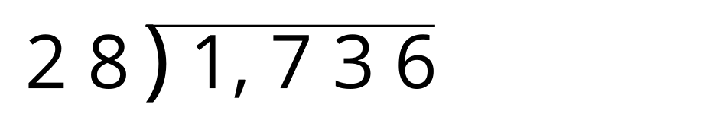

Student Responses
62. Sample response:
