Lesson 11: Preguntas sobre datos

Standards Alignments
Building On | 1.OA.C.6
Addressing | 2.MD.D.10, 2.OA.B.2

Teacher-facing Learning Goals
- Generate and answer questions about data represented in picture graphs and bar graphs.

Student-facing Learning Goals
- Respondamos preguntas usando gráficas de dibujos y gráficas de barras.

Lesson Purpose
The purpose of this lesson is for students to ask and answer questions about a given set of categorical data represented in picture and bar graphs.
In previous lessons, students interpreted picture graphs and bar graphs and answered questions using the data presented in graphs. In this lessons, students generate their own questions about the data represented in the graphs they created in the previous lesson. They use their classmates’ picture graphs and bar graphs to answer student-generated questions about the data. Throughout the lesson, students have opportunities to share and revise their work with different peers. These conversations help to deepen their understanding of the structure of picture and bar graphs and the features that help clearly communicate data (MP3, MP6). When students ask their own questions and answer questions about the data, they attend to the features of the graph and the meaning of these features within the context (MP2).
This lesson has a Student Section Summary.

Access for:

Students with Disabilities
- Representation (Activity 2)

English Learners
- MLR7 (Activity 1)

Instructional Routines
Number Talk (Warm-up)

Materials to Gather
- Materials from a previous lesson: Activity 1, Activity 2

Lesson Timeline
Warm-up | 10 min
Activity 1 | 15 min
Activity 2 | 20 min
Lesson Synthesis | 10 min
Cool-down | 5 min

Teacher Reflection Question
What aspects of today’s lesson allowed each of your students to see themselves as productive mathematical reasoners?

Cool-down
(to be completed at the end of the lesson) 5min
Preguntas sobre datos

Standards Alignments
Addressing | 2.MD.D.10

Student-facing Task Statement
A unos estudiantes les preguntaron: “¿Cuál es su deporte favorito?” y “¿Qué juegos de salón les gusta jugar en el recreo?”. Sus respuestas se muestran en la gráfica de dibujos y en la gráfica de barras.
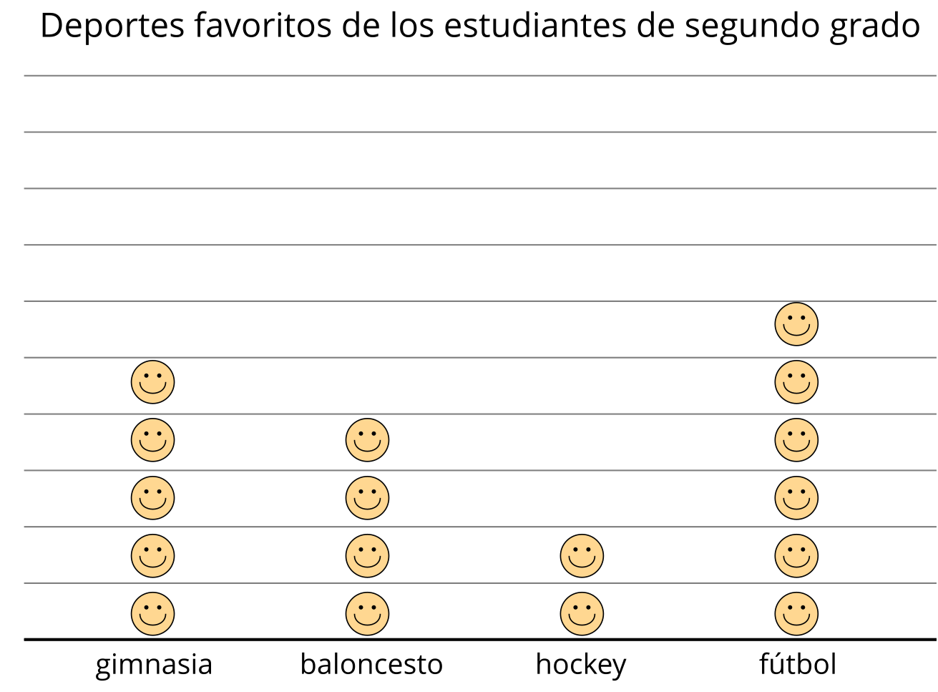
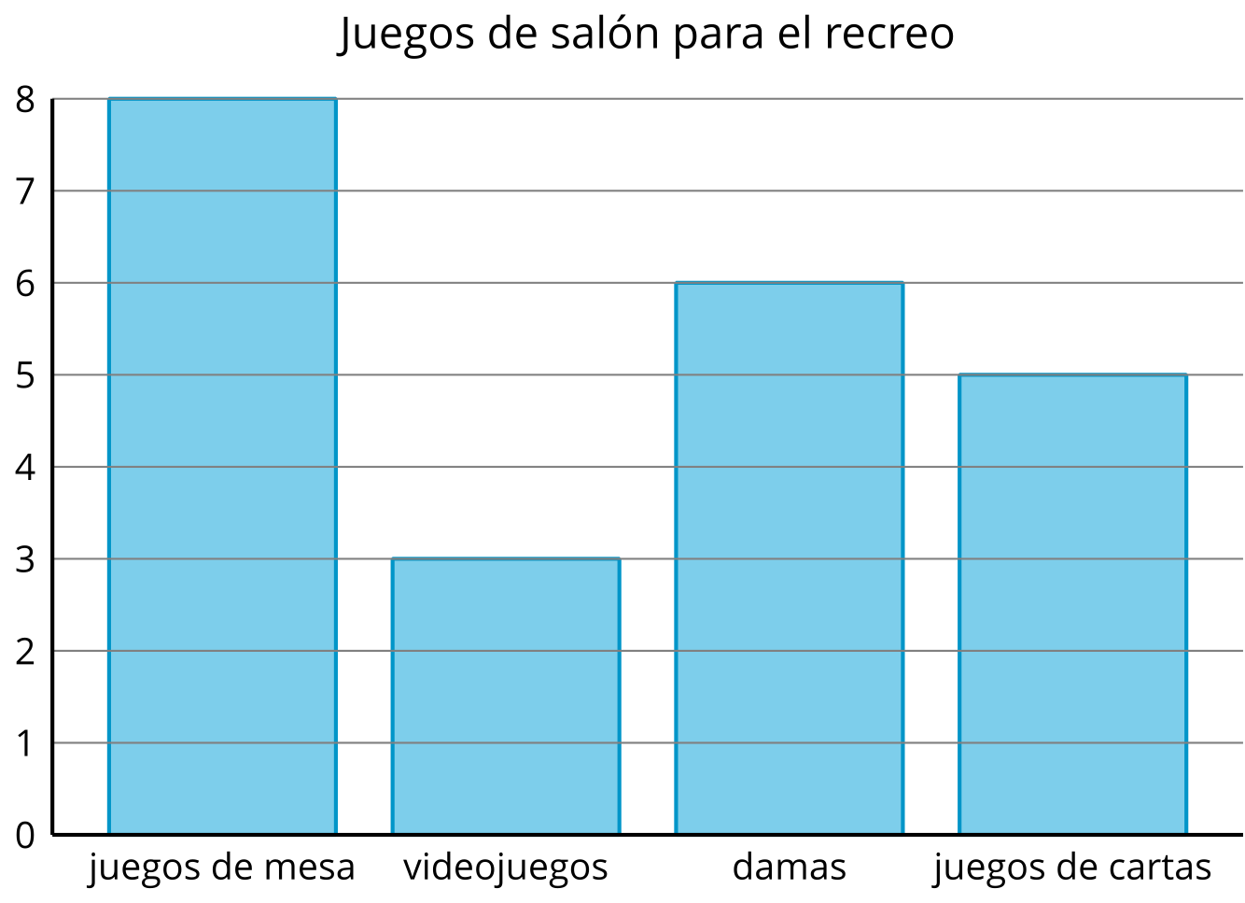
- ¿A cuántos estudiantes les gusta jugar fútbol? _______
- ¿Cuántos estudiantes escogieron la opción de juegos de mesa? _______
- ¿Cuál gráfica se usó para representar el número de estudiantes a los que les gusta el baloncesto?
- Marca una:
- Gráfica de dibujos
- Gráfica de barras
- ¿Cuál gráfica es sobre juegos de salón?
- Marca una:
- Gráfica de dibujos
- Gráfica de barras

Student Responses
- 6 students like to play soccer.
- 8 students like to play board games.
- picture graph
- bar graph

