Lesson 10: Graphs of Functions in Standard and Factored Forms
- Let’s find out what quadratic expressions in standard and factored forms can reveal about the properties of their graphs.

10.1: A Linear Equation and Its Graph
Here is a graph of the equation $y=8−2x$.
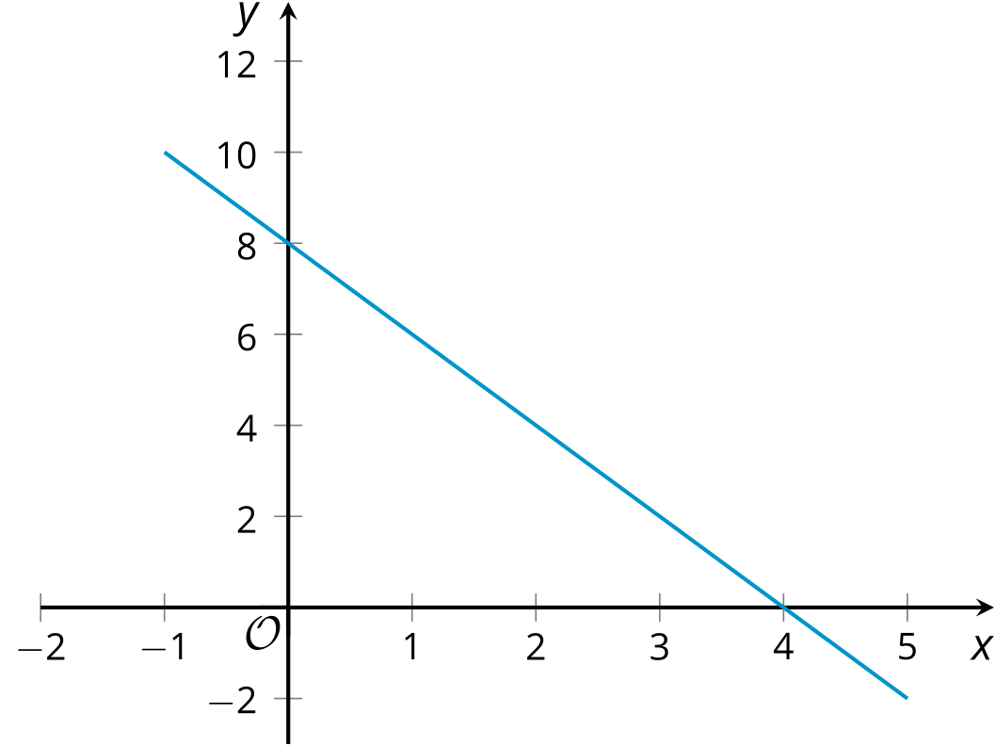
- Where do you see the 8 from the equation in the graph?
- Where do you see the -2 from the equation in the graph?
- What is the $x$-intercept of the graph? How does this relate to the equation?

10.2: Revisiting Projectile Motion
In an earlier lesson, we saw that an equation such as $h\left(t\right)=10+78t−16t^{2}$ can model the height of an object thrown upward from a height of 10 feet with a vertical velocity of 78 feet per second.
- Is the expression $10+78t−16t^{2}$ written in standard form? Explain how you know.
- Jada said that the equation $g\left(t\right)=\left(\text{-}16t−2\right)\left(t−5\right)$ also defines the same function, written in factored form. Show that Jada is correct.
- Here is a graph representing both $g\left(t\right)=\left(\text{-}16t−2\right)\left(t−5\right)$ and $h\left(t\right)=10+78t−16t^{2}$.
- 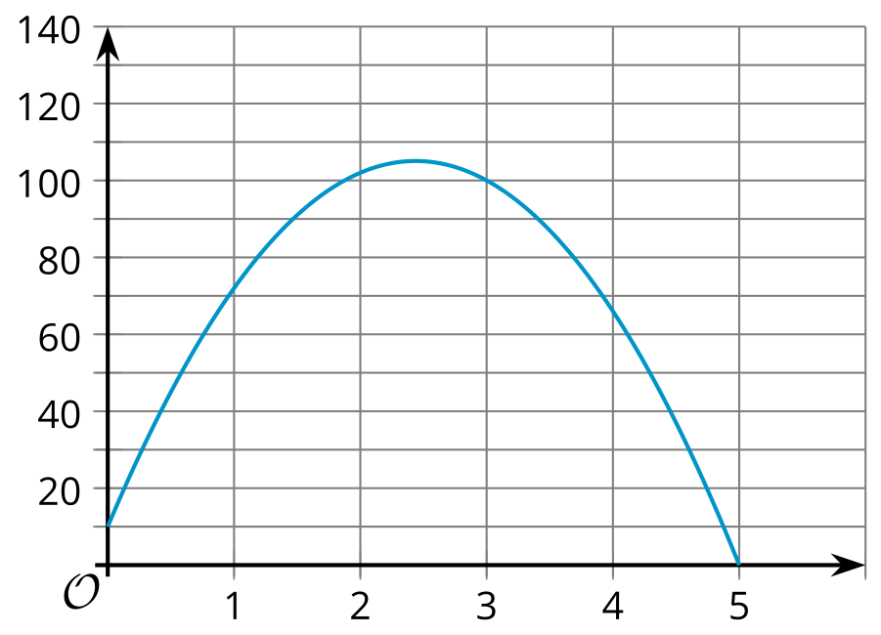
  - Identify or approximate the vertical and horizontal intercepts.
  - What do each of these points mean in this situation?

10.3: Relating Expressions and Their Graphs
Here are pairs of expressions in standard and factored forms. Each pair of expressions define the same quadratic function, which can be represented with the given graph.
- Identify the $x$-intercepts and the $y$-intercept of each graph.
- Function $f$
- $x^{2}+4x+3$
- $\left(x+3\right)\left(x+1\right)$
- 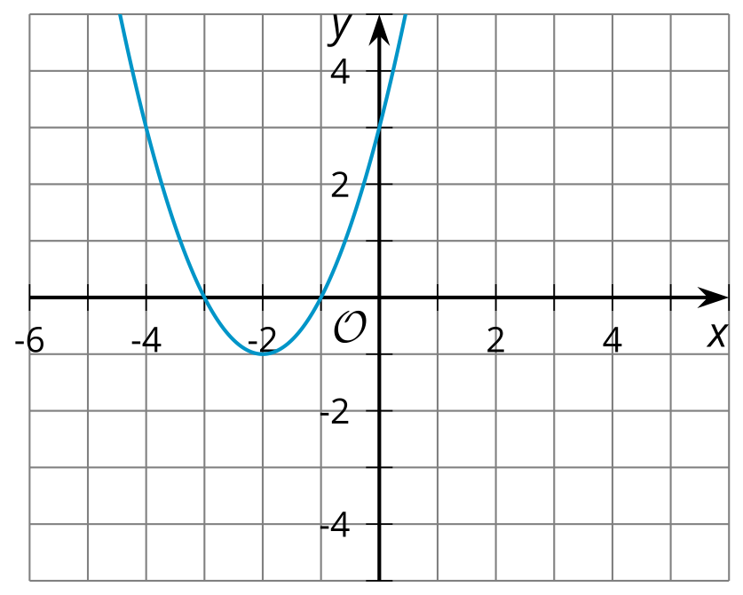
- $x$-intercepts:
- $y$-intercept:
- Function $g$
- $x^{2}−5x+4$
- $\left(x−4\right)\left(x−1\right)$
- 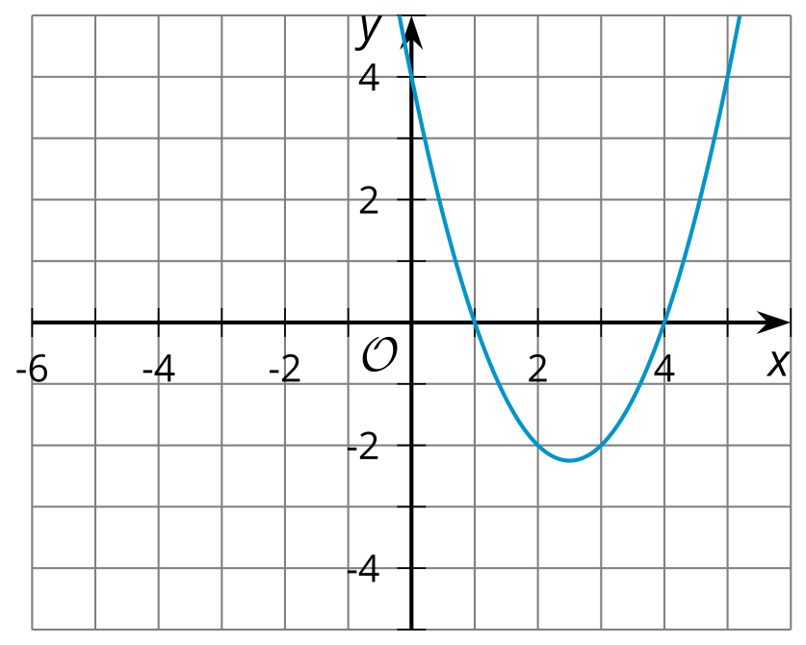
- $x$-intercepts:
- $y$-intercept:
- Function $h$
- $x^{2}−9$
- $\left(x−3\right)\left(x+3\right)$
- 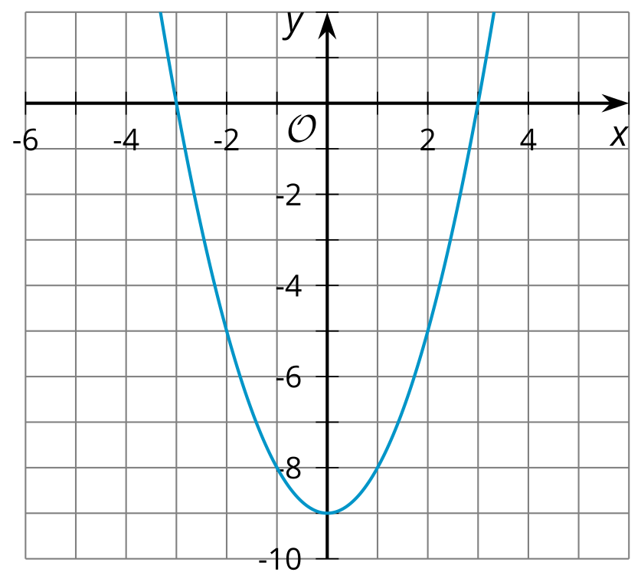
- $x$-intercepts:
- $y$-intercept:
- Function $i$
- $x^{2}−5x$
- $x\left(x−5\right)$
- 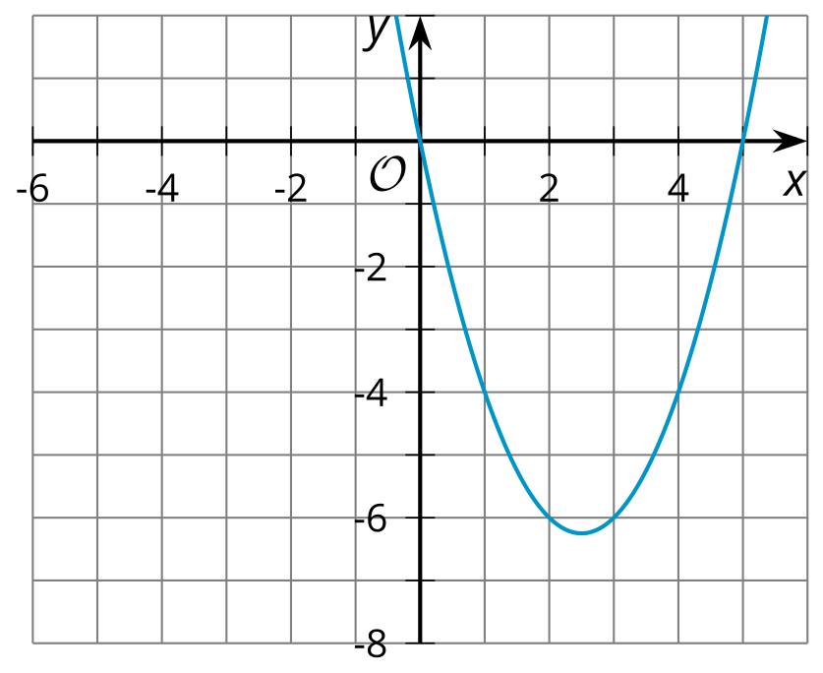
- $x$-intercepts:
- $y$-intercept:
- Function $j$
- $5x−x^{2}$
- $x\left(5−x\right)$
- 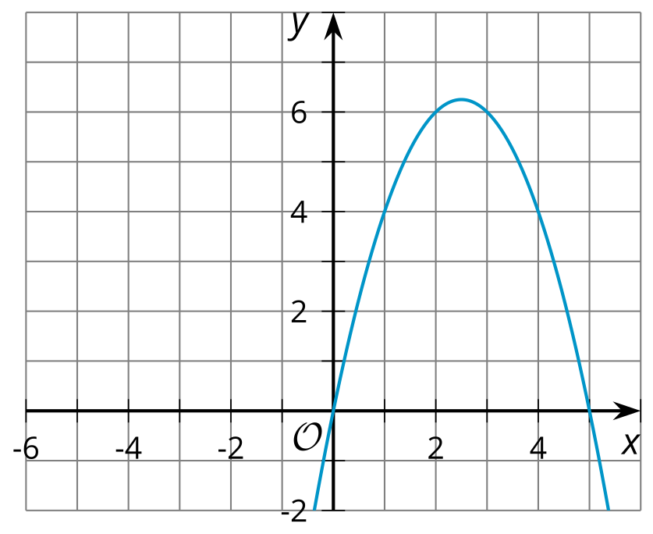
- $x$-intercepts:
- $y$-intercept:
- Function $k$
- $x^{2}+4x+4$
- $\left(x+2\right)\left(x+2\right)$
- 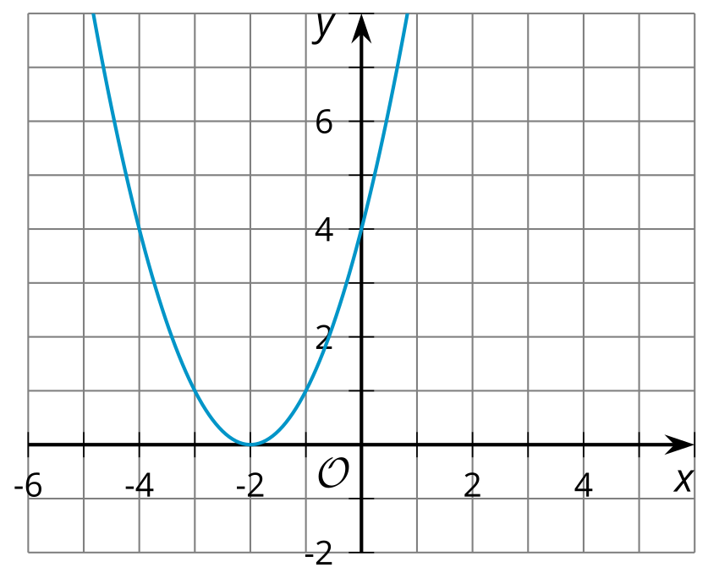
- $x$-intercepts:
- $y$-intercept:
- What do you notice about the $x$-intercepts, the $y$-intercept, and the numbers in the expressions defining each function? Make a couple of observations.
- Here is an expression that models function $p$, another quadratic function: $\left(x−9\right)\left(x−1\right)$. Predict the $x$-intercepts and the $y$-intercept of the graph that represent this function.

Are you ready for more?
Find the values of $a$, $p$, and $q$ that will make $y=a\left(x−p\right)\left(x−q\right)$ be the equation represented by the graph.
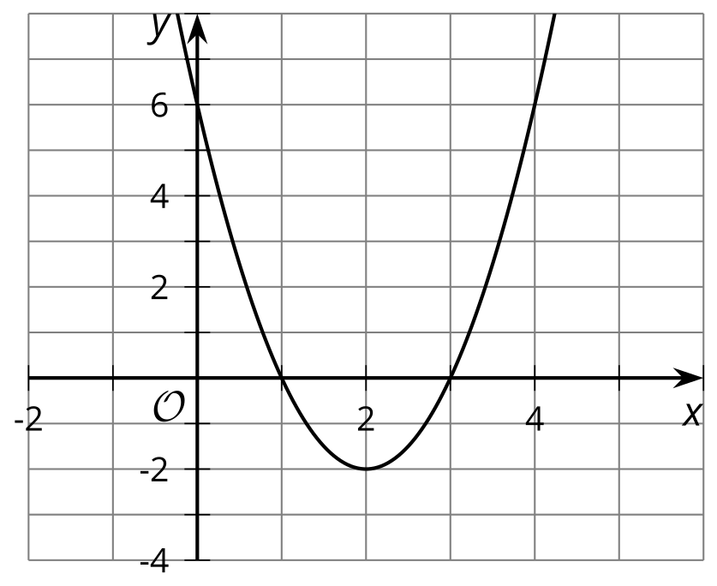

Lesson 10 Summary
Different forms of quadratic functions can tell us interesting information about the function’s graph. When a quadratic function is expressed in standard form, it can tell us the $y$-intercept of the graph representing the function. For example, the graph representing $y=x^{2}−5x+7$ has its $y$-intercept $\left(0,7\right)$. This makes sense because the $y$-coordinate is the $y$-value when $x$ is 0. Evaluating the expression at $x=0$ gives $y=0^{2}−5\left(0\right)+7$, which equals 7.
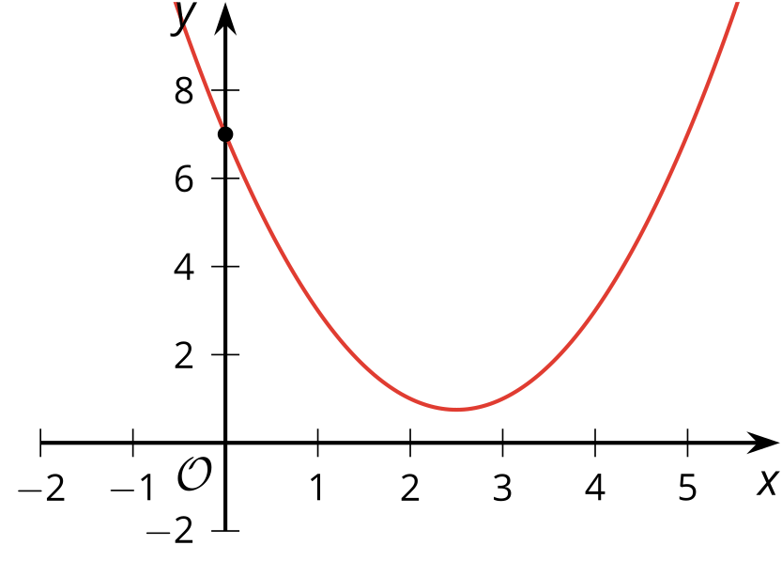
When a function is expressed in factored form, it can help us see the $x$-intercepts of its graph. Let’s look at the functions $f$ given by $f\left(x\right)=\left(x−4\right)\left(x−1\right)$ and $g$ given by $g\left(x\right)=\left(x+2\right)\left(x+6\right)$.
If we graph $y=f\left(x\right)$, we see that the $x$-intercepts of the graph are $\left(1,0\right)$ and $\left(4,0\right)$. Notice that “1” and “4” also appear in $f\left(x\right)=\left(x−4\right)\left(x−1\right)$, and they are subtracted from $x$.
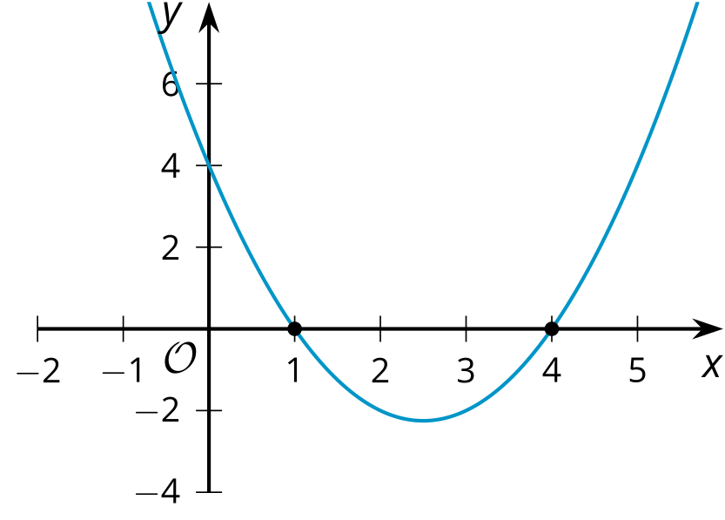
If we graph $y=g\left(x\right)$, we see that the $x$-intercepts are at $\left(\text{-}2,0\right)$ and $\left(\text{-}6,0\right)$. Notice that “2” and “6” are also in the equation $g\left(x\right)=\left(x+2\right)\left(x+6\right)$, but they are added to $x$.
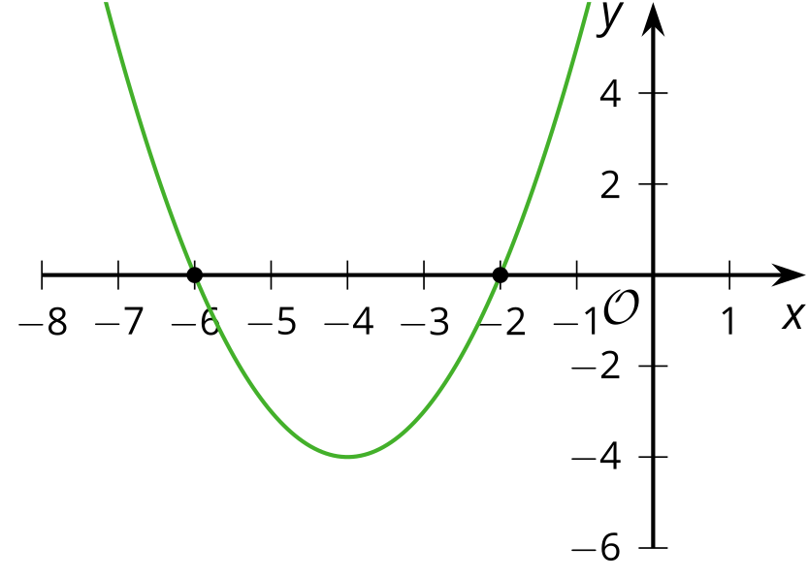
The connection between the factored form and the $x$-intercepts of the graph tells us about the zeros of the function (the input values that produce an output of 0). In the next lesson, we will further explore these connections between different forms of quadratic expressions and the graphs representing them.
© CC BY 2019 by Illustrative Mathematics®

