Lesson 13: Dividamos usando cocientes parciales

Standards Alignments
Addressing | 5.NBT.B.6

Teacher-facing Learning Goals
- Divide three-digit and four-digit dividends by two-digit divisors using an algorithm using partial quotients.

Student-facing Learning Goals
- Usemos un algoritmo de cocientes parciales para dividir dividendos de tres y cuatro dígitos entre divisores de dos dígitos.

Lesson Purpose
The purpose of this lesson is for students to deepen their understanding of an algorithm using partial quotients and use it to divide up to four-digit dividends by two-digit divisors.
In previous lessons, students compared different strategies to divide multi-digit numbers and learned to use an algorithm using partial quotients for division. In this lesson they refine strategies for using an algorithm using partial quotients. In the first activity, students compare their strategies, giving them an opportunity both to explain why they chose their partial quotients and to see that different choices are possible. In the second activity, they begin by estimating the value of the quotient and then use the estimate to help guide the partial quotients choices in the algorithm.

Access for:

Students with Disabilities
- Engagement (Activity 2)

English Learners
- MLR7 (Activity 2)

Instructional Routines
Number Talk (Warm-up)

Lesson Timeline
Warm-up | 10 min
Activity 1 | 20 min
Activity 2 | 15 min
Lesson Synthesis | 10 min
Cool-down | 5 min

Teacher Reflection Question
Reflect on who participated in math class today. What assumptions are you making about those who did not participate? How can you leverage each of your students’ ideas to support them in being seen and heard in tomorrow’s math class?

Cool-down
(to be completed at the end of the lesson) 5min
Divide usando cocientes parciales

Standards Alignments
Addressing | 5.NBT.B.6

Student-facing Task Statement
Encuentra el valor del cociente.
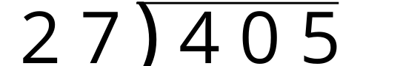

Student Responses
15. Sample response:
