Lesson 10: Usemos gráficas de dibujos y gráficas de barras para representar datos

Standards Alignments
Addressing | 2.MD.D.10

Teacher-facing Learning Goals
- Explain how picture graphs, bar graphs, and tables represent the same data.
- Represent data using a picture graph and a bar graph.

Student-facing Learning Goals
- Hagamos nuestras propias gráficas de dibujos y gráficas de barras.

Lesson Purpose
The purpose of this lesson is for students to attend to the features of picture graphs and bar graphs as they represent a given set of categorical data in picture graphs and bar graphs.
In the first activity, students are introduced to the idea of using one symbol in a picture graph rather than a picture based on the category. They may find it easier and more efficient to use a symbol when drawing their graphs. In the second activity, students attend to the features of bar graphs as they draw a bar graph to represent a given set of categorical data. The work of this lesson connects to upcoming lessons as students move from a discrete representation of numbers with the picture graph to a continuous representation of numbers with the bar graph. From there, students use bar graphs to help them understand tape diagrams in later lessons.
Students use the graphs they create in this lesson in the following lesson.

Access for:

Students with Disabilities
- Engagement (Activity 2)

Instructional Routines
MLR8 Discussion Supports (Activity 1), Which One Doesn’t Belong? (Warm-up)

Materials to Copy
- Data Tables, Spanish (groups of 6): Activity 1
- Picture and Bar Graph Template (groups of 1): Activity 1
- Picture and Bar Graph Template (groups of 1): Activity 2

Lesson Timeline
Warm-up | 10 min
Activity 1 | 20 min
Activity 2 | 15 min
Lesson Synthesis | 10 min
Cool-down | 5 min

Teacher Reflection Question
What was the best question you asked students today? Why would you consider it the best one based on what students said or did?

Cool-down
(to be completed at the end of the lesson) 5min
Gráficas de frutas que nos encantan

Standards Alignments
Addressing | 2.MD.D.10

Student-facing Task Statement
El señor Green le preguntó al equipo de fútbol: “¿Qué frutas les encanta comer?”.
Mai y Lin usaron los datos que él recolectó para hacer gráficas.
Mai empezó a hacer una gráfica de dibujos. Lin empezó a hacer una gráfica de barras.
Completa cada gráfica.
La gráfica de Mai
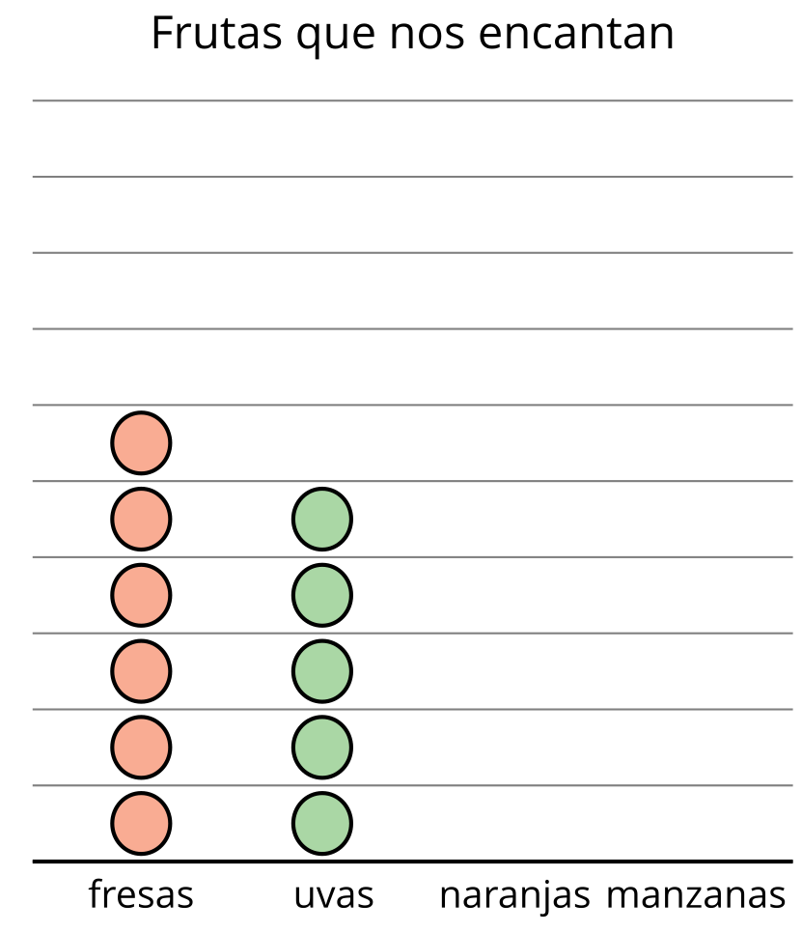
La gráfica de Lin
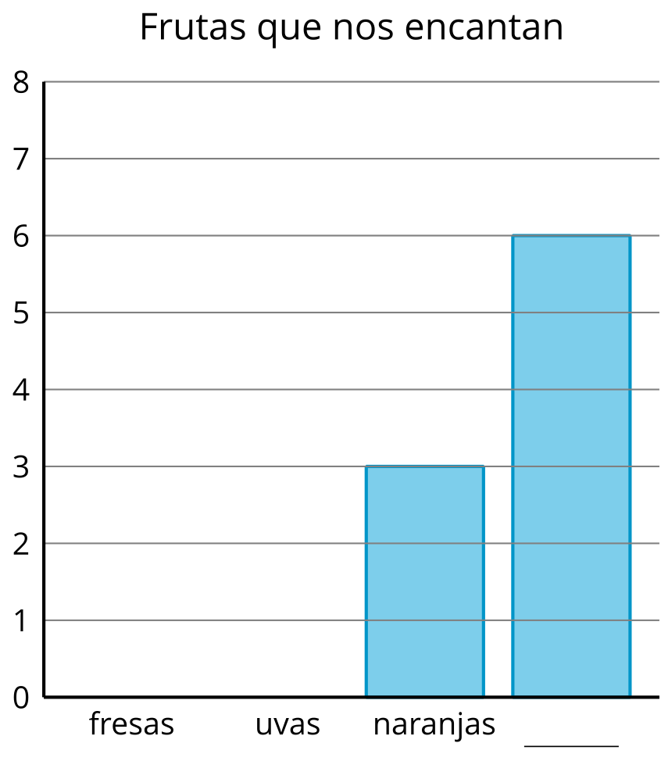

Student Responses
Students show 6 strawberries, 5 grapes, 3 oranges, and 6 apples in each graph.

