Lesson 3 Practice Problems
- This diagram is a straightedge and compass construction. $A$ is the center of one circle, and $B$ is the center of the other. Select all the true statements.
- 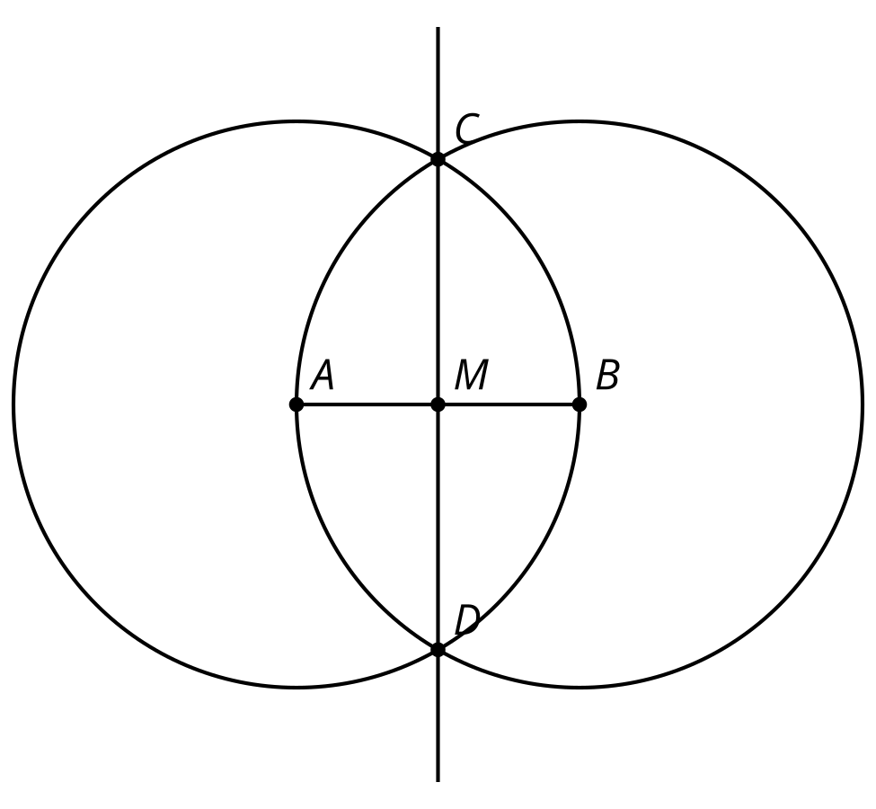
  - Line $CD$ is perpendicular to segment $AB$
  - Point $M$ is the midpoint of segment $AB$
  - The length $AB$ is the equal to the length $CD$.
  - Segment $AM$ is perpendicular to segment $BM$
  - $CB+BD>CD$
- In this diagram, line segment $CD$ is the perpendicular bisector of line segment $AB$. Assume the conjecture that the set of points equidistant from $A$ and $B$ is the perpendicular bisector of $AB$ is true. Is point $E$ closer to point $A$, closer to point $B$, or the same distance between the points? Explain how you know.

- $AB⊥CD$
- 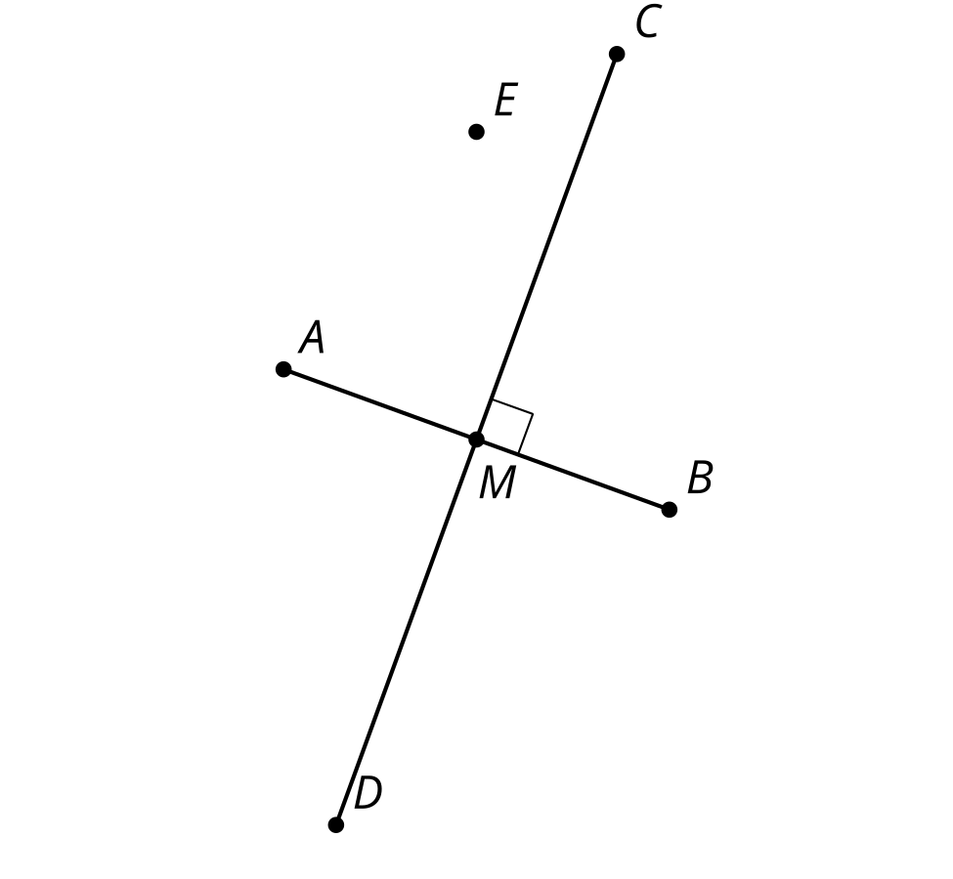

- Starting with 2 marked points, $A$ and $B$, precisely describe the straightedge and compass moves required to construct the triangle $ABC$ in this diagram.
- 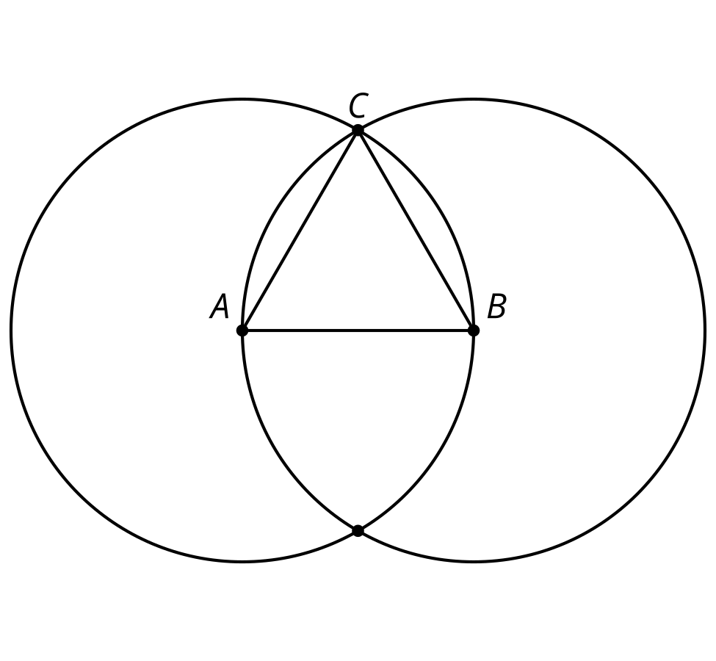
- (From Unit 1, Lesson 2.)
- This diagram was created by starting with points $C$ and $D$ and using only straightedge and compass to construct the rest. All steps of the construction are visible. Select all the steps needed to produce this diagram.
- 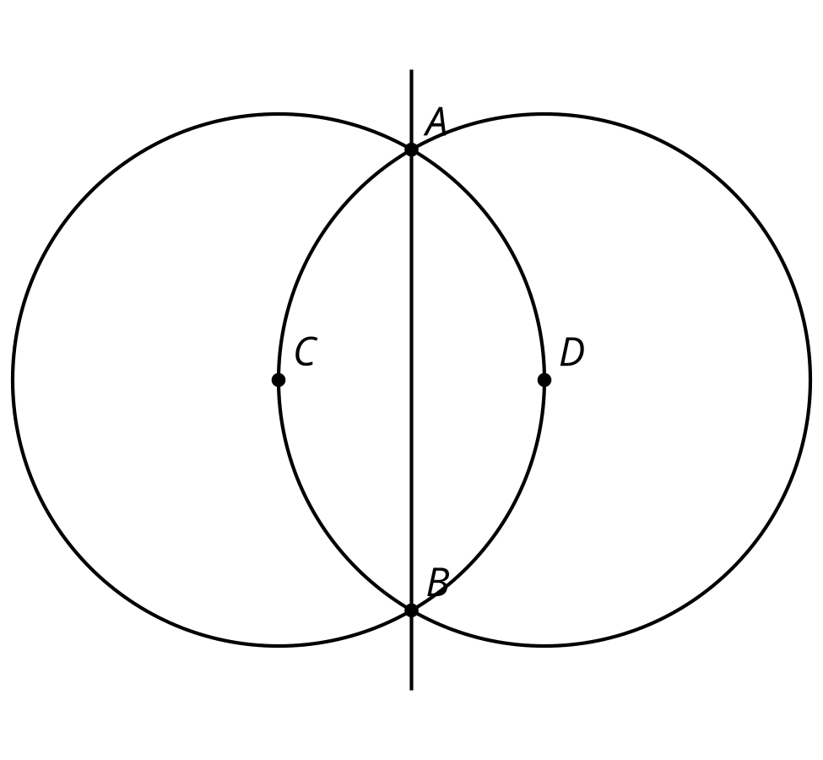
  - Construct a circle centered at $A$.
  - Construct a circle centered at $C$.
  - Construct a circle centered at $D$.
  - Label the intersection points of the circles $A$ and $B$.
  - Draw the line through points $C$ and $D$.
  - Draw the line through points $A$ and $B$.
- (From Unit 1, Lesson 2.)
- This diagram was constructed with straightedge and compass tools. $A$ is the center of one circle, and $C$ is the center of the other. Select all true statements.
- 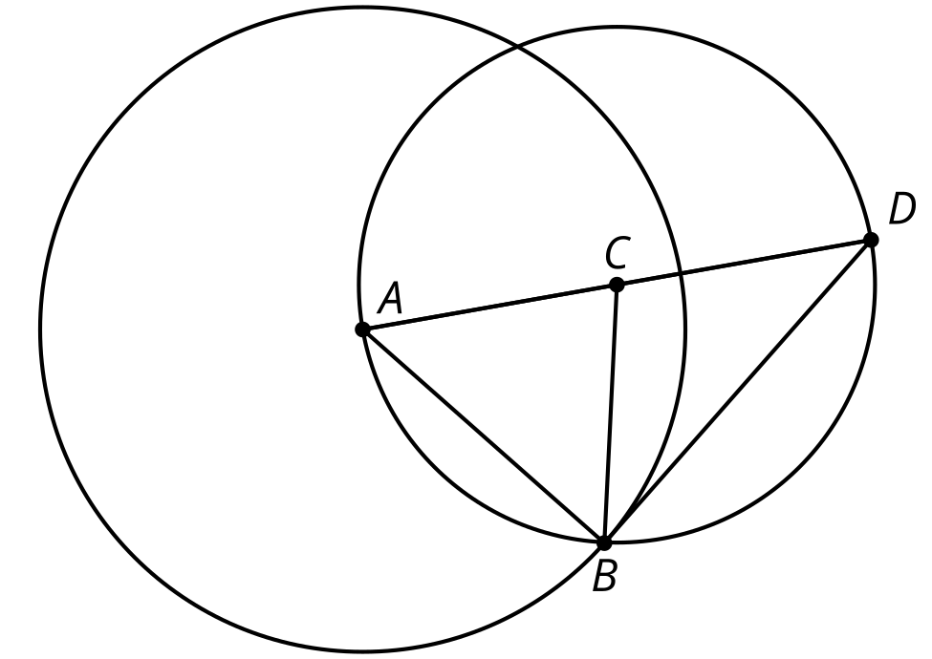
  - $AB=BC$
  - $AB=BD$
  - $AD=2AC$
  - $BC=CD$
  - $BD=CD$
- (From Unit 1, Lesson 1.)
© CC BY 2019 by Illustrative Mathematics®

