Lesson 9: Standard Form and Factored Form
- Let’s write quadratic expressions in different forms.

9.1: Math Talk: Opposites Attract
Solve each equation mentally.
$40−8=40+n$
$25+\text{-}100=25−n$
$3−\frac{1}{2}=3+n$
$72−n=72+6$

9.2: Finding Products of Differences
- Show that $\left(x−1\right)\left(x−1\right)$ and $x^{2}−2x+1$ are equivalent expressions by drawing a diagram or applying the distributive property. Show your reasoning.
- For each expression, write an equivalent expression. Show your reasoning.
  - $\left(x+1\right)\left(x−1\right)$
  - $\left(x−2\right)\left(x+3\right)$
  - ${\left(x−2\right)}^{2}$

9.3: What is the Standard Form? What is the Factored Form?
The quadratic expression $x^{2}+4x+3$ is written in standard form.
Here are some other quadratic expressions. The expressions on the left are written in standard form and the expressions on the right are not.
Written in standard form:
$x^{2}–1$
$x^{2}+9x$
$\frac{1}{2}x^{2}$
$4x^{2}–2x+5$
$\text{-}3x^{2}–x+6$
$1−x^{2}$
Not written in standard form:
$\left(2x+3\right)x$
$\left(x+1\right)\left(x−1\right)$
$3{\left(x−2\right)}^{2}+1$
$\text{-}4\left(x^{2}+x\right)+7$
$\left(x+8\right)\left(\text{-}x+5\right)$
- What are some characteristics of expressions in standard form?
- $\left(x+1\right)\left(x−1\right)$ and $\left(2x+3\right)x$ in the right column are quadratic expressions written in factored form. Why do you think that form is called factored form?

Are you ready for more?
What quadratic expression can be described as being both standard form and factored form? Explain how you know.

Lesson 9 Summary
A quadratic function can often be represented by many equivalent expressions. For example, a quadratic function $f$ might be defined by $f\left(x\right)=x^{2}+3x+2$. The quadratic expression $x^{2}+3x+2$ is called the standard form, the sum of a multiple of $x^{2}$ and a linear expression ($3x+2$ in this case).
In general, standard form is $ax^{2}+bx+c$
We refer to $a$ as the coefficient of the squared term $x^{2}$, $b$ as the coefficient of the linear term $x$, and $c$ as the constant term.
The function $f$ can also be defined by the equivalent expression $\left(x+2\right)\left(x+1\right)$. When the quadratic expression is a product of two factors where each one is a linear expression, this is called the factored form.
An expression in factored form can be rewritten in standard form by expanding it, which means multiplying out the factors. In a previous lesson we saw how to use a diagram and to apply the distributive property to multiply two linear expressions, such as $\left(x+3\right)\left(x+2\right)$. We can do the same to expand an expression with a sum and a difference, such as $\left(x+5\right)\left(x−2\right)$, or to expand an expression with two differences, for example, $\left(x−4\right)\left(x−1\right)$.
To represent $\left(x−4\right)\left(x−1\right)$ with a diagram, we can think of subtraction as adding the opposite:
 | $x$ | $\text{-}4$
$x$ | $x^{2}$ | $\text{-}4x$
$\text{-}1$ | $\text{-}x$ | $4$
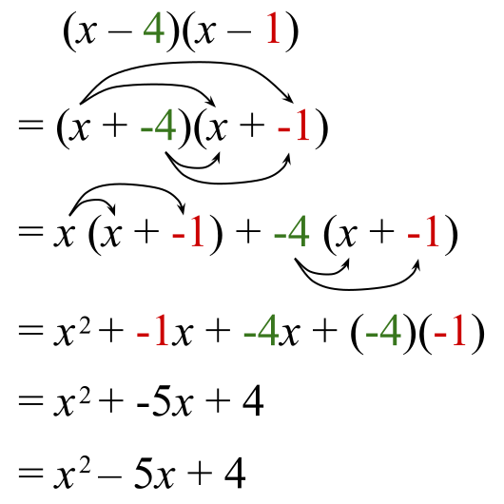
© CC BY 2019 by Illustrative Mathematics®

