Lesson 2: Formemos centenas

Standards Alignments
Addressing | 2.NBT.A.1.a, 2.NBT.A.1.b, 2.NBT.A.2

Teacher-facing Learning Goals
- Read, write, and represent multiples of 100.

Student-facing Learning Goals
- Representemos centenas de distintas formas.

Lesson Purpose
The purpose of this lesson is for students to represent hundreds in different ways.
In a previous lesson, students learned that a hundred is composed of 10 tens or 100 ones.
In this lesson, students deepen their understanding of a hundred as a unit. They learn that for every 10 tens, they can compose 1 hundred. Students notice that it may be easier to count the hundreds rather than count the tens to find a total value. Students begin to recognize and describe the patterns in the structure of the base-ten system (MP7, MP8). They recognize that 10 tens make 1 hundred, 30 tens make 3 hundreds, 60 tens make 6 hundreds, etc. as they build numbers with tens and exchange them for hundreds. Students identify the multiples of 100 written as numerals and begin to make connections between base-ten blocks and the value of each digit in a three-digit number.

Access for:

Students with Disabilities
- Action and Expression (Activity 2)

English Learners
- MLR8 (Activity 1)

Instructional Routines
Choral Count (Warm-up)

Materials to Gather
- Base-ten blocks: Activity 1, Activity 2

Lesson Timeline
Warm-up | 10 min
Activity 1 | 20 min
Activity 2 | 15 min
Lesson Synthesis | 10 min
Cool-down | 5 min

Teacher Reflection Question
As students worked in their small groups today, whose ideas were heard, valued, and accepted? How can you adjust the group structure tomorrow to ensure each student’s ideas are a part of the collective learning?

Cool-down
(to be completed at the end of the lesson) 5min
¿Cuántos?

Standards Alignments
Addressing | 2.NBT.A.1.a, 2.NBT.A.1.b

Student-facing Task Statement
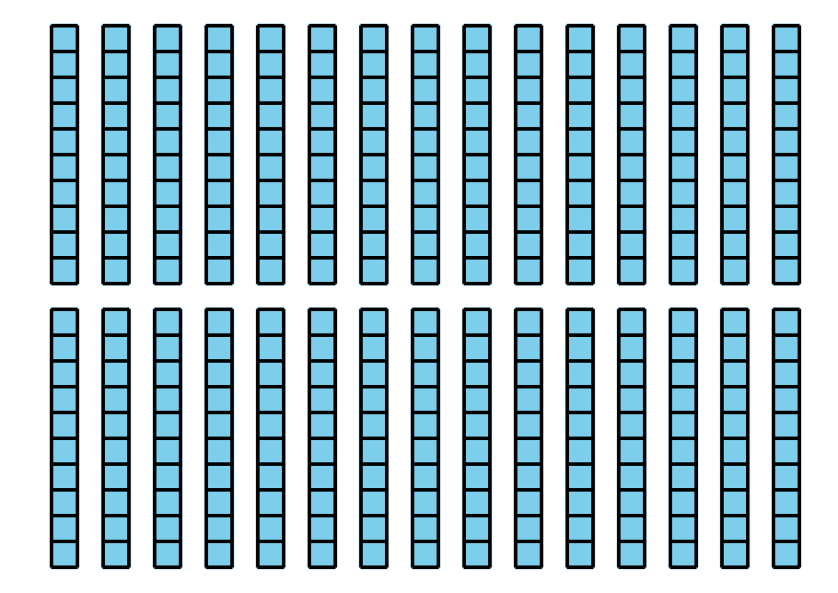
- ¿Cuántos ves? _______________
- ¿Cómo puedes representar el mismo valor de otra forma? Muestra cómo pensaste. Usa un diagrama o palabras.

Student Responses
- Answers vary. Sample responses:
  - 30 tens
  - 300
  - 3 hundreds
- Sample response: Students draw 3 squares and label or explain them as 3 hundreds.

