Unit 6 Lesson 7: Tax and Tip

1 Notice and Wonder: The Price of Sunglasses (Warm up)

Student Task Statement
You are on vacation and want to buy a pair of sunglasses for $10 or less. You find a pair with a price tag of $10. The cashier says the total cost will be $10.45.
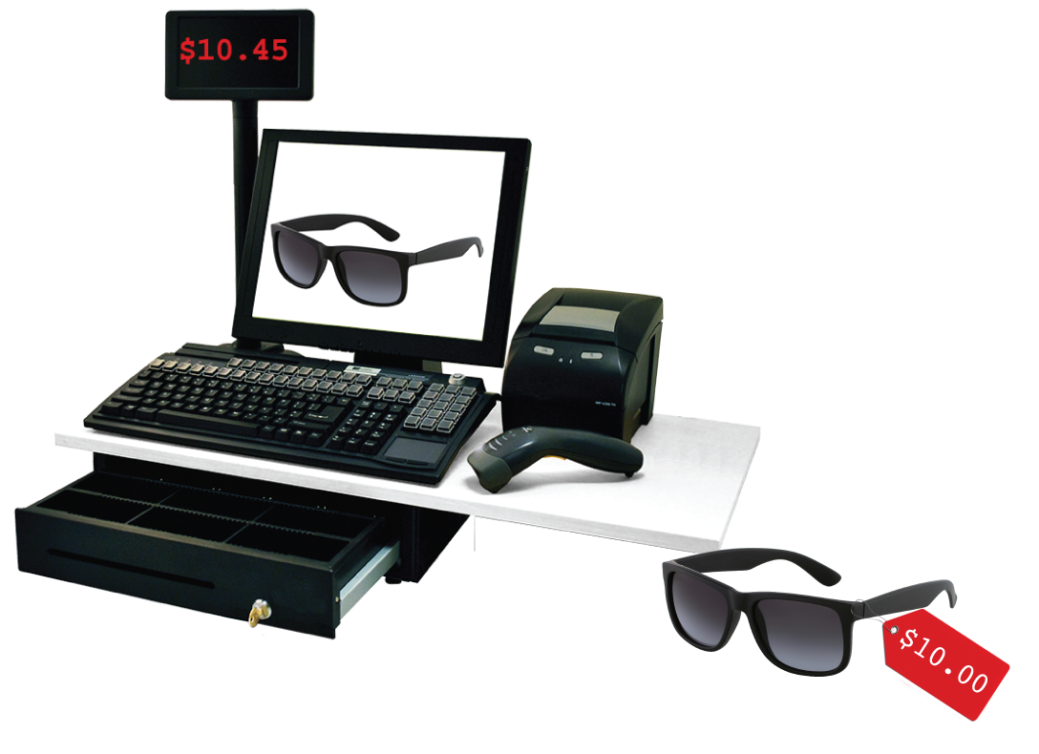
What do you notice? What do you wonder?

2 Shopping in Two Different Cities

Student Task Statement
Different cities have different sales tax rates. Here are the sales tax charges on the same items in two different cities. Complete the tables.
City 1
item | price  (dollars) | sales tax  (dollars) | total cost  (dollars)
paper towels | 8.00 | 0.48 | 8.48
lamp | 25.00 | 1.50
pack of gum | 1.00
laundry soap | 12.00
 | $x$

City 2
item | price  (dollars) | sales tax  (dollars) | total cost  (dollars)
paper towels | 8.00 | 0.64 | 8.64
lamp | 25.00 | 2.00
pack of gum | 1.00
laundry soap | 12.00
 | $x$

3 Shopping in a Third City (Optional)

Student Task Statement
Here is the sales tax on the same items in City 3.
item | price  (dollars) | sales tax  (dollars)
paper towels | 8.00 | 0.58
lamp | 25.00 | 1.83
pack of gum | 1.00 | 0.07
laundry soap | 12.00
- What is the tax rate in this city?
- For the sales tax on the laundry soap, Kiran says it should be $0.84. Lin says it should be $0.87. Do you agree with either of them? Explain your reasoning.

4 Dining at a Restaurant

Student Task Statement
- Jada has a meal in a restaurant. She adds up the prices listed on the menu for everything they ordered and gets a subtotal of $42.00.
- 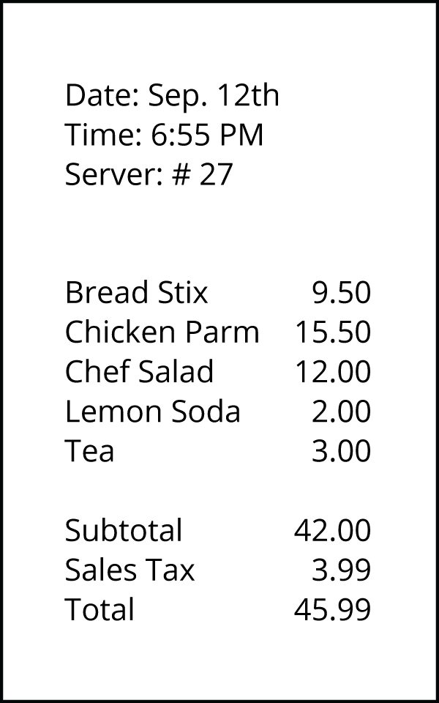
  - When the check comes, it says they also need to pay $3.99 in sales tax. What percentage of the subtotal is the sales tax?
  - After tax, the total is $45.99. What percentage of the subtotal is the total?
  - They actually pay $52.99. The additional $7 is a tip for the server. What percentage of the subtotal is the tip?
- The tax rate at this restaurant is 9.5%.
- 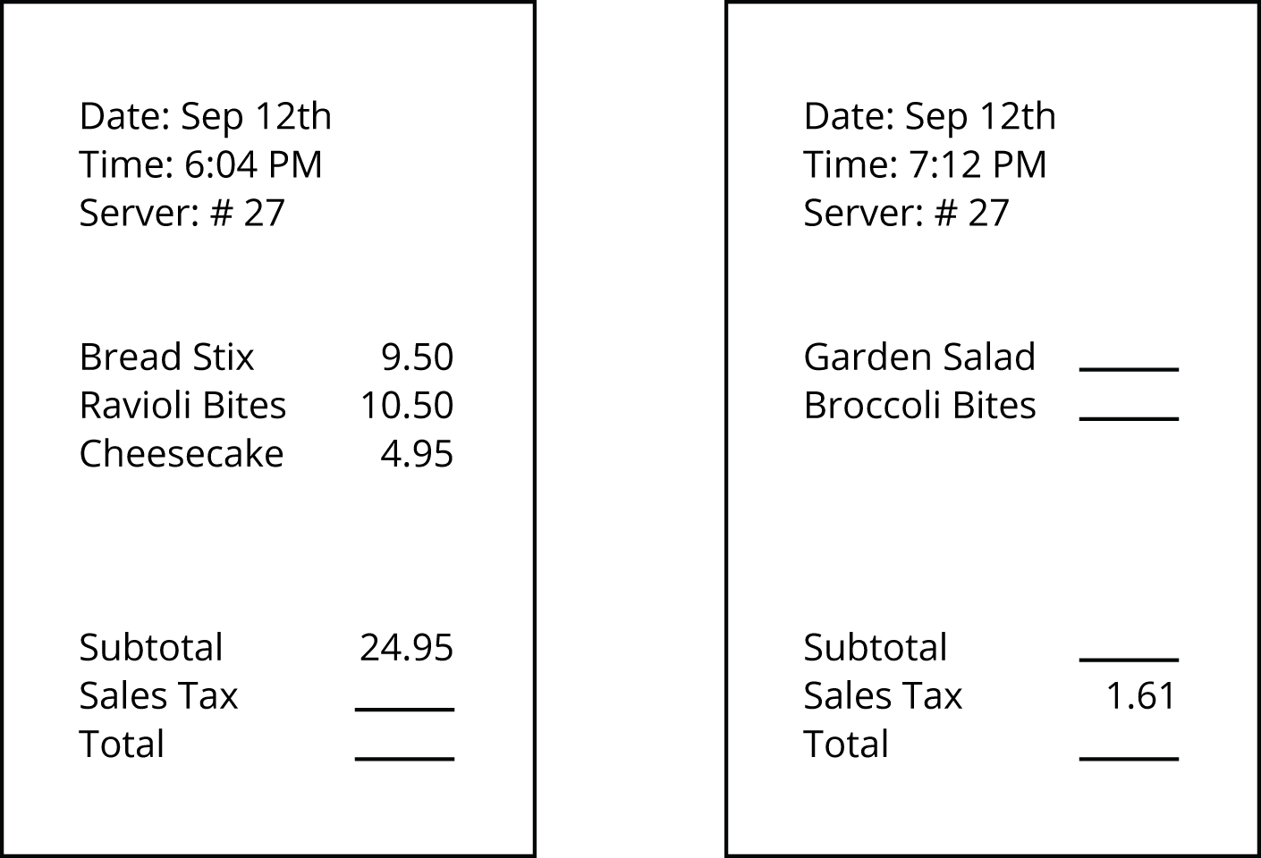
- Another person’s subtotal is $24.95. How much will their sales tax be?
- Some other person’s sales tax is $1.61. How much was their subtotal?
© CC BY Open Up Resources. Adaptations CC BY IM.

