Lesson 9: Interpretemos gráficas de barras

Standards Alignments
Addressing | 2.MD.D.10
Building Towards | 2.MD.D.10

Teacher-facing Learning Goals
- Answer questions based on a bar graph.
- Interpret data represented in a bar graph.

Student-facing Learning Goals
- Interpretemos datos en gráficas de barras.

Lesson Purpose
The purpose of this lesson is for students to interpret data in a bar graph in order to answer questions.
In previous lessons, students learned how to interpret categorical data represented in picture graphs and other displays. In this lesson, bar graphs are introduced as another way to represent categorical data. Students compare the features of bar graphs to picture graphs and use the unique features of bar graphs to interpret data and answer questions. When students relate the data to the context it represents and carefully interpret the elements of a graph, they reason abstractly and quantitatively and attend to precision (MP2, MP6).

Access for:

Students with Disabilities
- Action and Expression (Activity 1)

Instructional Routines
MLR6 Three Reads (Activity 2), Notice and Wonder (Warm-up)

Lesson Timeline
Warm-up | 10 min
Activity 1 | 15 min
Activity 2 | 20 min
Lesson Synthesis | 10 min
Cool-down | 5 min

Teacher Reflection Question
The scale of the bar graph will be important as students solve problems based on data. How did you see students using the scale on the bar graph today?

Cool-down
(to be completed at the end of the lesson) 5min
Animales en el zoológico

Standards Alignments
Addressing | 2.MD.D.10

Student-facing Task Statement
Un cuidador de animales del zoológico contó el número de leones, guepardos, monos y cebras en el zoológico. Los datos del cuidador de animales se muestran en esta gráfica de barras.
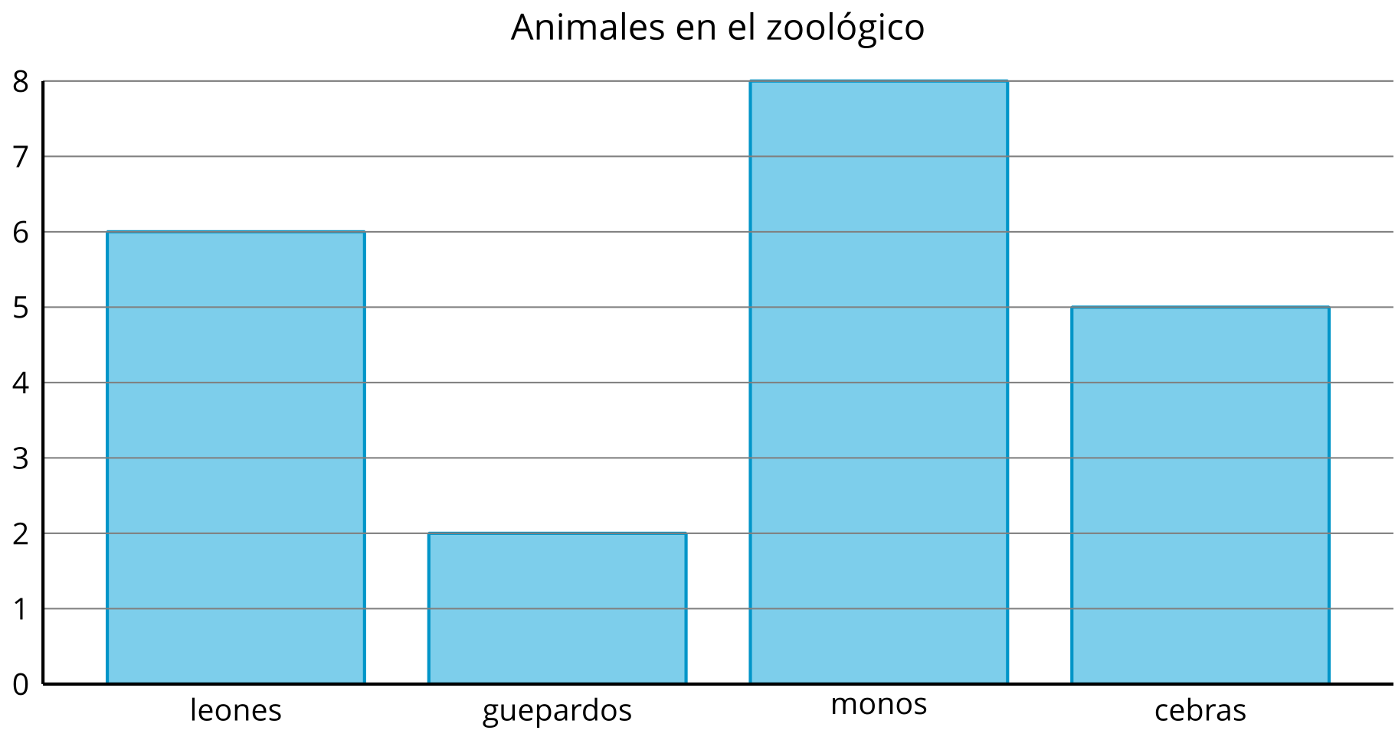
- ¿Cuántos monos había en el zoológico? __________
- ¿Cuántos leones había en el zoológico? ___________
- ¿Cuál es el número total de guepardos y cebras juntos? __________

Student Responses
- 8
- 6
- 7

