Unit 5 Lesson 16: Surface Area and Volume

1 Maximize Area (Warm up)

Student Task Statement
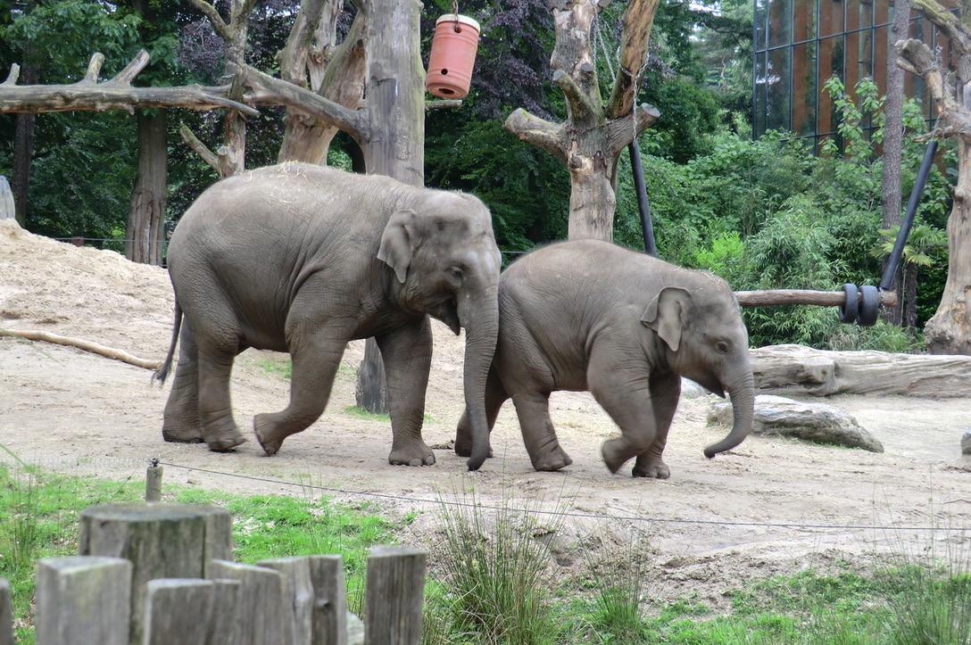
The zoo wants to give the elephants as much space as possible in a rectangular enclosure meant for feeding. The zoo has 180 feet of fencing. What should the dimensions of the rectangle be? Be prepared to share your reasoning.

2 Maximize in Three Dimensions

Student Task Statement
- Find a set of dimensions for a rectangular prism with volume 60 cubic units. Calculate the surface area of your prism. Add your data to the class chart.
- A lithium ion battery contains a rectangular prism made of lithium. The energy in the battery is proportional to the surface area of this prism. Assume the lithium has a fixed volume of 60 cubic millimeters. Find the dimensions of a rectangular prism with this volume that maximizes its surface area. What is its surface area?

3 Assume a Spherical Elephant

Student Task Statement
For a sphere with radius $r$, its volume is $\frac{4}{3}πr^{3}$ and its surface area is $4πr^{2}$.
- Let’s model an elephant with a sphere that has a radius of 4.5 feet.
  - What is the volume of the elephant?
  - What is the surface area of the elephant?
- Let’s model a snake with a cylinder of length 3 feet and diameter 0.2 feet.
  - What is the volume of the snake?
  - What is the surface area of the snake?
- Compute the surface area to volume ratio, or $\frac{SA}{V}$, for each animal.

4 Measuring Strength (Optional)

Student Task Statement
Suppose a human is a sphere with a radius of 1 unit, an ant is a sphere with a radius of $\frac{1}{200}$ unit, and an elephant is a sphere with a radius of 5 units.
- The raw strength of a living creature is the cross-sectional area of its muscles. The cross section of each of our spherical beings is a circle of radius $r$ where $r$ is the creature’s radius. Order the human, ant, and elephant by their raw strength from least to greatest. Show your reasoning.
- Relative strength is given by the ratio of raw strength to volume. It measures how strong a creature is for its size. Create an expression for the relative strength of a spherical being with radius $r$. (Remember that the raw strength formula is $πr^{2}$ and the volume formula for a sphere is $\frac{4}{3}πr^{3}$.)
- Order the human, the ant, and the elephant by their relative strength. Which is the strongest for its size?
© CC BY 2019 by Illustrative Mathematics®

