Lesson 2 Practice Problems
- This diagram was created by starting with points $A$ and $B$ and using only straightedge and compass to construct the rest. All steps of the construction are visible. Describe precisely the straightedge and compass moves required to construct the line $CD$ in this diagram.
- 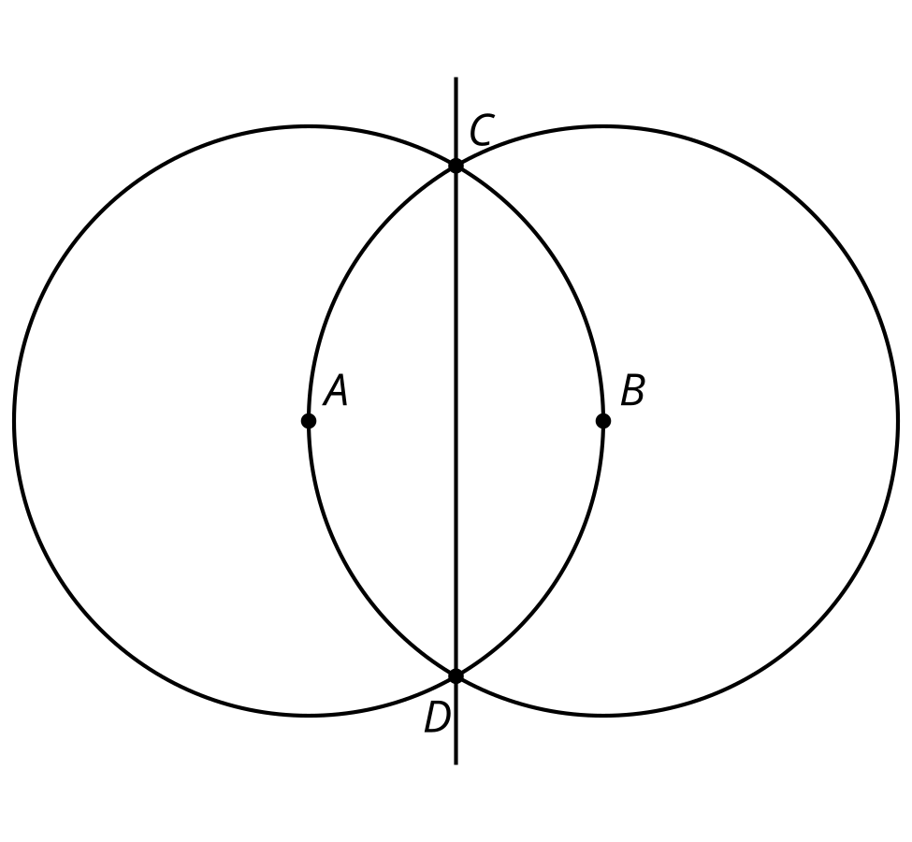
- In the construction, $A$ is the center of one circle, and $B$ is the center of the other. Identify all segments that have the same length as segment $AB$.
- 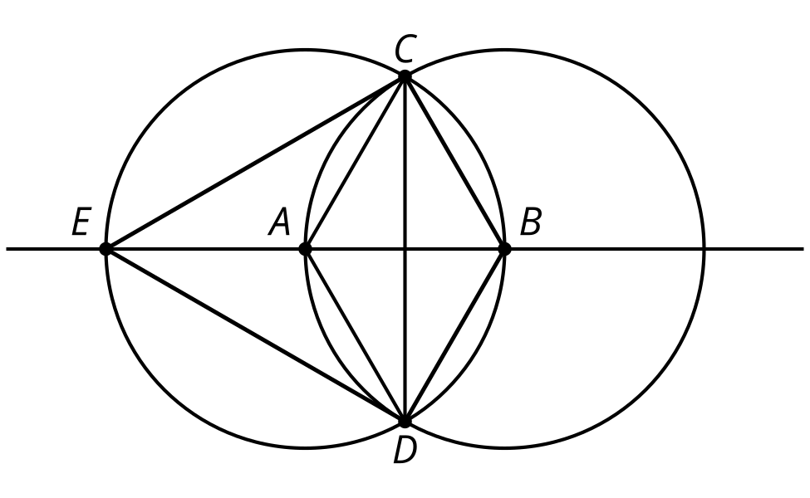
  - segment $AC$
  - segment $AE$
  - segment $BC$
  - segment $CD$
  - segment $DE$
- This diagram was constructed with straightedge and compass tools. $A$ is the center of one circle, and $C$ is the center of the other. Select all line segments that must have the same length as segment $AB$.
- 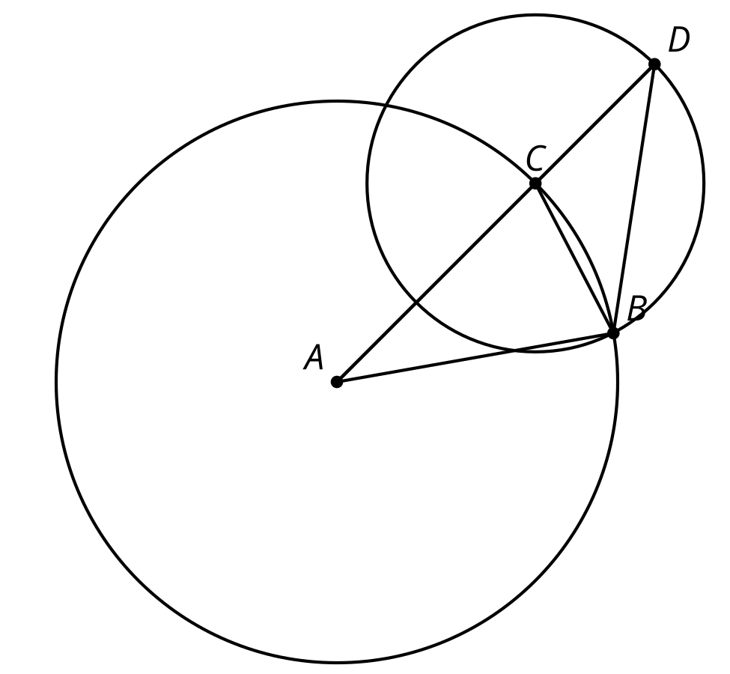
  - $AB$
  - $AC$
  - $BC$
  - $BD$
  - $CD$
- (From Unit 1, Lesson 1.)
- Clare used a compass to make a circle with radius the same length as segment $AB$. She labeled the center $C$. Which statement must be true?
- 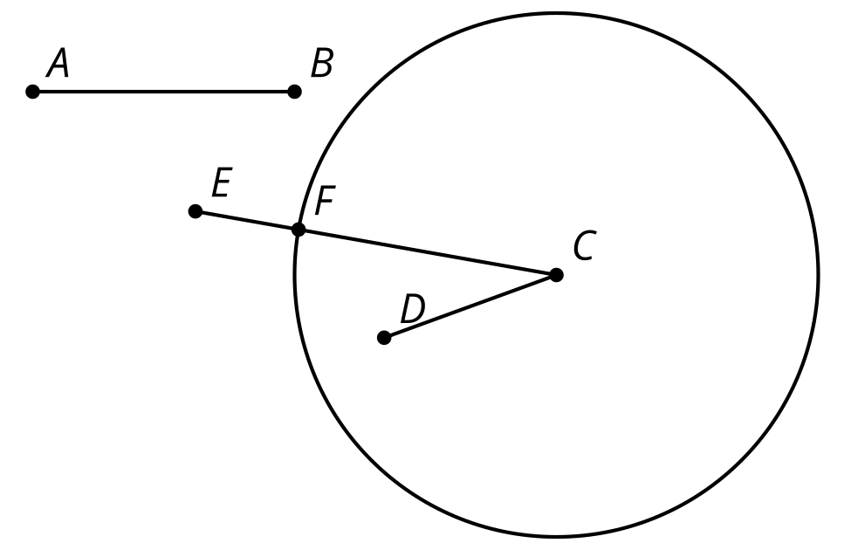
  - $AB=CD$
  - $AB=CE$
  - $AB=CF$
  - $AB=EF$
- (From Unit 1, Lesson 1.)
© CC BY 2019 by Illustrative Mathematics®

