Lesson 20: Writing and Solving Inequalities in One Variable
- Let’s solve problems by writing and solving inequalities in one variable.

20.1: Dinner for Drama Club
Kiran is getting dinner for his drama club on the evening of their final rehearsal. The budget for dinner is $60.
Kiran plans to buy some prepared dishes from a supermarket. The prepared dishes are sold by the pound, at $5.29 a pound. He also plans to buy two large bottles of sparkling water at $2.49 each.
- Represent the constraints in the situation mathematically. If you use variables, specify what each one means.
- How many pounds of prepared dishes can Kiran buy? Explain or show your reasoning.

20.2: Gasoline in the Tank
Han is about to mow some lawns in his neighborhood. His lawn mower has a 5-gallon fuel tank, but Han is not sure how much gasoline is in the tank.
He knows, however, that the lawn mower uses 0.4 gallon of gasoline per hour of mowing.
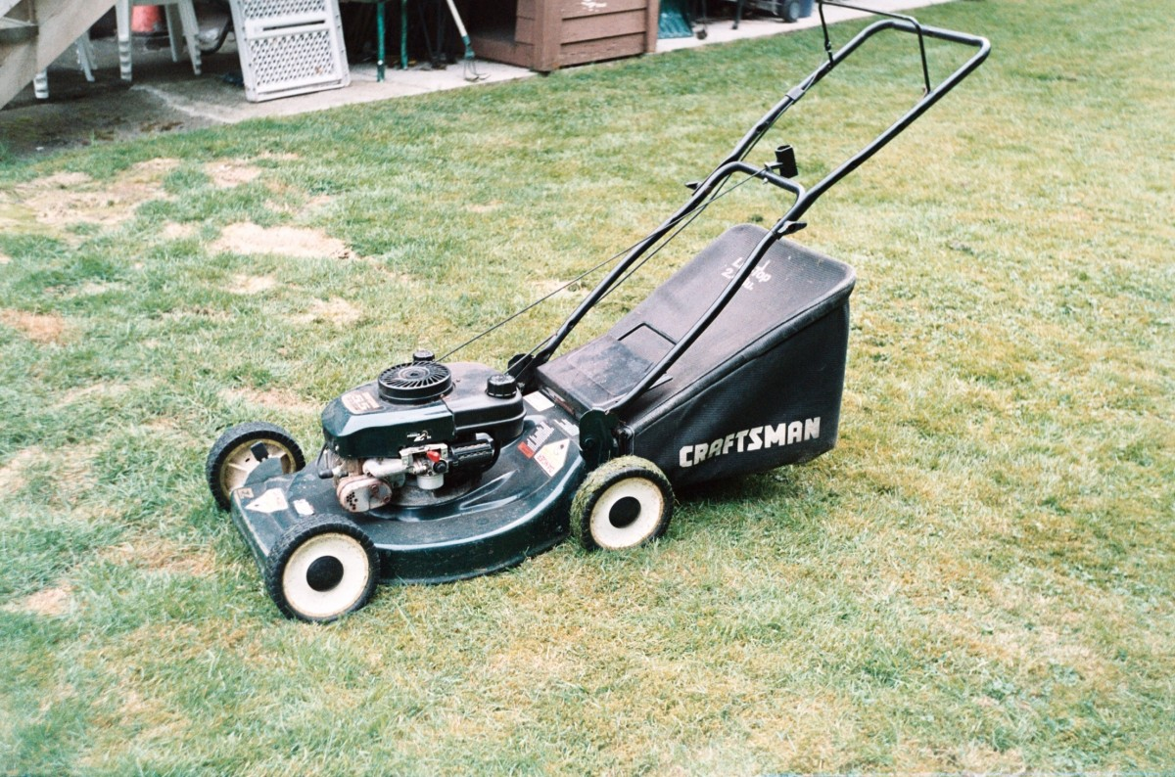
What are all the possible values for $x$, the number of hours Han can mow without refilling the lawn mower?
Write one or more inequalities to represent your response. Be prepared to explain or show your reasoning.

20.3: Different Ways of Solving
Andre and Priya used different strategies to solve the following inequality but reached the same solution.
$2\left(2x+1.5\right)<18−x$
- Make sense of each strategy until you can explain what each student has done.
- Andre
- $\begin{matrix}2\left(2x+1.5\right) & =18−x \\ 4x+3 & =18−x \\ 4x−15 & =\text{-}x \\ \text{-}15 & =\text{-}5x \\ 3 & =x\end{matrix}$
- Testing to see if $x=4$ is a solution:
- $\begin{matrix}2\left(2⋅4+1.5\right) & <18−4 \\ 2\left(9.5\right) & <14 \\ 19 & <14\end{matrix}$
- The inequality is false, so 4 is not a solution. If a number greater than 3 is not a solution, the solution must be less than 3, or $3>x$.
- Priya
- $\begin{matrix}2\left(2x+1.5\right) & =18−x \\ 4x+3 & =18−x \\ 5x+3 & =18 \\ 5x & =15 \\ x & =3\end{matrix}$
- In $4x+3=18−x$, there is $4x$ on the left and $\text{-}x$ on the right.
- If $x$ is a negative number, $4x+3$ could be positive or negative, but $18−x$ will always be positive.
- For $4x+3<18−x$ to be true, $x$ must include negative numbers or $x$ must be less than 3.
- Here are four inequalities.
  - $\frac{1}{5}p>\text{-}10$.
  - $4\left(x+7\right)≤\text{4}\left(2x+8\right)$
  - $\text{-}9n<36$
  - $\frac{c}{3}<\text{-}2\left(c−7\right)$
- Work with a partner to decide on at least two inequalities to solve. Solve one inequality using Andre's strategy (by testing values on either side the given solution), while your partner uses Priya's strategy (by reasoning about the parts of the inequality). Switch strategies for the other inequality.

Are you ready for more?
Using positive integers between 1 and 9 and each positive integer at most once, fill in values to get two constraints so that $x=7$ is the only integer that will satisfy both constraints at the same time.
3x+3<3x+3
3x+3>3x+3

20.4: Matching Inequalities and Solutions
Match each inequality to a graph that represents its solutions. Be prepared to explain or show your reasoning.
- $6x≤3x$
- $\frac{1}{4}x>\text{-}\frac{1}{2}$
- $5x+4≥7x$
- $8x−2<−4\left(x−1\right)$
- $\frac{4x−1}{3}>\text{-}1$
- $\frac{12}{5}−\frac{x}{5}≤x$

A

B

C

D

E

F

Lesson 20 Summary
Writing and solving inequalities can help us make sense of the constraints in a situation and solve problems. Let's look at an example.
Clare would like to buy a video game that costs $130. She has saved $48 so far and plans on saving $5 of her allowance each week. How many weeks, $w$, will it be until she has enough money to buy the game? To represent the constraints, we can write $48+5w≥130$. Let’s reason about the solutions:
- Because Clare has $48 already and needs to have at least $130 to afford the game, she needs to save at least $82 more.
- If she saves $5 each week, it will take at least $\frac{82}{5}$ weeks to reach $82.
- $\frac{82}{5}$ is 16.4. Any time shorter than 16.4 weeks won't allow her to save enough.
- Assuming she saves $5 at the end of each week (instead of saving smaller amounts throughout a week), it will be at least 17 weeks before she can afford the game.
We can also solve by writing and solving a related equation to find the boundary value for $w$, and then determine whether the solutions are less than or greater than that value.
$\begin{matrix}48+5w & =130 \\ 5w & =82 \\ w & =\frac{82}{5} \\ w & =16.4\end{matrix}$
- Substituting 16.4 for $w$ in the original inequality gives a true statement. (When $w=16.4$, we get $130≥130$.)
- Substituting a value greater than 16.4 for $w$ also gives a true statement. (When $w=17$, we get $133≥130$.)
- Substituting a value less than 16.4 for $w$ gives a false statement. (When $w=16$, we get $128≥130$.)
- The solution set is therefore $w≥16.4$.
Sometimes the structure of an inequality can help us see whether the solutions are less than or greater than a boundary value. For example, to find the solutions to $3x>8x$, we can solve the equation $3x=8x$, which gives us $x=0$. Then, instead of testing values on either side of 0, we could reason as follows about the inequality:
- If $x$ is a positive value, then $3x$ would be less than $8x$.
- For $3x$ to be greater than $8x$, $x$ must include negative values.
- For the solutions to include negative values, they must be less than 0, so the solution set would be $x<0$.
© CC BY 2019 by Illustrative Mathematics®

