Unit 2 Lesson 13: The Shadow Knows

1 Notice and Wonder: Long Shadows and Short Shadows (Warm up)

Student Task Statement
What do you notice? What do you wonder?
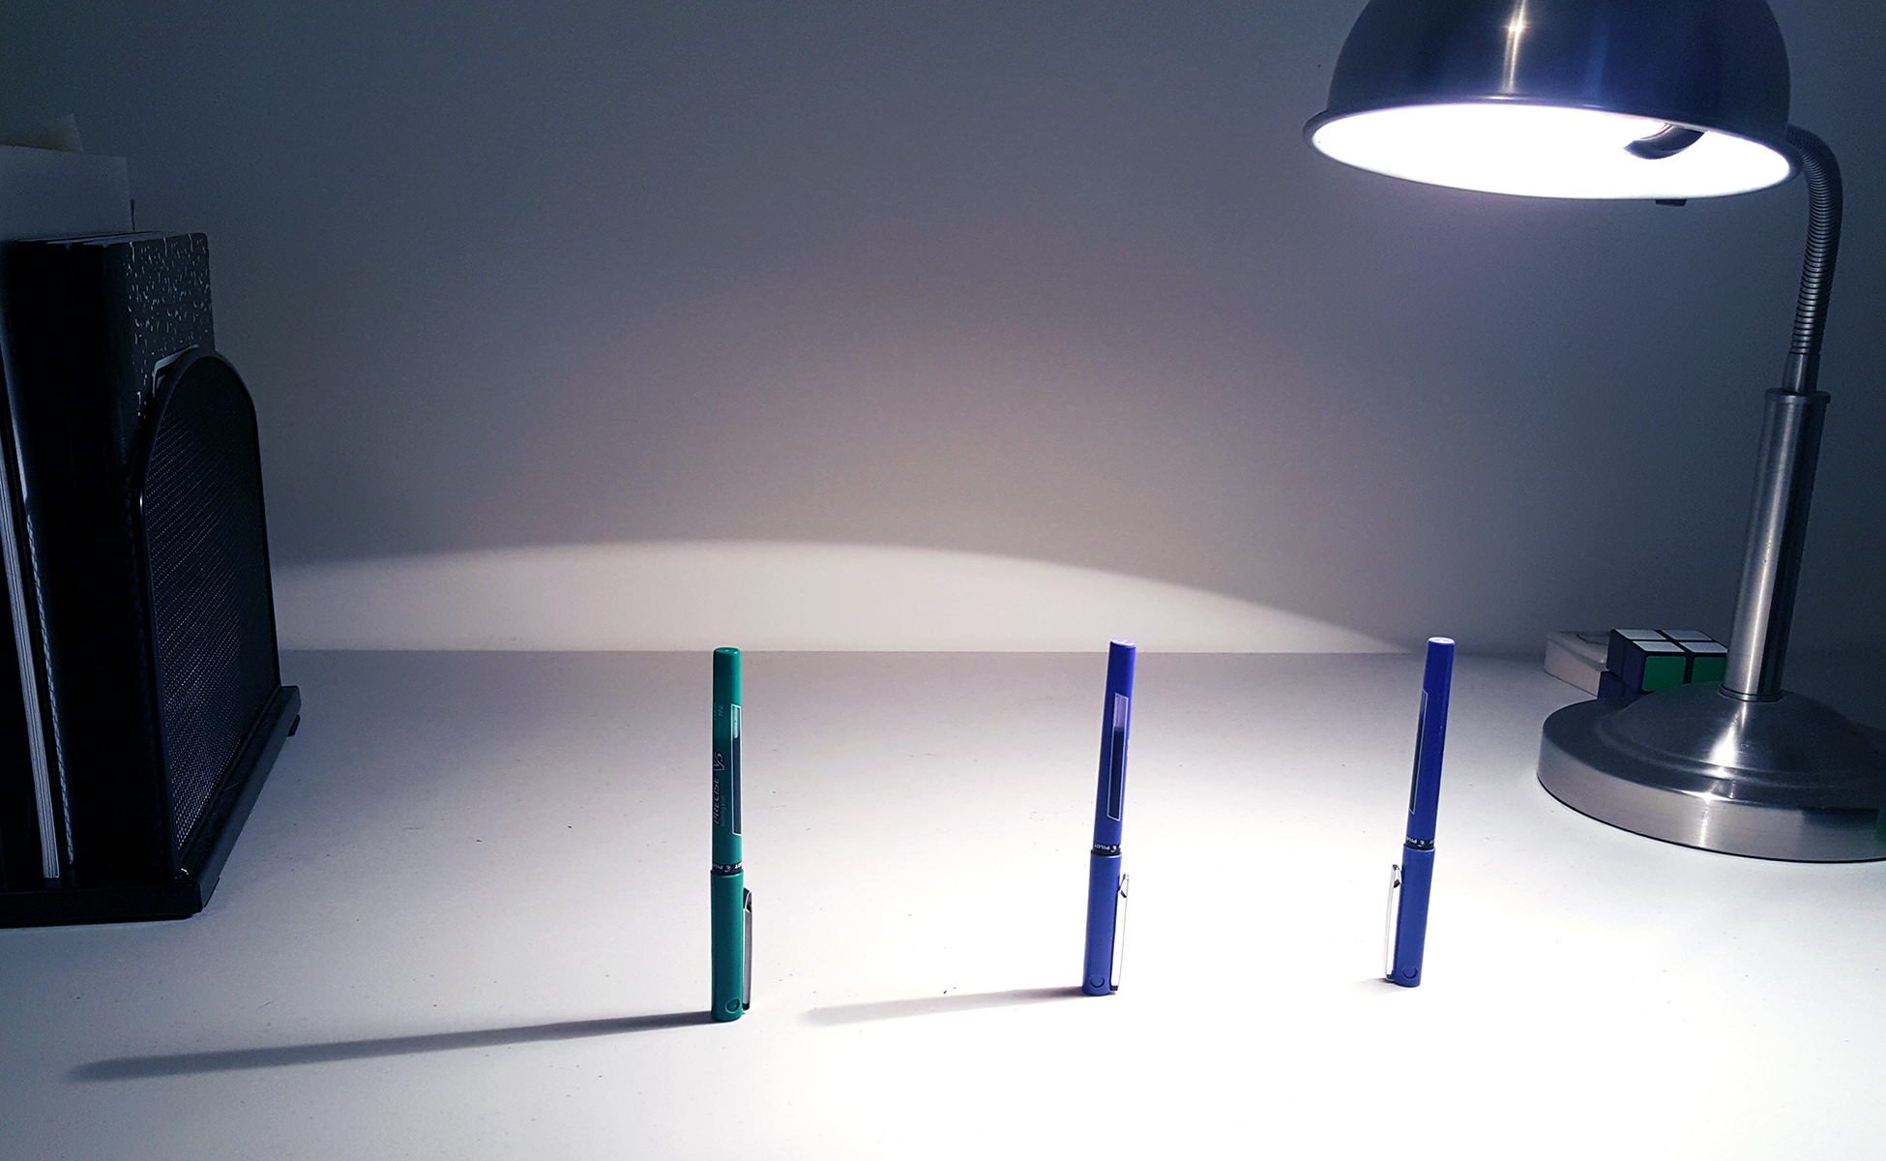
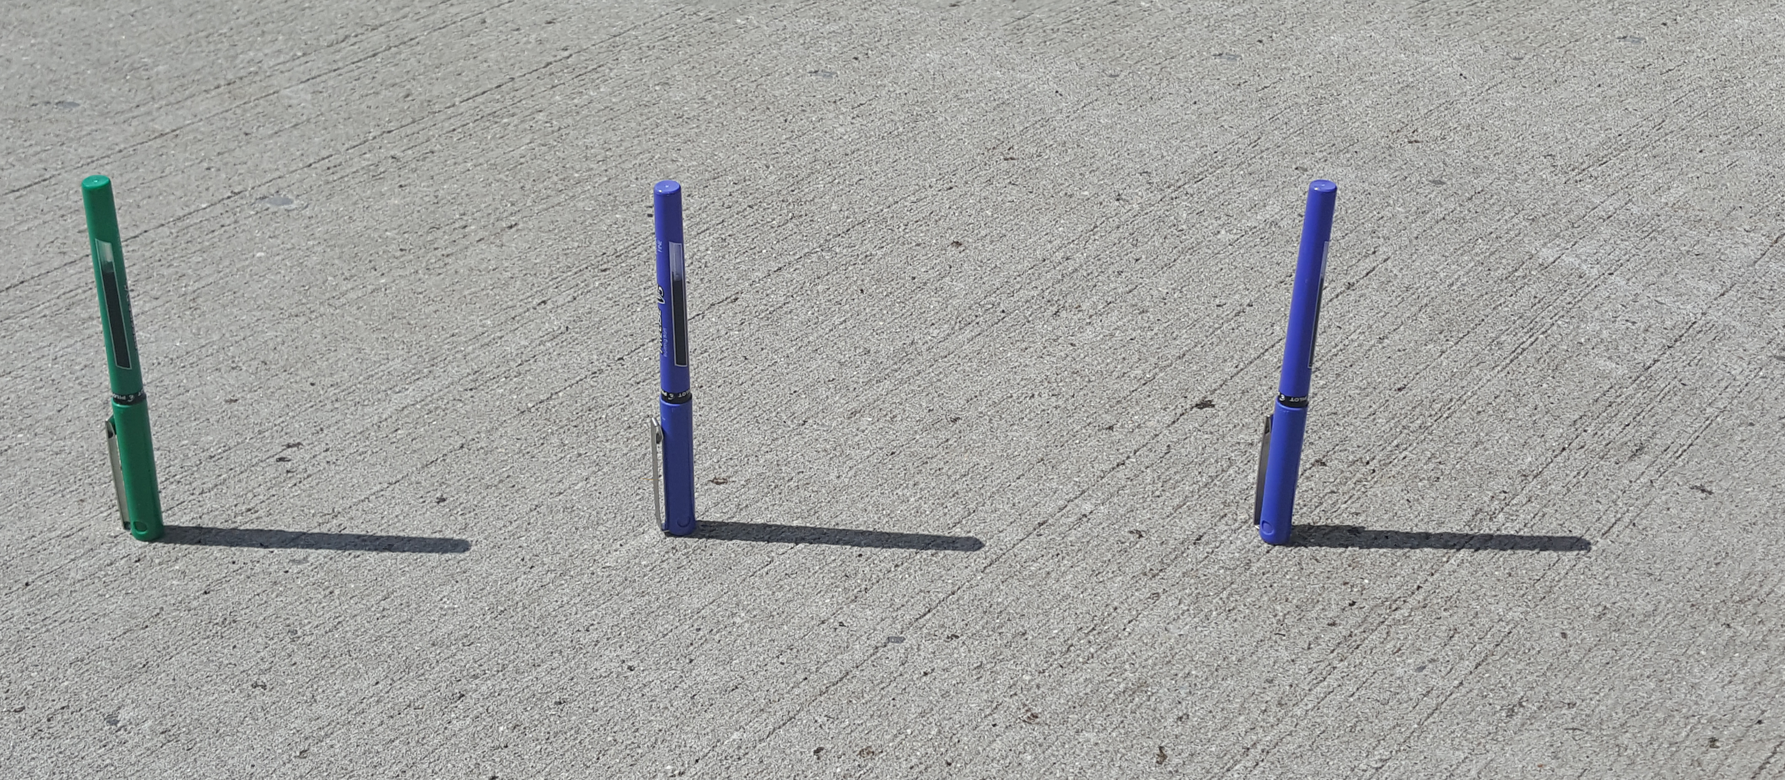

Activity Synthesis
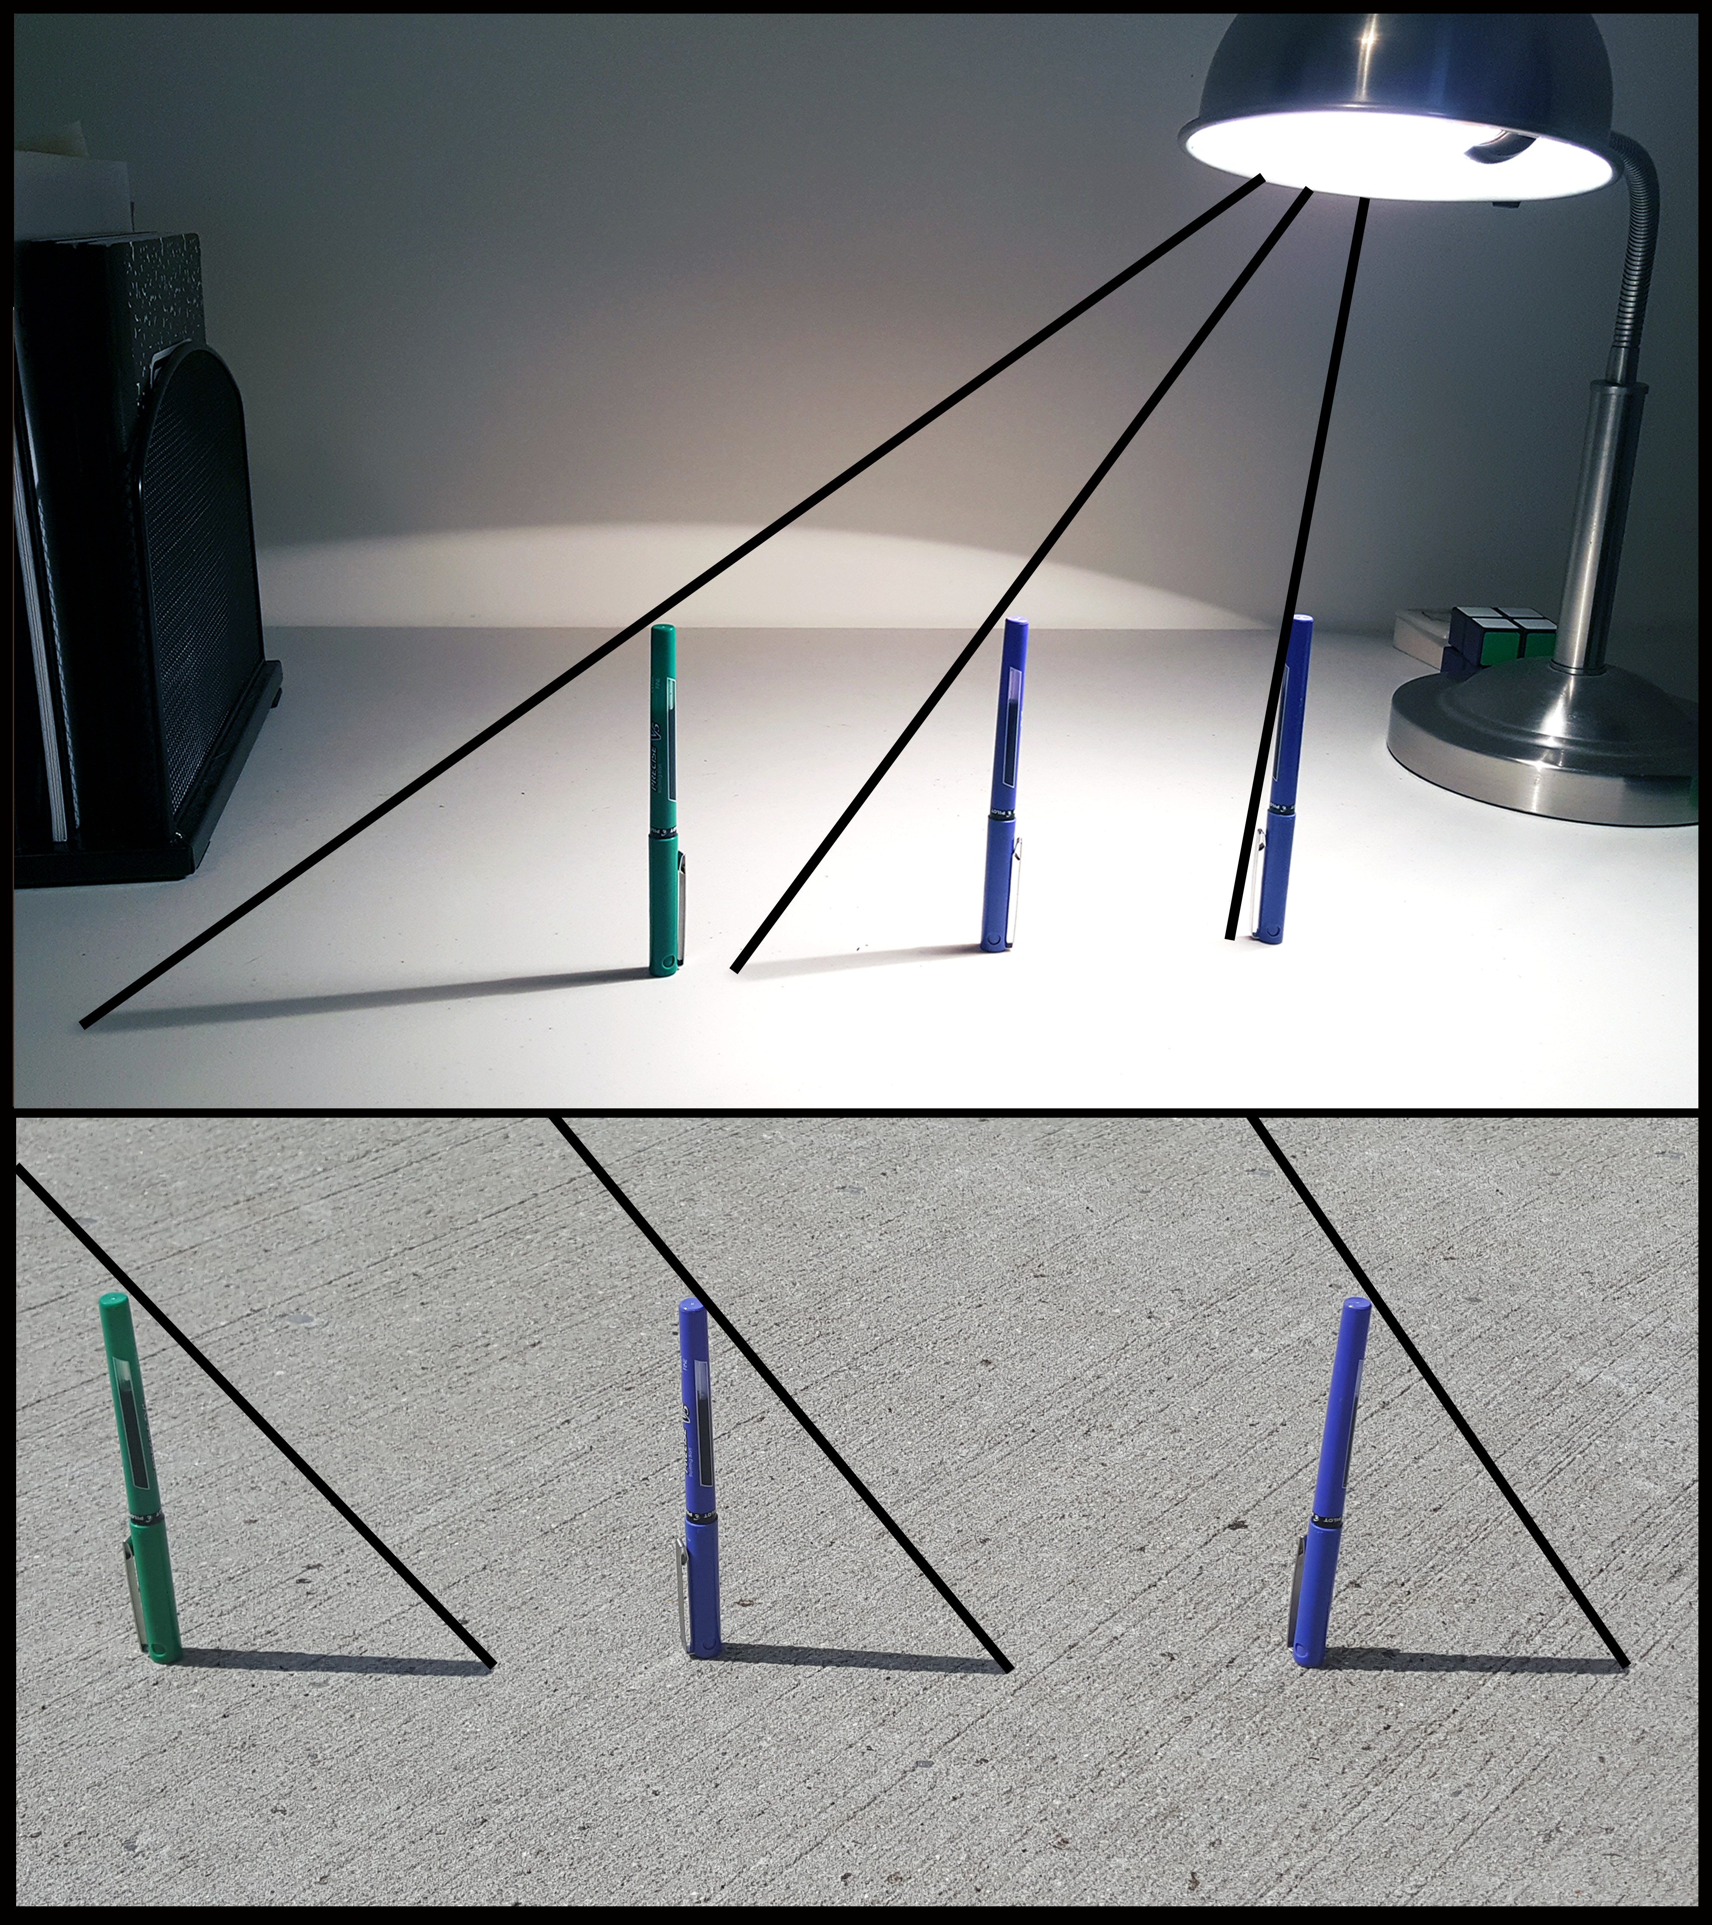

2 Objects and Shadows

Student Task Statement
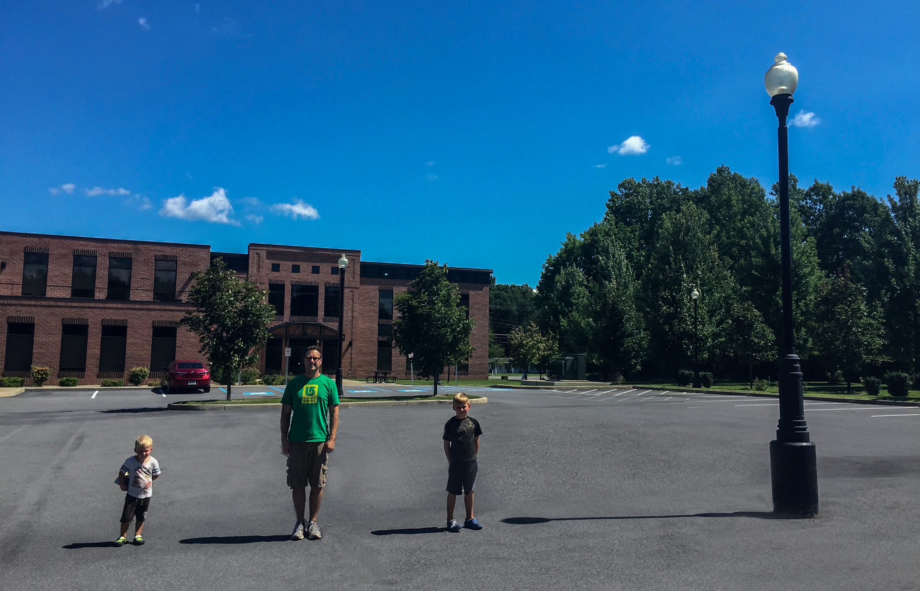
Here are some measurements that were taken when the photo was taken. It was impossible to directly measure the height of the lamppost, so that cell is blank.
 | height (inches) | shadow length (inches)
younger boy | 43 | 29
man | 72 | 48
older boy | 51 | 34
lamppost |  | 114
- What relationships do you notice between an object’s height and the length of its shadow?
- Make a conjecture about the height of the lamppost and explain your thinking.

Activity Synthesis
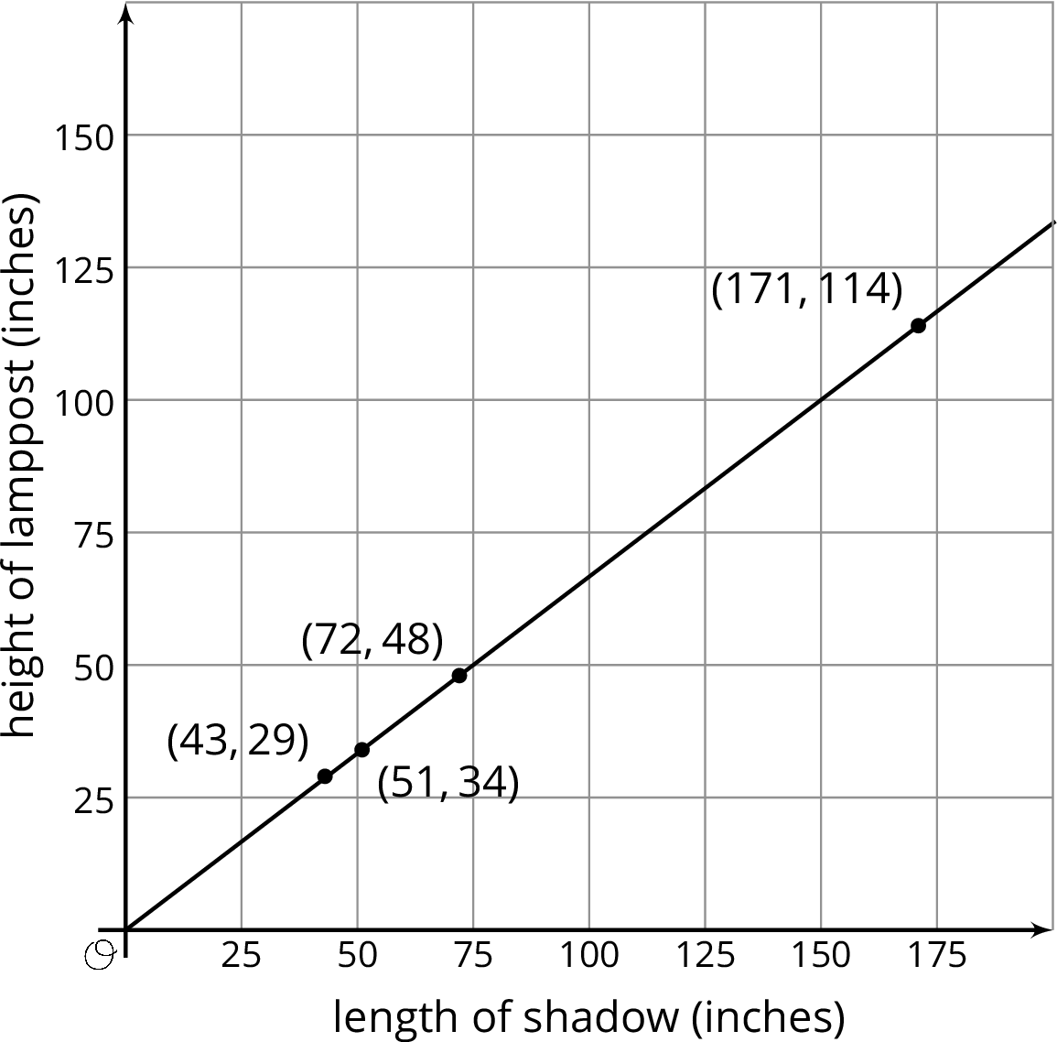

3 Justifying the Relationship

Student Task Statement
Explain why the relationship between the height of these objects and the length of their shadows is approximately proportional.
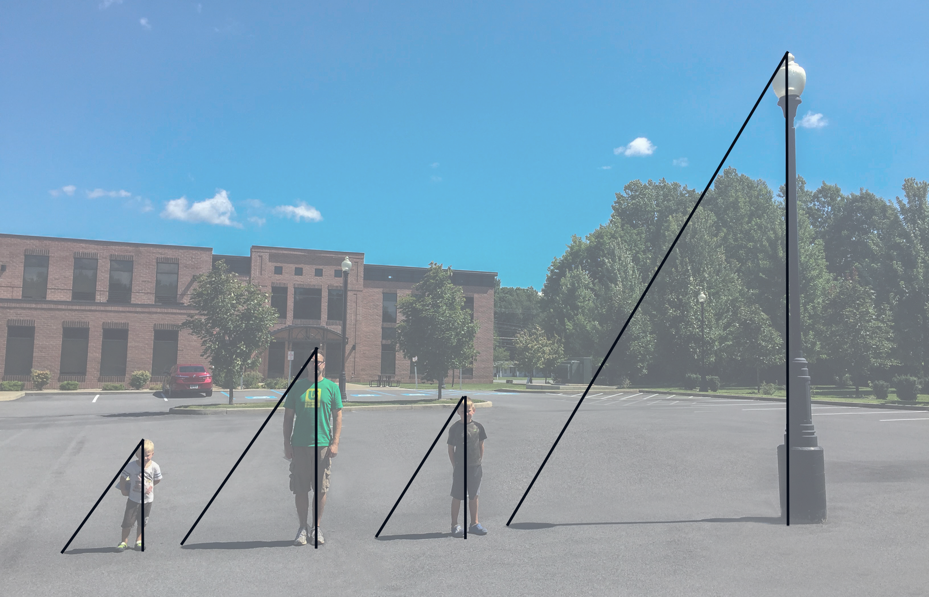

4 The Height of a Tall Object

Student Task Statement
- Head outside. Make sure that it is a sunny day and you take a measuring device (like a tape measure or meter stick) as well as a pencil and some paper.
- Choose an object whose height is too large to measure directly. Your teacher may assign you an object.
- Use what you have learned to figure out the height of the object! Explain or show your reasoning.
© CC BY Open Up Resources. Adaptations CC BY IM.

