Unit 7 Lesson 12: Center Day 2

WU How Many Do You See: 2 or 3 Parts (Warm up)

Student Task Statement
How many do you see?
How do you see them?
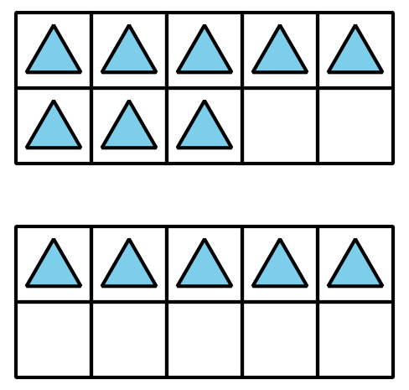
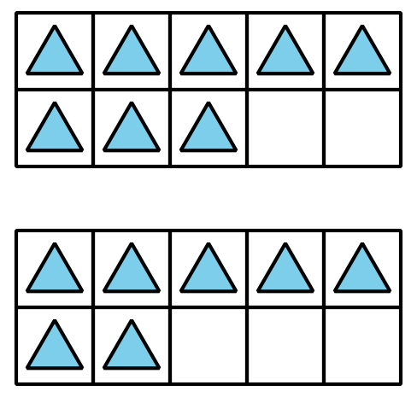
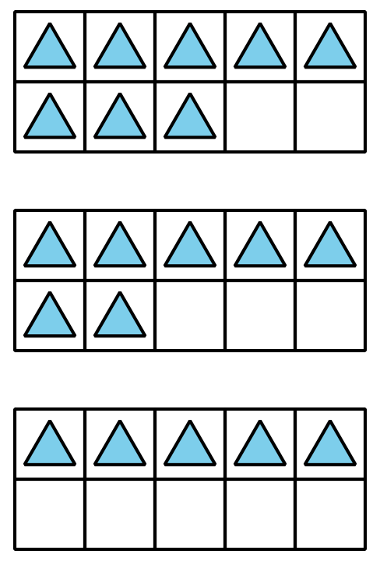

1 Introduce Can You Draw It, Grade 1 Shapes

Student Task Statement

2 Centers: Choice Time

Student Task Statement
Choose a center.
Picture Books
Match Mine
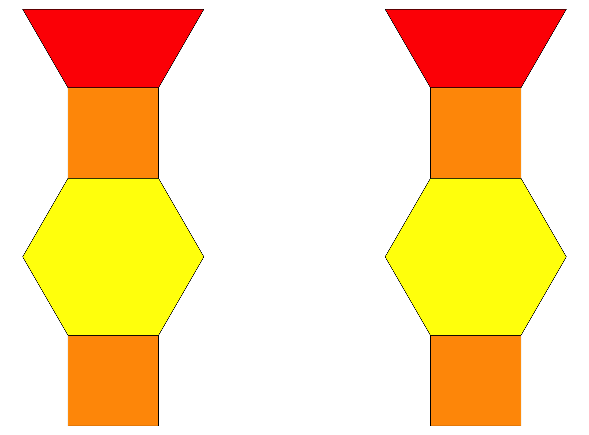
Capture Squares
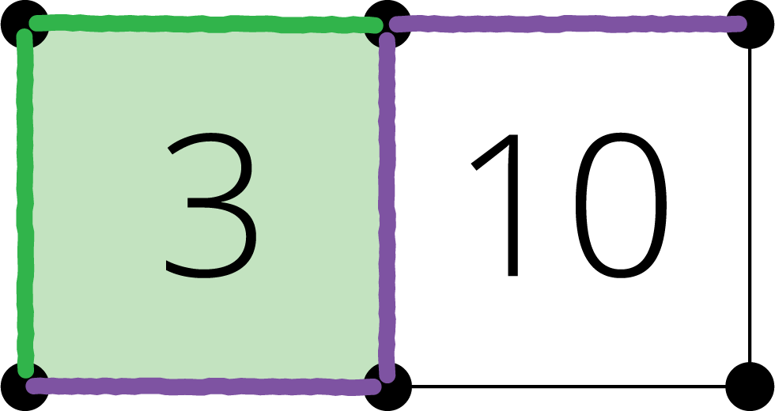
Target Numbers
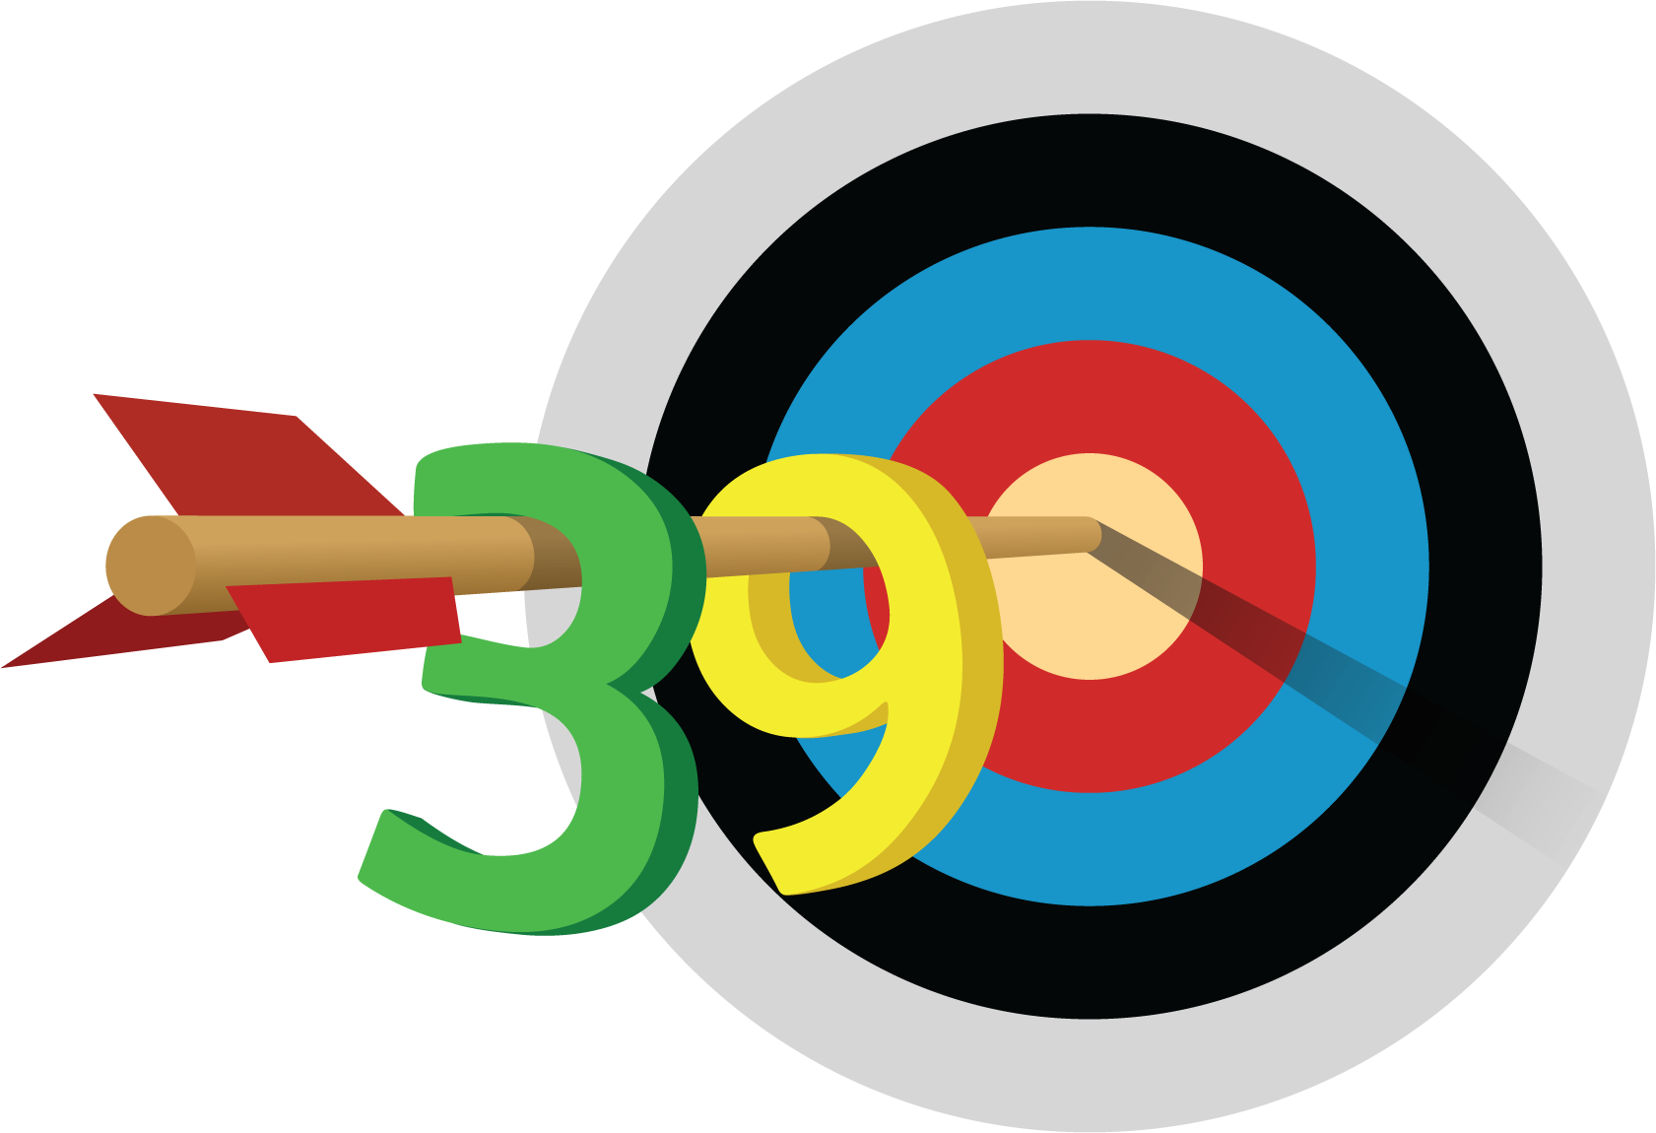
© CC BY 2021 Illustrative Mathematics®

