Unit 2 Lesson 9: Side Length Quotients in Similar Triangles

1 Two-three-four and Four-five-six (Warm up)

Student Task Statement
Triangle $A$ has side lengths 2, 3, and 4. Triangle $B$ has side lengths 4, 5, and 6. Is Triangle $A$ similar to Triangle $B$?

Activity Synthesis
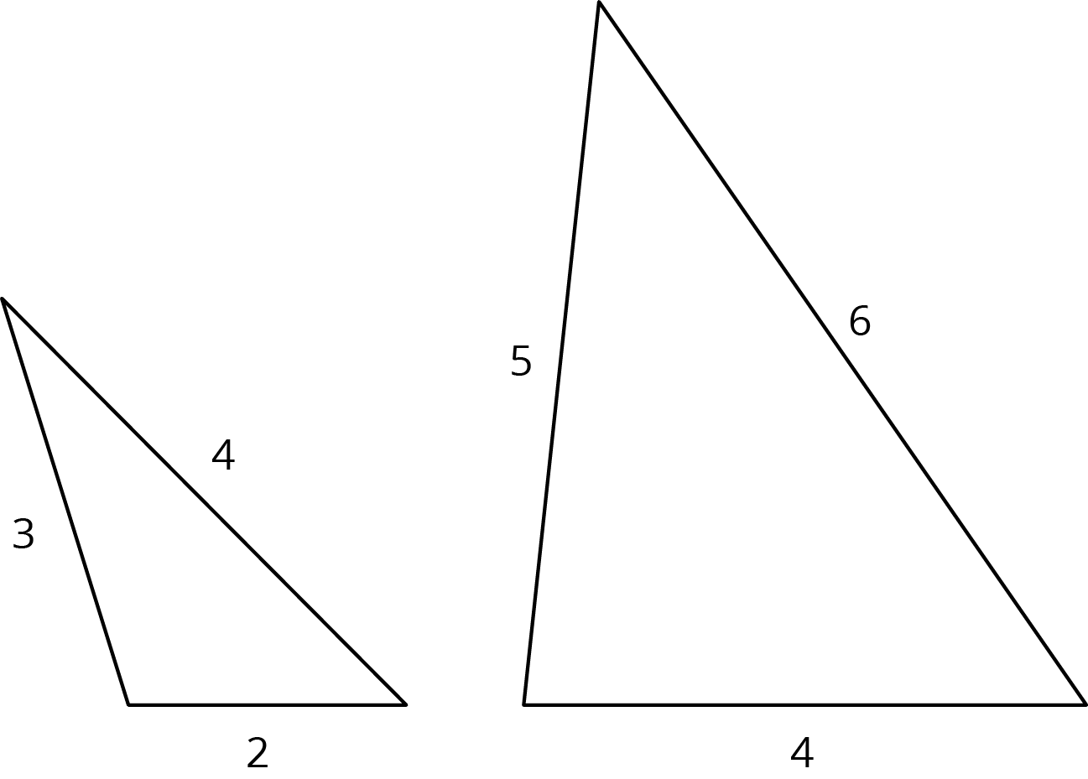

2 Quotients of Sides Within Similar Triangles

Student Task Statement
Triangle $ABC$ is similar to triangles $DEF$, $GHI$, and $JKL$. The scale factors for the dilations that show triangle $ABC$ is similar to each triangle are in the table.
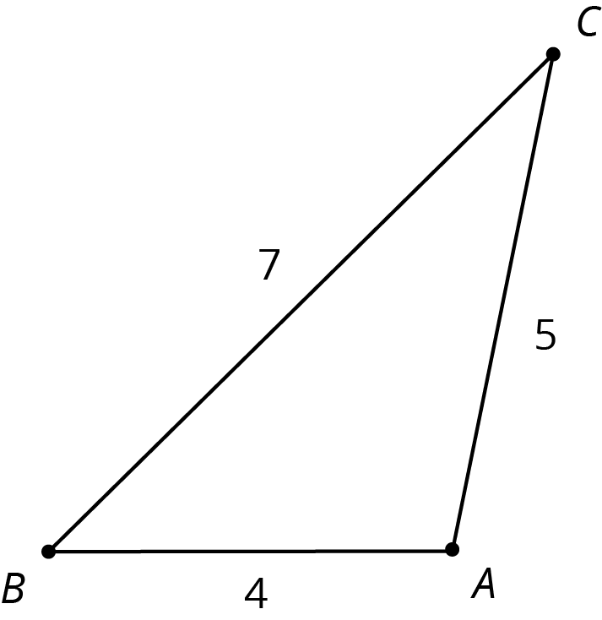
- Find the side lengths of triangles $DEF$, $GHI$, and $JKL$. Record them in the table.
- triangle | - scale factor | - length of  short side | - length of  medium side | - length of  long side
- $ABC$ | - 1 | - 4 | - 5 | - 7
- $DEF$ | - 2
- $GHI$ | - 3
- $JKL$ | - $\frac{1}{2}$
- Your teacher will assign you one of the three columns. For all four triangles, find the quotient of the triangle side lengths assigned to you and record it in the table. What do you notice about the quotients?
- triangle | - (long side) $÷$ (short side) | - (long side) $÷$ (medium side) | - (medium side) $÷$ (short side)
- $ABC$ | - $\frac{7}{4}$ or 1.75
- $DEF$
- $GHI$
- $JKL$
- Compare your results with your partners’ and complete your table.

3 Using Side Quotients to Find Side Lengths of Similar Triangles

Student Task Statement
Triangles $ABC$, $EFD$, and $GHI$ are all similar. The side lengths of the triangles all have the same units. Find the unknown side lengths.
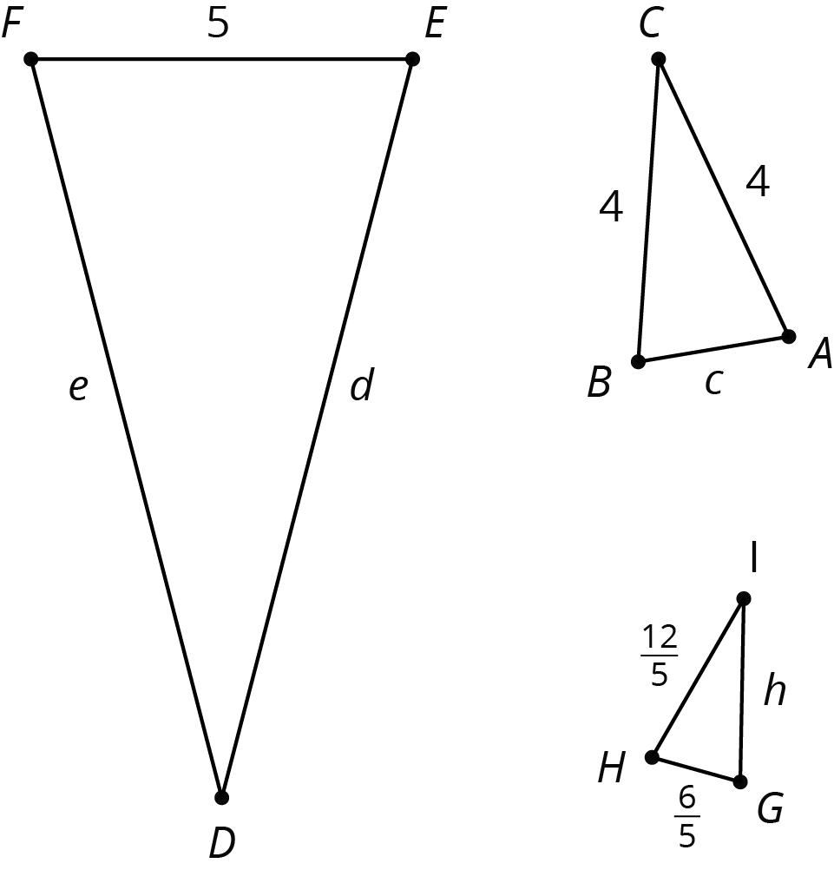

Images for Activity Synthesis
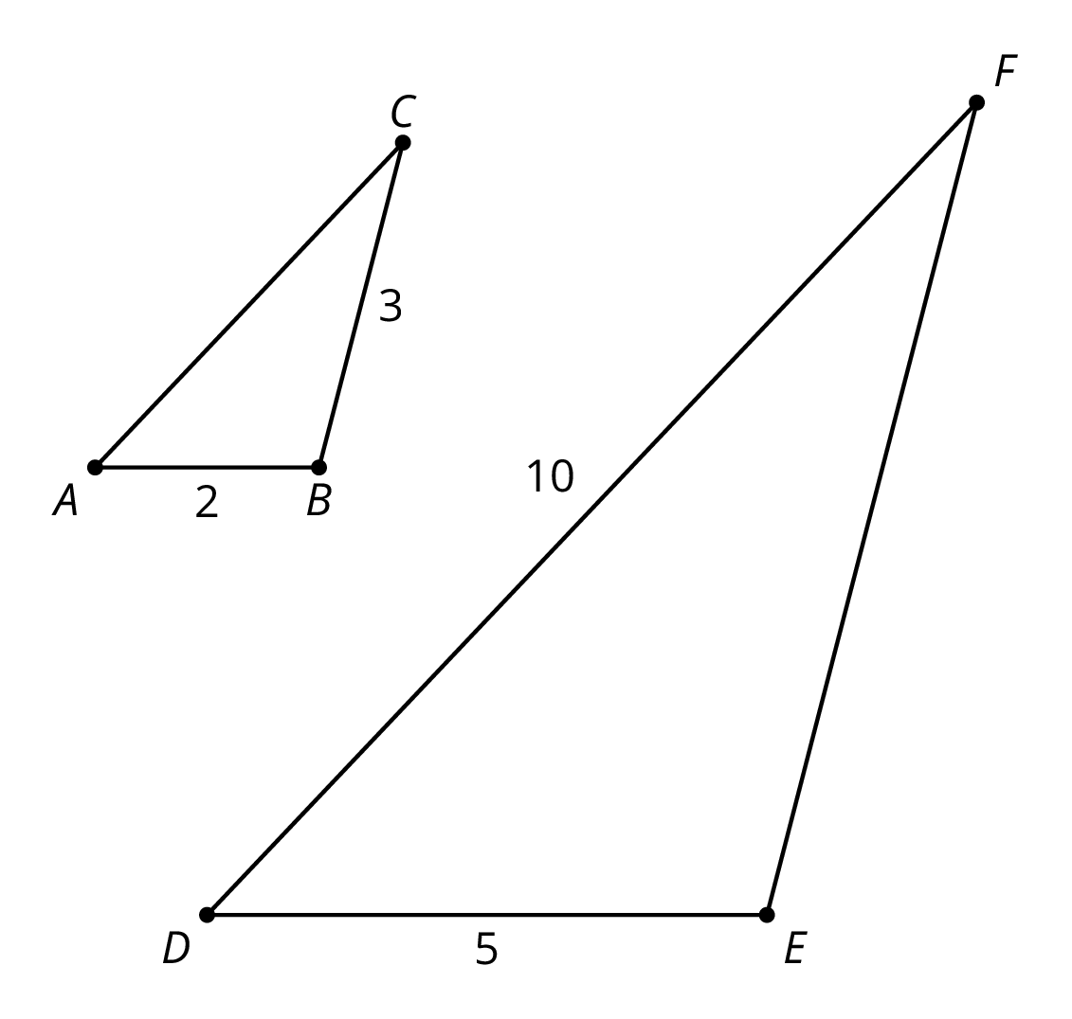
© CC BY Open Up Resources. Adaptations CC BY IM.

