Unit 5 Lesson 15: Putting All the Solids Together

1 Math Talk: Volumes (Warm up)

Student Task Statement
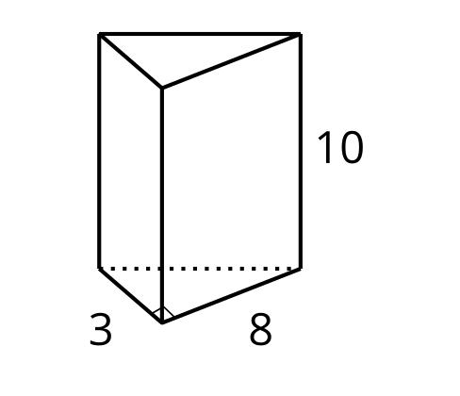
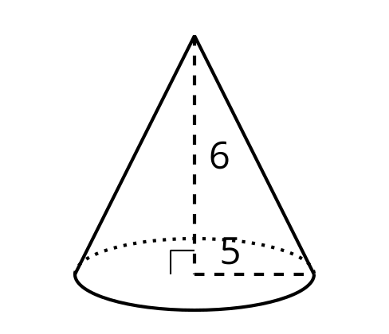
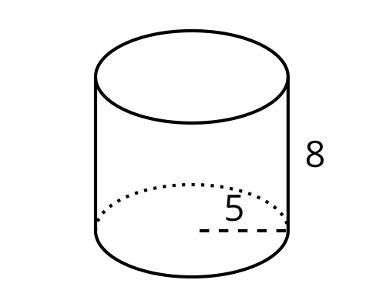
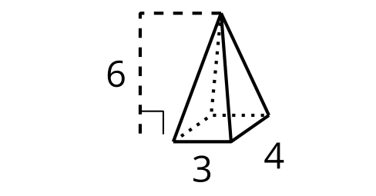
Evaluate the volume of each solid mentally.

2 Missing Measurements

Student Task Statement
- Answer the questions for each of the two solids shown.

- A
- 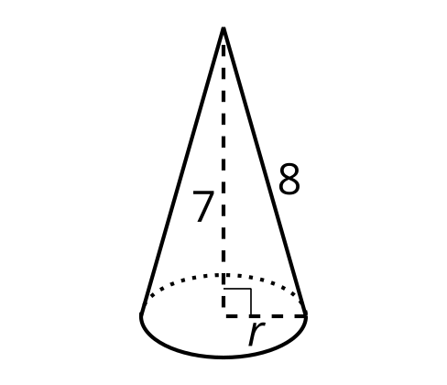

- B
- 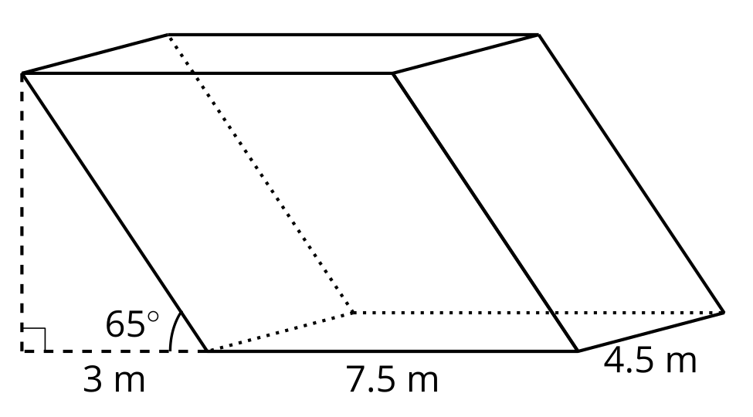
  - Which measurement that you need to calculate the volume isn’t given?
  - How can you find the value of the missing measurement?
  - What volume formula applies?
  - Calculate the volume of the solid, rounding to the nearest tenth if necessary.
- Calculate the volume of each solid, rounding to the nearest tenth if necessary.

- A
- 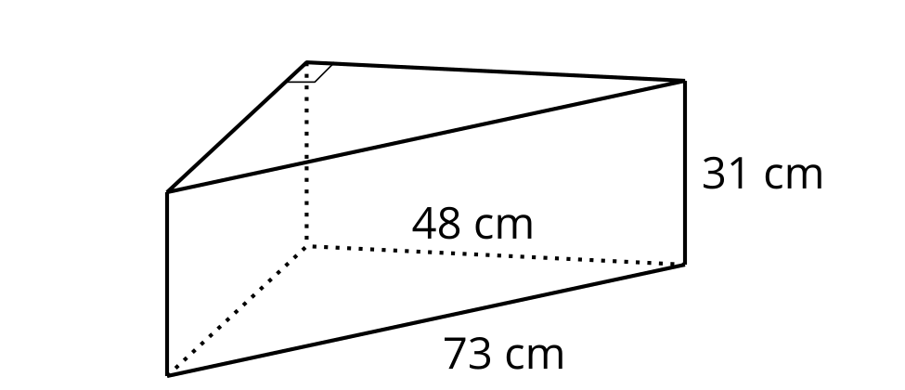

- B
- 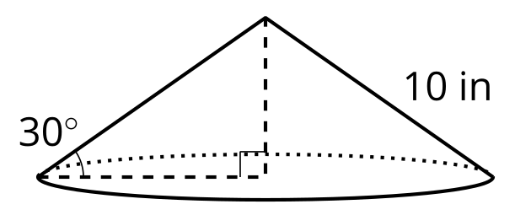

3 Spinning into Three Dimensions

Student Task Statement
Suppose this two-dimensional figure is rotated 360 degrees using the vertical axis shown. Each small square on the grid represents 1 square inch.
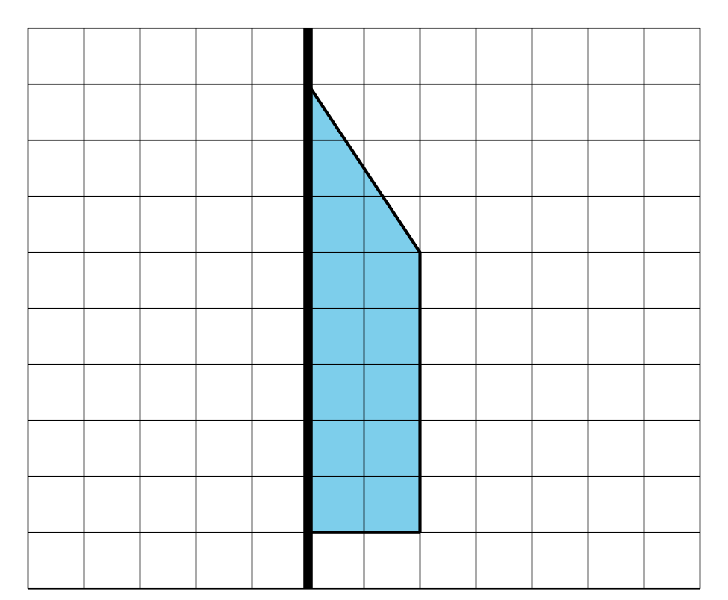
- Draw the solid that would be traced out. Label the dimensions of the solid.
- Find the volume of the solid. Round your answer to the nearest tenth if needed.
© CC BY 2019 by Illustrative Mathematics®

