Lesson 7: Recolectemos y representemos datos

Standards Alignments
Building On | 1.MD.C.4
Building Towards | 2.MD.D.10

Teacher-facing Learning Goals
- Analyze different representations of the same data to identify common features.
- Represent data in a way that makes sense to them.

Student-facing Learning Goals
- Organicemos datos y compartámoslos.

Lesson Purpose
The mathematical purpose of this lesson is to elicit and build on students’ previous understandings and experiences with organizing and representing data.
In grade 1, students collected data and represented it in different ways. In this lesson, students collect data about their class, answer questions, discuss the need to represent data in an organized way, and create their own representations of their data. Throughout the lesson monitor for the different ways students choose to organize and represent the data and ask them about the decisions they make. In upcoming lessons, students learn how to interpret and represent data using picture and bar graphs.
In this lesson, students collect data about the question “¿Cómo llegamos a la escuela?” // “How do we get to school?” If this question is not relevant to your class, choose a different survey question or change the categories to be more relevant for your students.

Access for:

Students with Disabilities
- Representation (Activity 1)

Instructional Routines
MLR7 Compare and Connect (Activity 2), Notice and Wonder (Warm-up)

Materials to Gather
- Chart paper: Activity 1
- Glue: Activity 2
- Markers: Activity 2
- Materials from a previous activity: Activity 2
- Scissors: Activity 1, Activity 2
- Stickers: Activity 2
- Tape: Activity 1, Activity 2

Materials to Copy
- How We Get to School, Spanish (groups of 1): Activity 1

Lesson Timeline
Warm-up | 10 min
Activity 1 | 15 min
Activity 2 | 20 min
Lesson Synthesis | 10 min
Cool-down | 5 min

Teacher Reflection Question
In grade 1, students organized and represented data with up to three categories. How did you see or hear students demonstrate their understanding of different ways to organize data?

Cool-down
(to be completed at the end of the lesson) 5min
Organiza datos

Standards Alignments
Building Towards | 2.MD.D.10

Student-facing Task Statement
Mai y Priya mostraron cómo iban a la escuela los estudiantes de su curso.
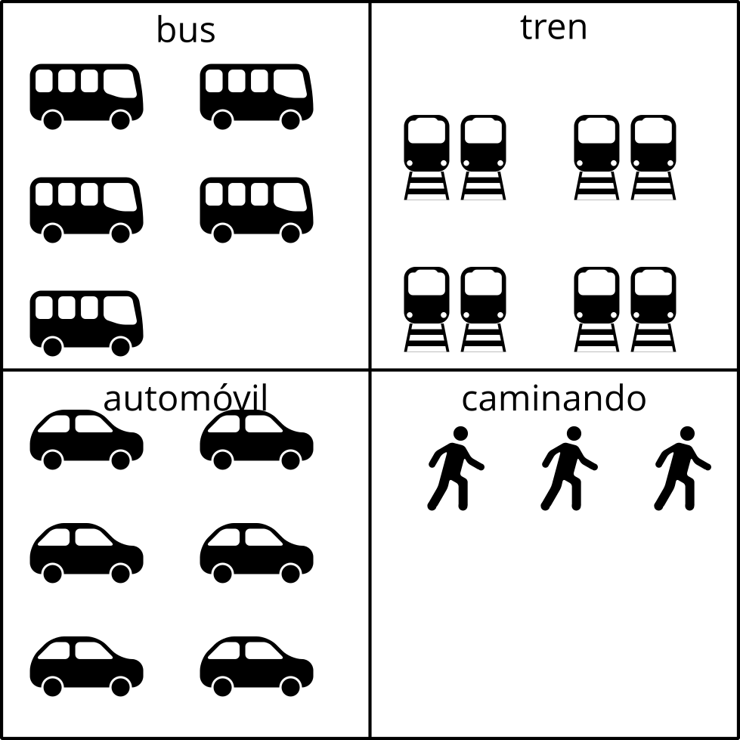
Manera de Mai
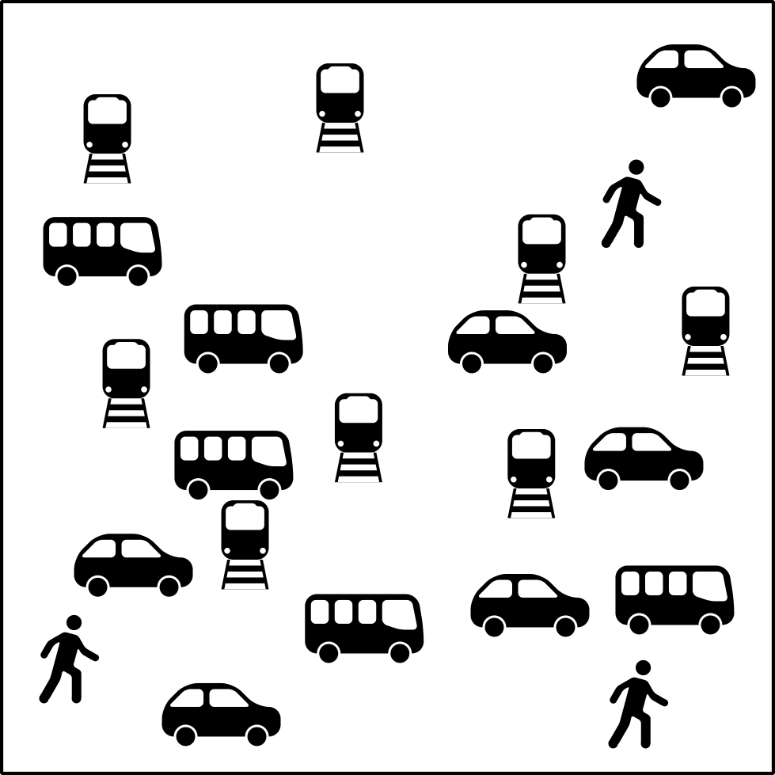
Manera de Priya
¿En qué son iguales la manera de Mai y la manera de Priya?, ¿en qué son diferentes?

Student Responses
Sample responses:
- They both use pictures. Mai grouped the pictures together.
- They both have the same number of pictures. Mai used words and grouped the pictures together.

