Lesson 6: Working with Trigonometric Ratios
- Let’s solve problems using cosine, sine, and tangent.

6.1: This Time with Strategies
Estimate the value of $z$.
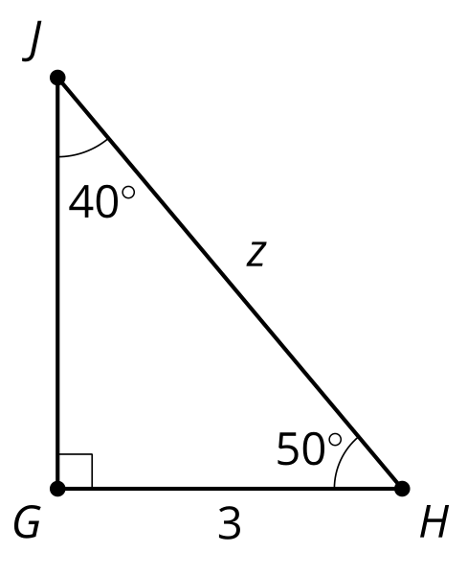

6.2: New Names, Same Ratios
- Use your calculator to determine the values of $cos\left(50\right)$, $sin\left(50\right)$, and $tan\left(50\right)$.
- Use your calculator to determine the values of $cos\left(40\right)$, $sin\left(40\right)$, and $tan\left(40\right)$.
- How do these values compare to your chart?
- Find the value of $z$.

6.3: Solve These Triangles
- Solve for $x$.
- 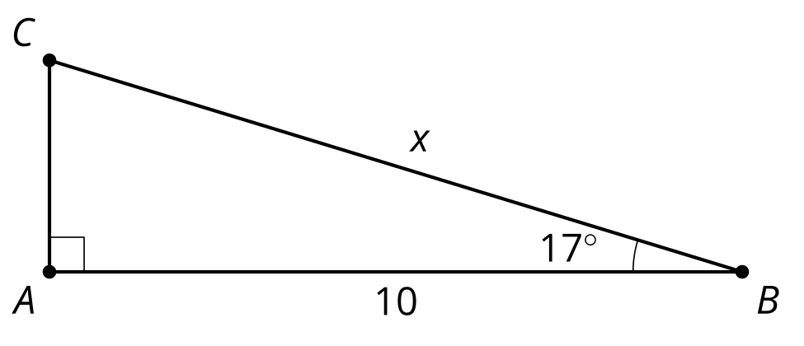
- Solve for $y$.
- 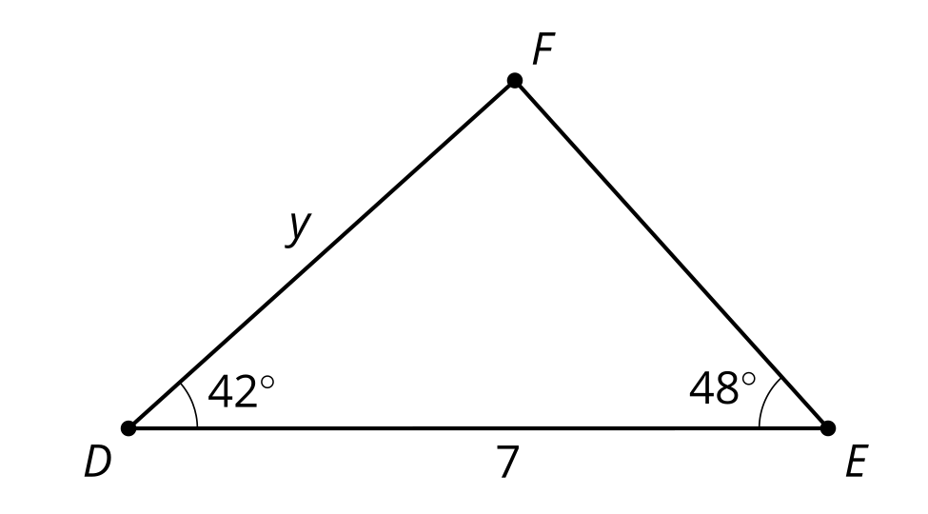
- Find all the missing sides and angle measures.
  - The measure of angle $X$ is 90 degrees and angle $Y$ is 12 degrees. Side $XZ$ has length 2 cm.
  - The measure of angle $K$ is 90 degrees and angle $L$ is 71 degrees. Side $LM$ has length 20 cm.

Are you ready for more?
Complete the table.
angle | cosine | sine | tangent
${80}^{∘}$
${85}^{∘}$
${89}^{∘}$
Based on this information, what do you think are the cosine, sine, and tangent of 90 degrees? Explain or show your reasoning.

Lesson 6 Summary
We have a column in the right triangle table for "adjacent leg $÷$ hypotenuse." We use this ratio so frequently it has a name. It is called the cosine of the angle. We write $cos\left(25\right)$ to say the cosine of 25 degrees. A scientific calculator can display the cosine of any angle. This means we can more precisely calculate unknown side lengths rather than estimating using the table. The right triangle table is sometimes called a trigonometry table since cosine, sine, and tangent are trigonometric ratios. Here is what the table looks like with the ratios labeled with their special names:
 | cosine | sine | tangent
angle | adjacent leg $÷$ hypotenuse | opposite leg $÷$ hypotenuse | opposite leg $÷$ adjacent leg
${25}^{∘}$ | $cos\left(25\right)=0.906$ | $sin\left(25\right)=0.423$ | $tan\left(25\right)=0.466$
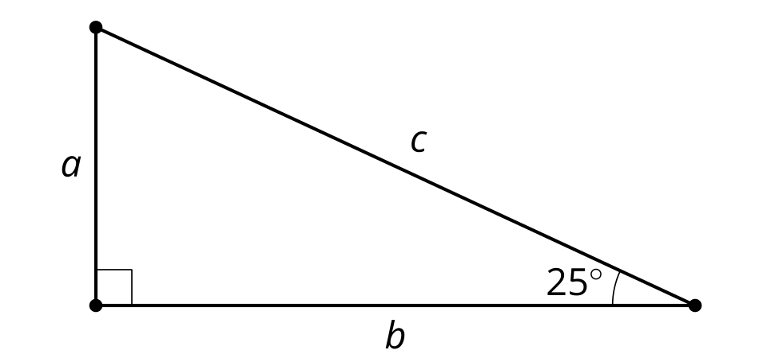
If the length $b$ is 7, we can find $c$ by solving the equation $cos\left(25\right)=\frac{7}{c}$. So $c$ is about 7.7 units. To solve for $a$ we have 3 choices: the Pythagorean Theorem, sine, and tangent. Let’s use tangent by solving the equation $tan\left(25\right)=\frac{a}{7}$. So $a$ is about 3.3 units. We can check our answers using the Pythagorean Theorem. It should be true that ${3.3}^{2}+7^{2}={7.7}^{2}$. The two expressions are almost equal, which makes sense because we expect some error due to rounding.
© CC BY 2019 by Illustrative Mathematics®

