Unit 4 Lesson 17: Writing Inverse Functions to Solve Problems

1 Water in a Tank

Student Task Statement
A tank contained some water. The function $w$ represents the relationship between $t$, time in minutes, and the amount of water in the tank in liters. The equation $w\left(t\right)=80−2.5t$ defines this function.
- Discuss with a partner:
  - How is the water in the tank changing? Be as specific as possible.
  - What does $w\left(t\right)$ represent? Is $w\left(t\right)$ the input or the output of this function?
- Sketch a graph of the function. Be sure to label the axes.
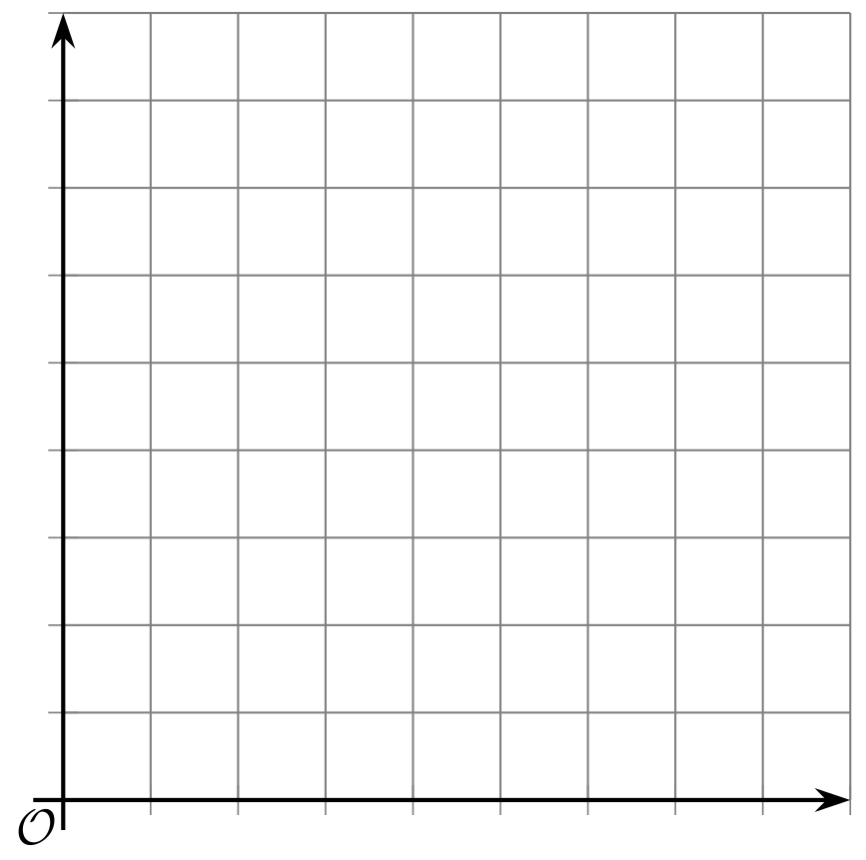

2 Another Look at the Tank

Student Task Statement
A tank contained 80 liters of water. The function $w$ represents the relationship between $t$, time in minutes, and the amount of water in the tank in liters. The equation $w\left(t\right)=80−2.5t$ defines this function.
- How much water will be in the tank after 13 minutes?
- How many minutes will it take until the tank has 5 liters of water?
- In this situation, what information can we gain from the inverse of function $w$?
- Find the inverse of function $w$. Be prepared to explain or show your reasoning.
- How would the graph of the inverse function of $w$ compare to the graph of $w$? Describe or sketch your prediction.

Activity Synthesis
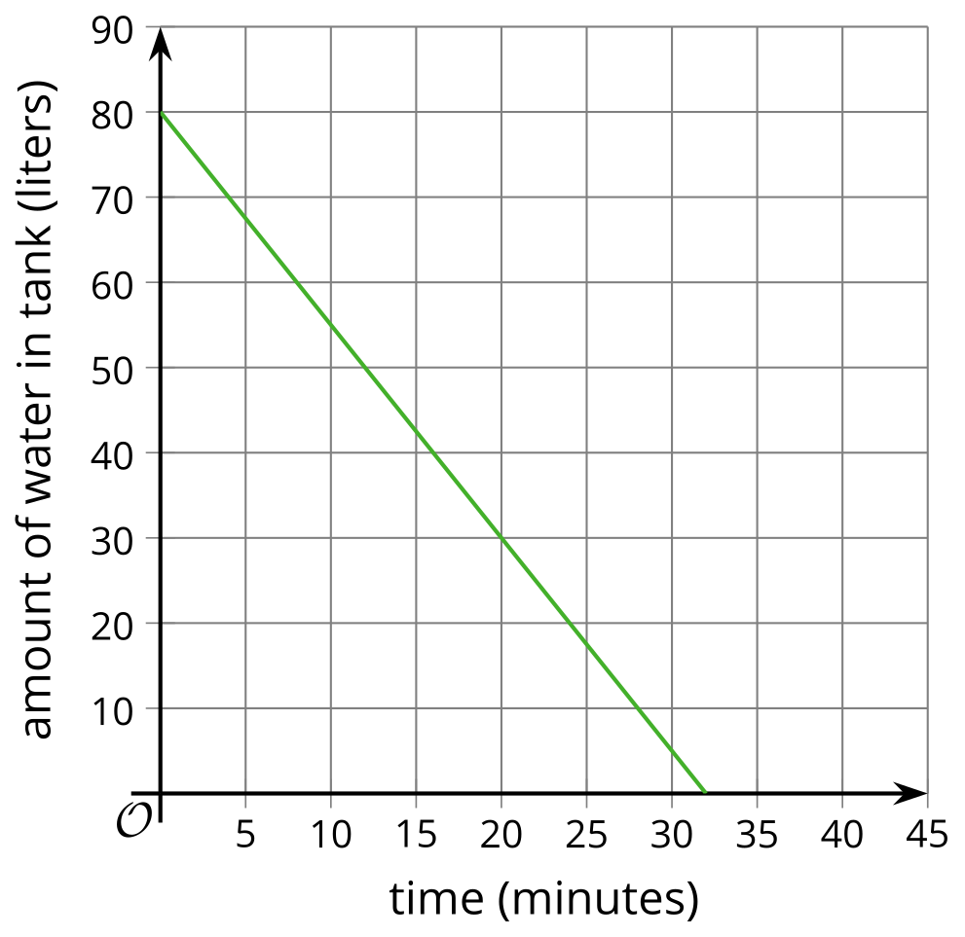
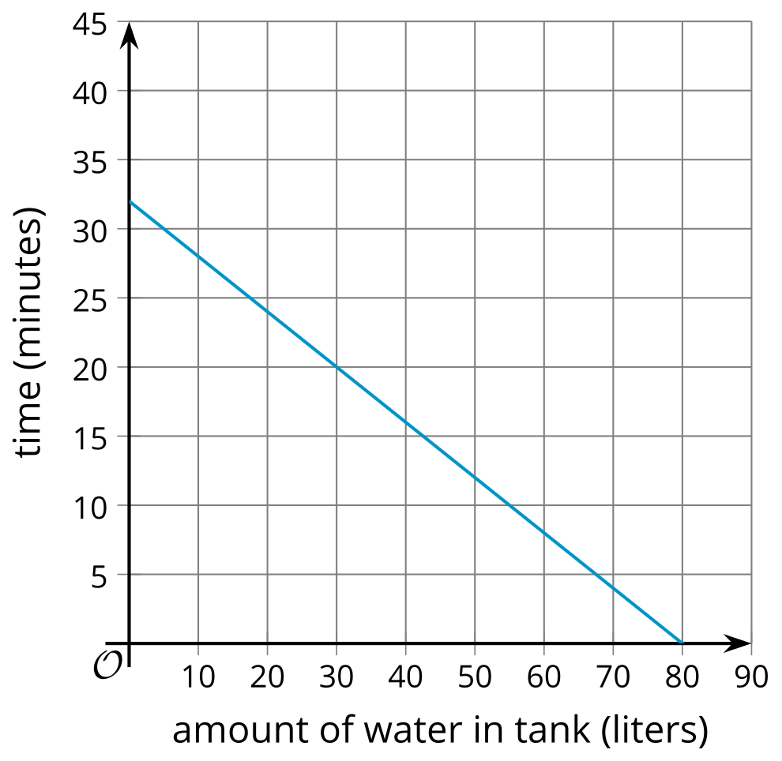

3 Phones in Homes

Student Task Statement
In 2004, less than 5% of the homes in the U.S. relied only on a cell phone. Since then, the percentage of homes that used only cell phones have increased.
Here are the percentages of homes with only cell phones from 2004 to 2009.
years since 2004 | percentages
0 | 4.4
1 | 6.7
2 | 9.6
3 | 13.6
4 | 17.5
5 | 22.7
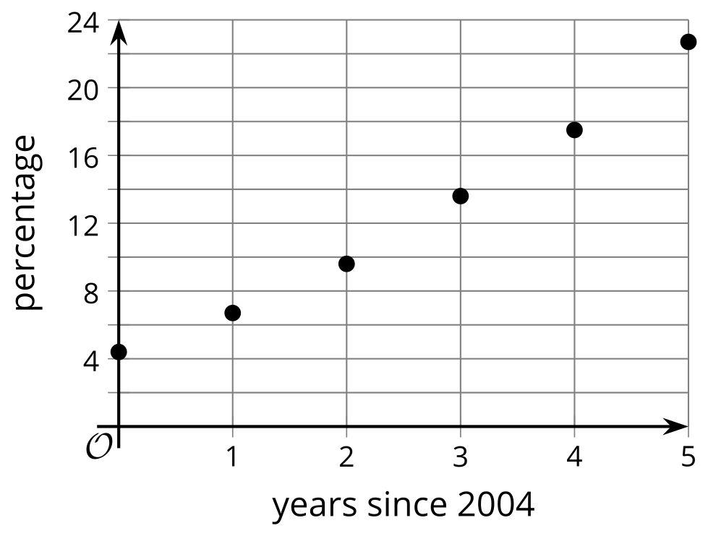
​​​​​​
- Suppose a linear function, $P$, gives us the percentage of homes with only cell phones as a function of years since 2004, $t$.
- Fit a line on the scatter plot to represent this function and write an equation that could define the function. Use function notation.
- Use your equation to find the value of $P\left(6\right)$. Then, explain what it means in this situation.
- Use your equation to solve $P\left(t\right)=30$ for $t$. What does the solution represent?
- Suppose we want to know when the percentage of homes with only cell phones would reach 50%, 75%, or 100% (assuming that the trend continues and the function stays valid). What equation could be written to help us find the years that correspond to those percentages? Show your reasoning.
© CC BY 2019 by Illustrative Mathematics®

