Lesson 11 Practice Problems
- Use a geometric tool to draw a circle. Draw and measure a radius and a diameter of the circle.
- Here is a circle with center $H$ and some line segments and curves joining points on the circle.
- 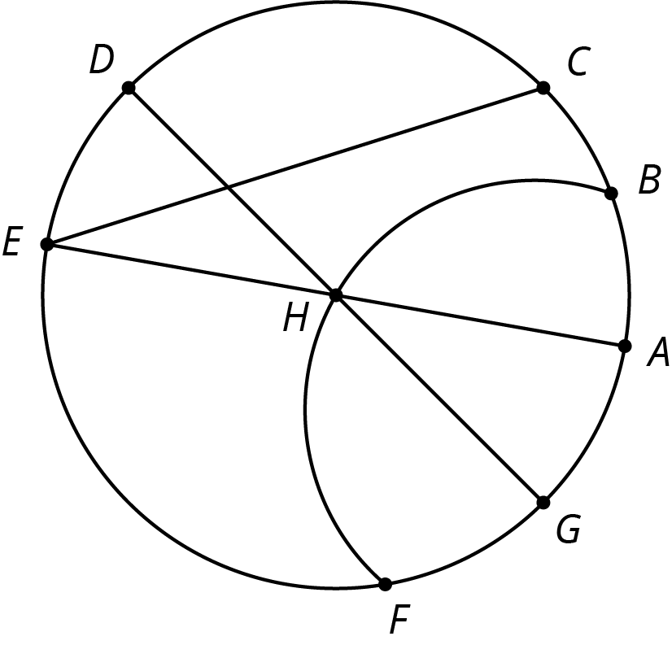
- Identify examples of the following. Explain your reasoning.
  - Diameter
  - Radius
- Lin measured the diameter of a circle in two different directions. Measuring vertically, she got 3.5 cm, and measuring horizontally, she got 3.6 cm. Explain some possible reasons why these measurements differ.
- A small, test batch of lemonade used $\frac{1}{4}$ cup of sugar added to 1 cup of water and $\frac{1}{4}$ cup of lemon juice. After confirming it tasted good, a larger batch is going to be made with the same ratios using 10 cups of water. How much sugar should be added so that the large batch tastes the same as the test batch?
- (From Unit 5, Lesson 1.)
- The graph of a proportional relationship contains the point with coordinates $\left(3,12\right)$. What is the constant of proportionality of the relationship?
- (From Unit 5, Lesson 9.)
© CC BY Open Up Resources. Adaptations CC BY IM.

