Lesson 4: Ratios in Right Triangles
- Let’s investigate ratios in the side lengths of right triangles.

4.1: Ratio Rivalry
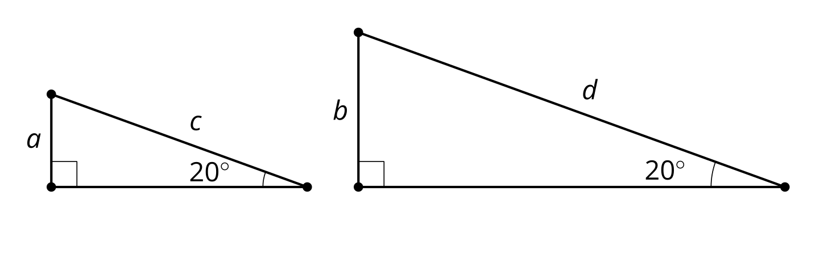
Consider $\frac{a}{c}\text{ and }\frac{b}{d}$. Which is greater, or are they equal? Explain how you know.

4.2: Tons of Triangles
Your teacher will give you some angles.
- Draw several right triangles using the angles you receive.
- Precisely measure the side lengths of the triangles.
- Complete the tables by computing 3 quotients for the acute angles in each triangle:
  - The length of the leg adjacent to your angle divided by the length of the hypotenuse
  - The length of the leg opposite from your angle divided by the length of the hypotenuse
  - The length of the leg opposite from your angle divided by the length of the leg adjacent to your angle
- Find the mean of each column in your table.
- What do you notice about your table? What do you wonder about your table?

4.3: Tons of Ratios
- Compare the row for 20 degrees and the row for 70 degrees in the right triangle table. What is the same? What is different?
- The row for 55 degrees is given here. Complete the row for 35 degrees.
- angle | - adjacent leg $÷$ hypotenuse | - opposite leg $÷$ hypotenuse | - opposite leg $÷$ adjacent leg
- ${35}^{∘}$
- ${55}^{∘}$ | - 0.574 | - 0.819 | - 1.428
- What do you know about a triangle with an adjacent leg to hypotenuse ratio value of 0.839?

Are you ready for more?
- What is the range for the possible ratios of each of the following ratios?
  - adjacent leg $÷$ hypotenuse
  - opposite leg $÷$ hypotenuse
  - opposite leg $÷$ adjacent leg
- What would the triangle look like if the adjacent leg $÷$ hypotenuse ratio was 1? Greater than 1?

Lesson 4 Summary
All right triangles that contain the same acute angles are similar to each other. This means that the ratios of corresponding side lengths are equal for all right triangles with the same acute angles.
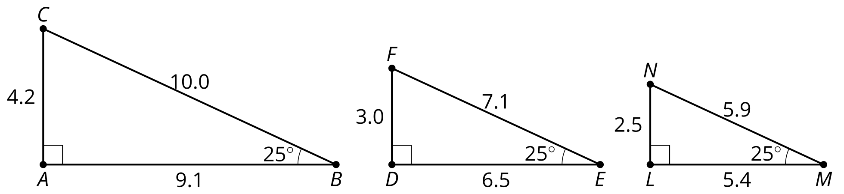
These triangles are all similar by the Angle-Angle Triangle Similarity Theorem. Focusing on the 25 degree angles, we see that all 3 triangles have adjacent leg to hypotenuse ratios of approximately 0.91.
Because all right triangles with the same acute angle measures have the same ratios, we can look for patterns that will help us solve problems. The right triangle table comes from measuring and finding ratios in several right triangles with different angle measures.
angle | adjacent leg $÷$ hypotenuse | opposite leg $÷$ hypotenuse | opposite leg $÷$ adjacent leg
${25}^{∘}$ | 0.906 | 0.423 | 0.466
${35}^{∘}$ | 0.819 | 0.574 | 0.700
${45}^{∘}$ | 0.707 | 0.707 | 1.000
${55}^{∘}$ | 0.574 | 0.819 | 1.428
${65}^{∘}$ | 0.423 | 0.906 | 2.145
Some ratios in this table are repeated. Notice that the rows for 25 degrees and 65 degrees have 2 of the same ratios. What is special about 25 and 65? They are complementary angles, that is, the 2 angles sum to 90 degrees. This seems to be true for other complementary angles. Notice that $35+55=90$ and those rows both have 0.819 as a ratio.
© CC BY 2019 by Illustrative Mathematics®

