Lesson 11 Practice Problems
- Each diagram has a pair of figures, one larger than the other. For each pair, show that the two figures are similar by identifying a sequence of translations, rotations, reflections, and dilations that takes the smaller figure to the larger one.
- 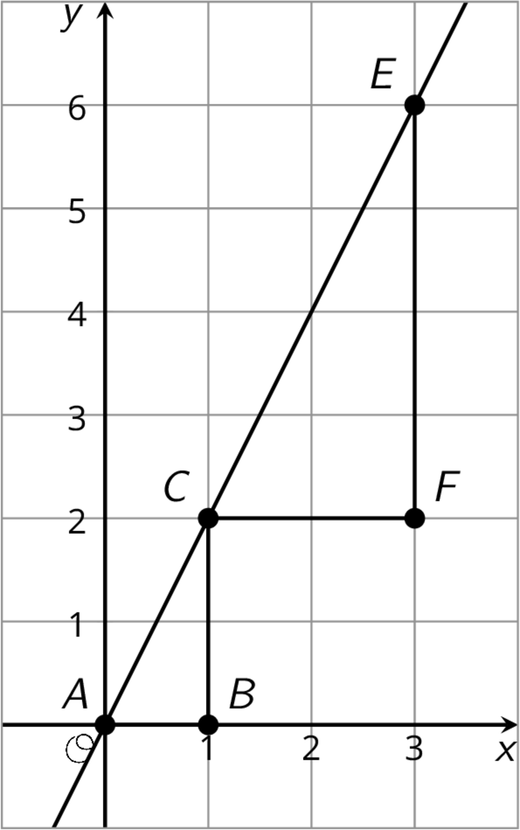
- 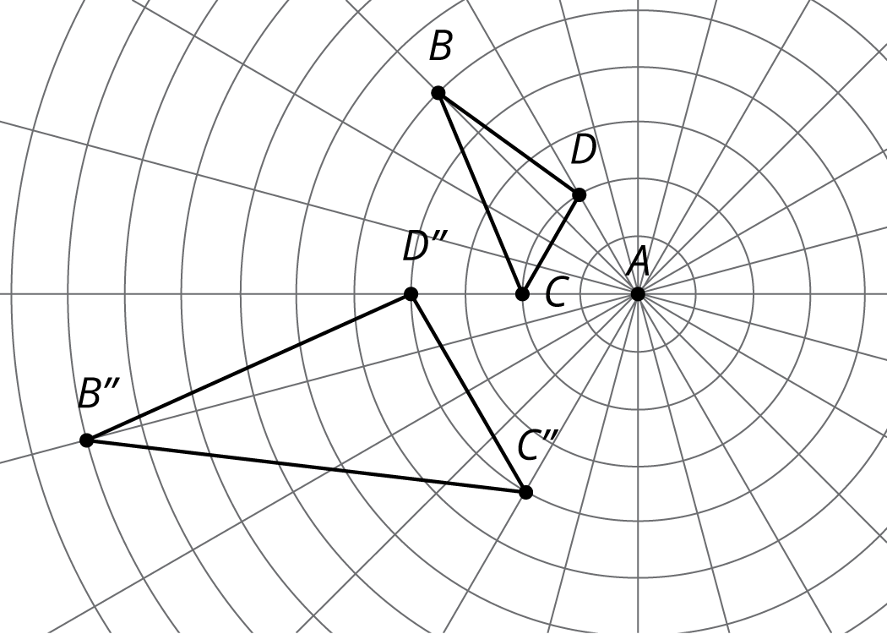
- Here are two similar polygons.
- Measure the side lengths and angles of each polygon. What do you notice?
- 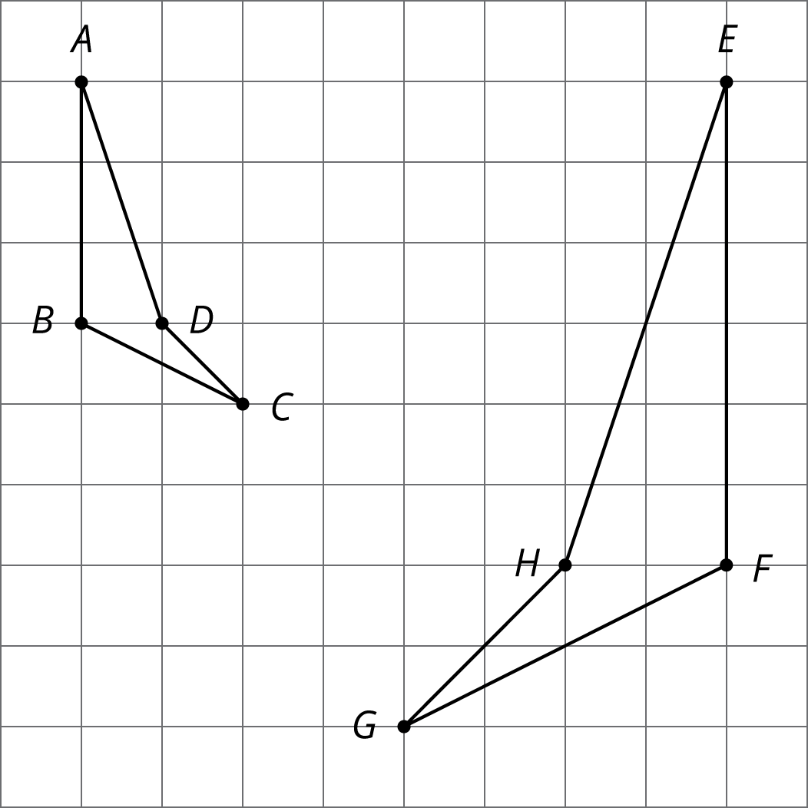
- Each figure shows a pair of similar triangles, one contained in the other. For each pair, describe a point and a scale factor to use for a dilation moving the larger triangle to the smaller one. Use a measurement tool to find the scale factor.
- 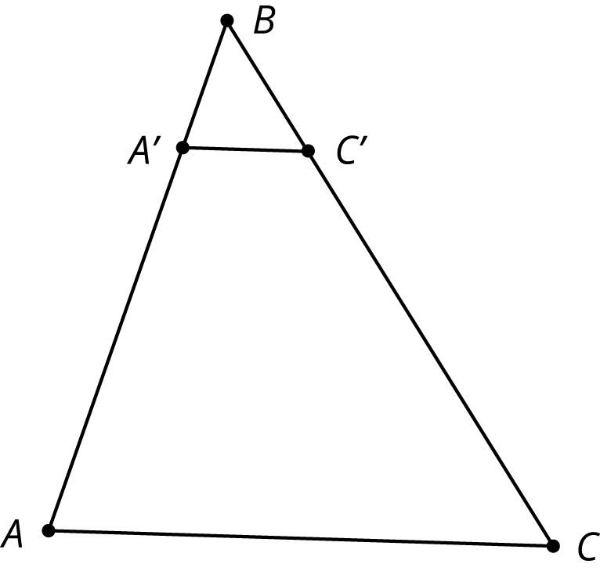
- 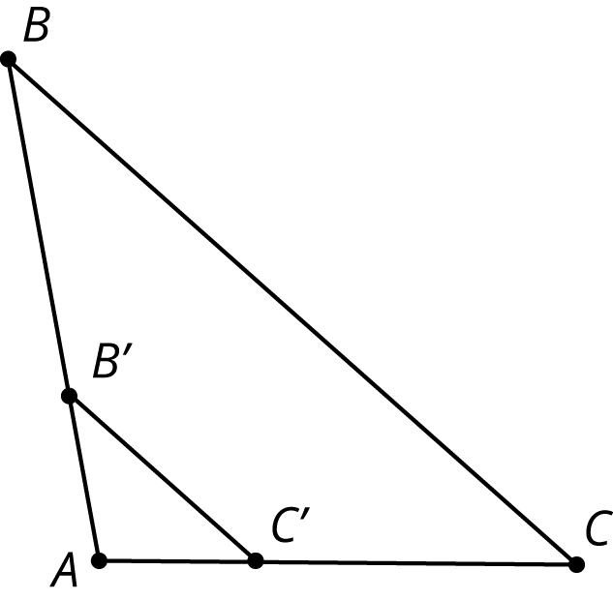
- Describe a sequence of translations, rotations, and reflections that takes Polygon P to Polygon Q.
- 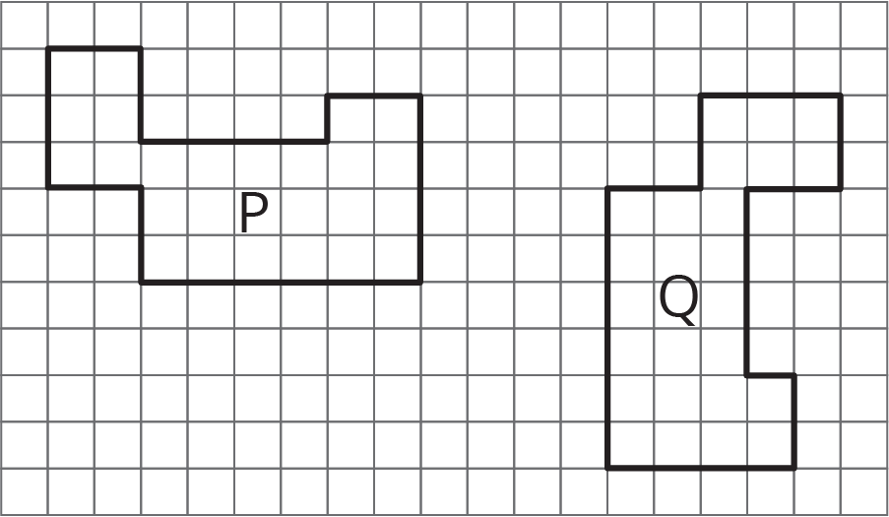

- (From Unit 1, Lesson 3.)

  - Draw the translated image of $ABCDE$ so that vertex $C$ moves to $C^{′}$. Tracing paper may be useful.
  - 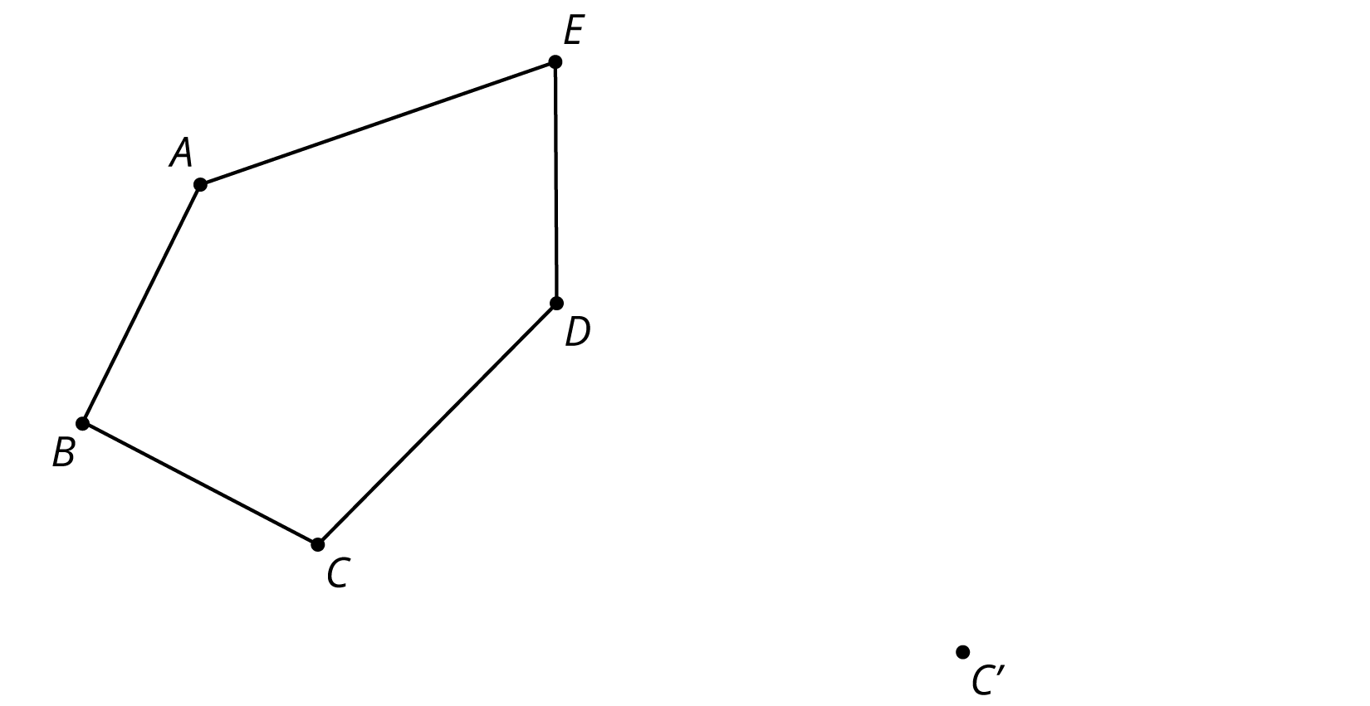
  - Draw the reflected image of Pentagon $ABCDE$ with line of reflection $ℓ$. Tracing paper may be useful.
  - 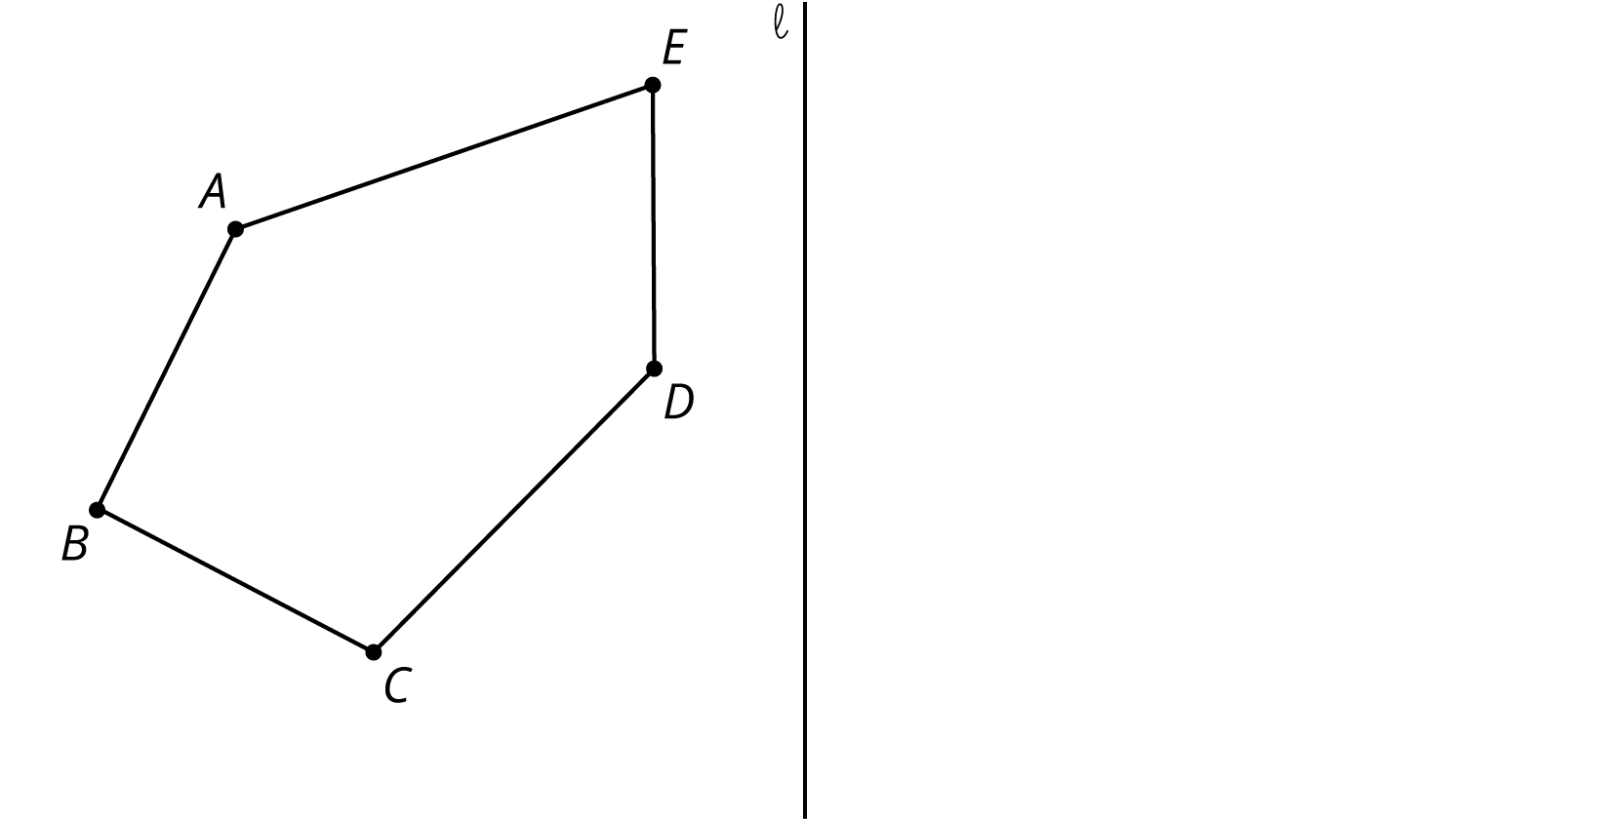
  - Draw the rotation of Pentagon $ABCDE$ around $C$ clockwise by an angle of 150 degrees. Tracing paper and a protractor may be useful.
  - 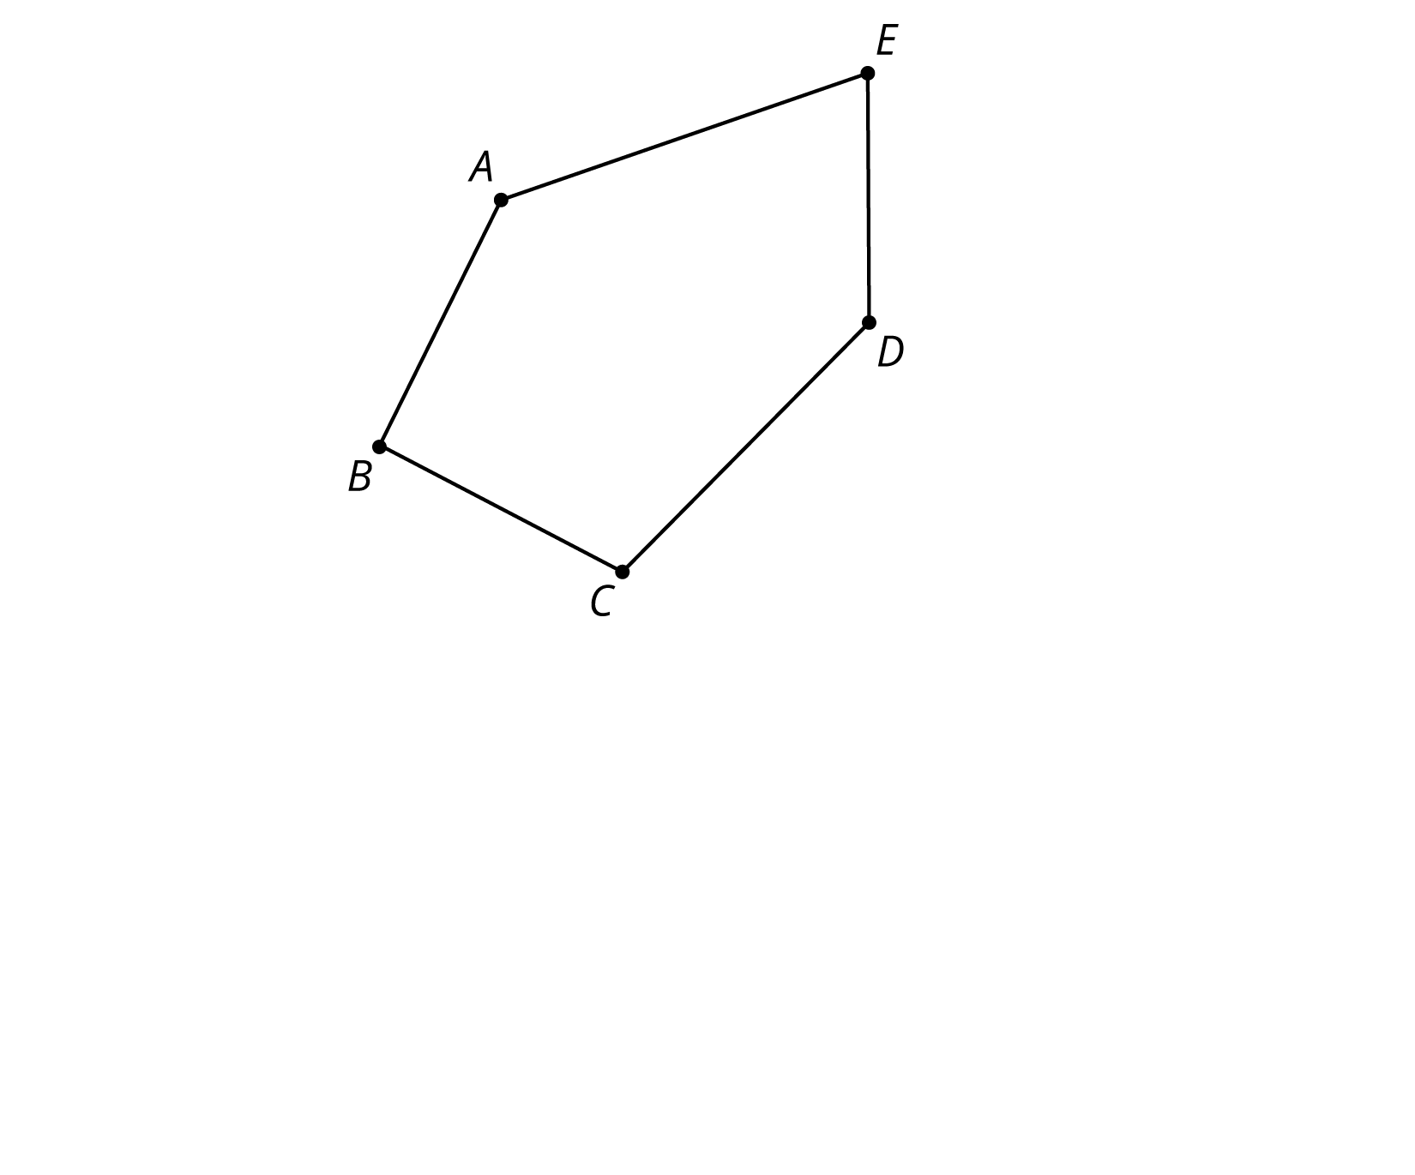
- (From Unit 1, Lesson 2.)
© CC BY Open Up Resources. Adaptations CC BY IM.

