Unit 2 Lesson 5: More Dilations

1 Many Dilations of a Triangle (Warm up)

Student Task Statement
All of the triangles are dilations of Triangle D. The dilations use the same center $P$, but different scale factors. What do Triangles A, B, and C have in common? What do Triangles E, F, and G have in common? What does this tell us about the different scale factors used?
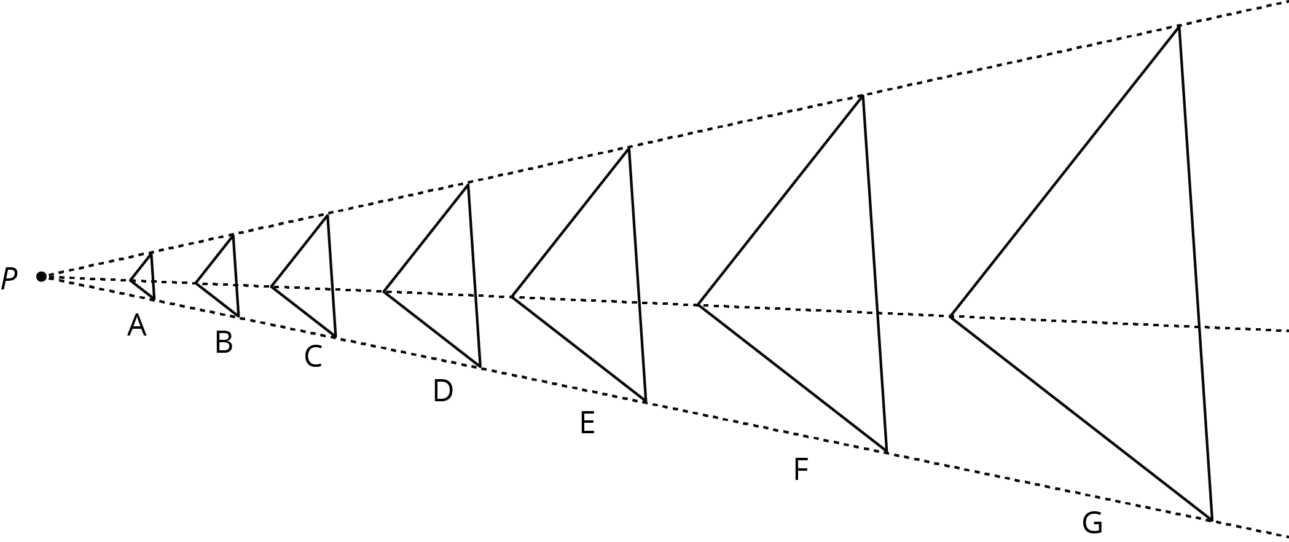

2 Info Gap: Dilations

Student Task Statement
Your teacher will give you either a problem card or a data card. Do not show or read your card to your partner.
If your teacher gives you the problem card:
- Silently read your card and think about what information you need to be able to answer the question.
- Ask your partner for the specific information that you need.
- Explain how you are using the information to solve the problem.
- Continue to ask questions until you have enough information to solve the problem.
- Share the problem card and solve the problem independently.
- Read the data card and discuss your reasoning.
If your teacher gives you the data card:
- Silently read your card.
- Ask your partner “What specific information do you need?” and wait for them to ask for information.
- If your partner asks for information that is not on the card, do not do the calculations for them. Tell them you don’t have that information.
- Before sharing the information, ask “Why do you need that information?” Listen to your partner’s reasoning and ask clarifying questions.
- Read the problem card and solve the problem independently.
- Share the data card and discuss your reasoning.
Pause here so your teacher can review your work. Ask your teacher for a new set of cards and repeat the activity, trading roles with your partner.
© CC BY Open Up Resources. Adaptations CC BY IM.

