Unit 5 Lesson 11: Prisms Practice

1 New Heights (Warm up)

Student Task Statement
Calculate the height of each solid. Round your answers to the nearest tenth if needed.

A
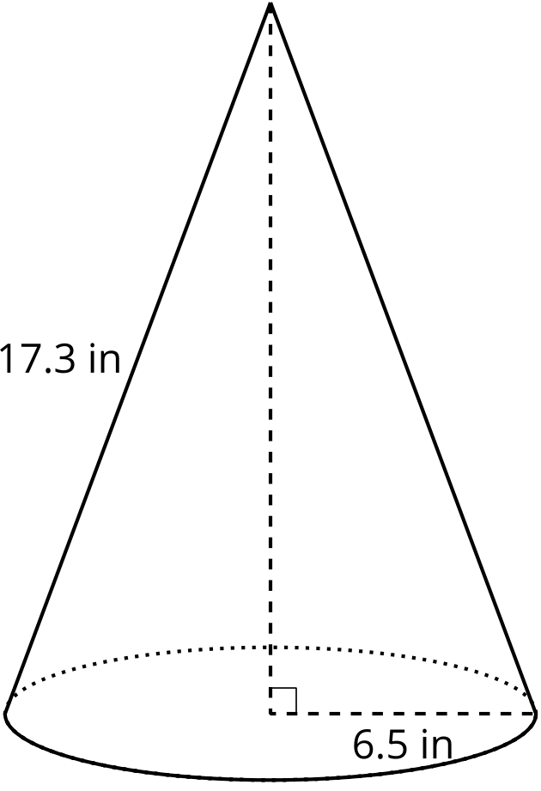

B
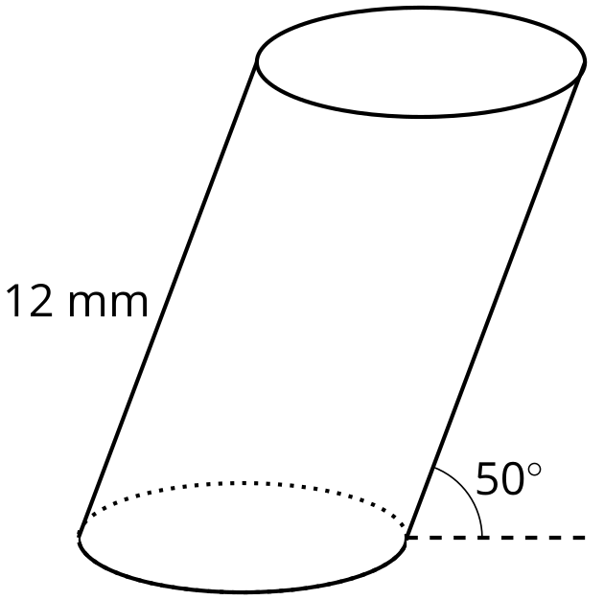

2 The Choice is Yours

Student Task Statement
Here are several solids.

A
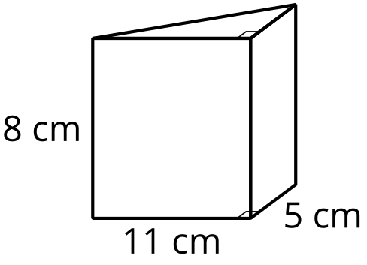

B
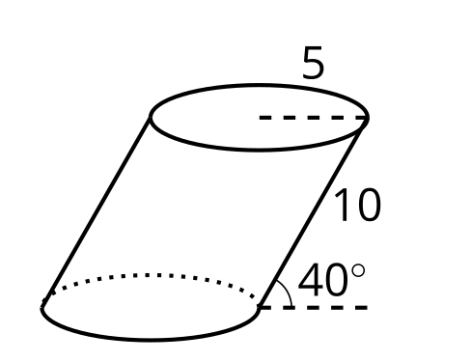

C
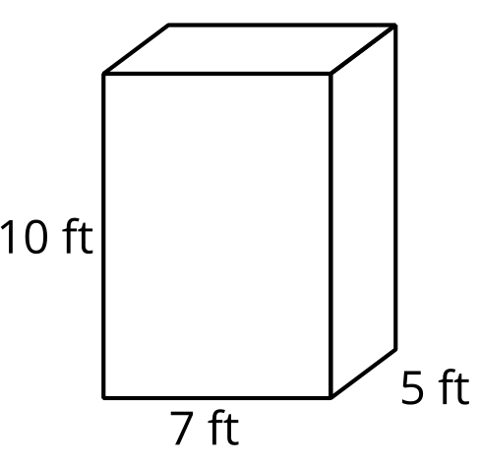

D
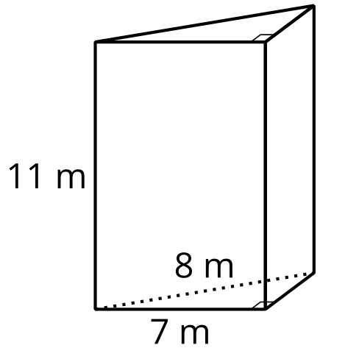

E
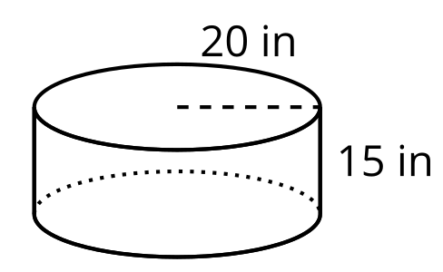

F
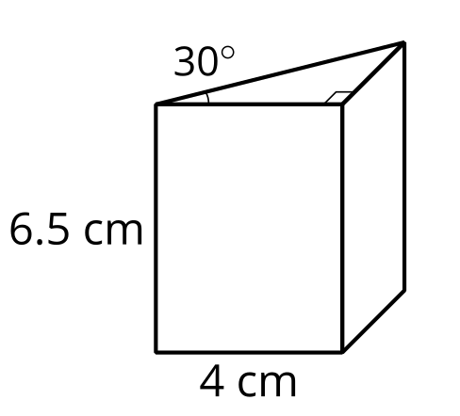

G
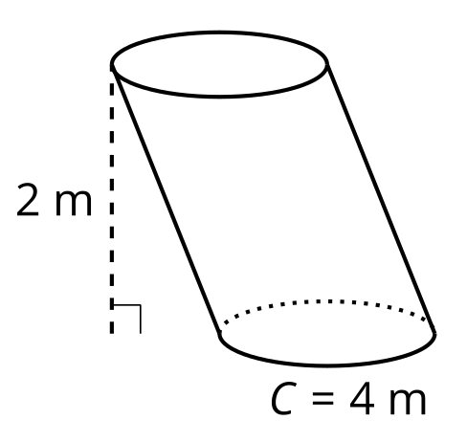
- Without doing any calculating, identify 2 solids you think would have the least difficult volume calculations and 2 solids that would have the most difficult volume calculations. Be prepared to explain your reasoning.
- Choose 3 of the solids. At least 1 should be from your “least difficult” list and 1 should be from your “most difficult” list. Calculate the volumes of the solids you chose. Round your answers to the nearest tenth if needed.

3 The Cayan Tower

Student Task Statement
The building on the left side of the picture is called the Cayan Tower. It’s in the city of Dubai. The tower is about 306 meters tall. It’s made up of identical floors that are each rotated slightly compared to the one underneath it.
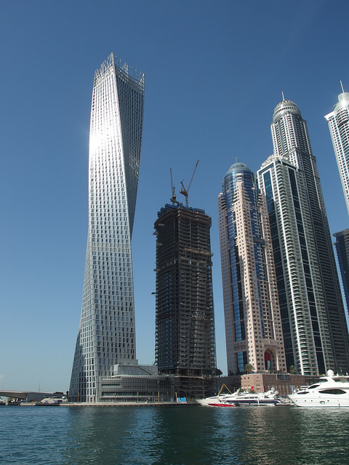

floor plan
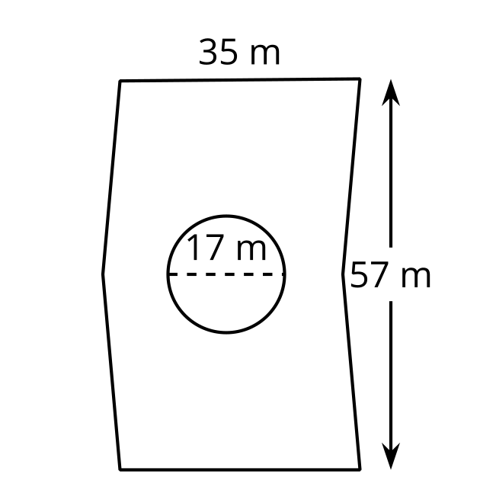
Each floor is the same chevron shape that is approximately 2 parallelograms put together, with the dimensions shown in the image. The circle in the floor plan shows the cross section of the core, which is used to circulate air and carry pipes and wiring throughout the building.
- The area of the Cayan Tower’s base is $57⋅35$ or 1,995 square meters. Why is it possible to find the area of the chevron shape by just multiplying its width and height?
- Describe how the total volume of the building (including the core) can be calculated.
- What shape is the core of the building, whose cross section is shown in the floor plan as a circle?
- Describe how the volume of the building’s core can be calculated, including describing the measurements that would be used.
- What percentage of the building’s volume is taken up by its core?
© CC BY 2019 by Illustrative Mathematics®

